

**LATE BHAUSAHEB HIRAY S.S. TRUST’S INSTITUTE OF**

**COMPUTER APPLICATION**

**ISO 9001-2008 CERTIFIED**

**S.N. 341, Next to New English School, Govt.Colony,**

**Bandra (East), Mumbai – 400051,**

**Tel: 91-22-26570892/3181**

**Date: 10/08/2022**

**CERTIFICATE**

**This is to certify that Mr. Saurabh Bhausaheb Gawali**

**Roll No. 2021105 is a student of MCA of 1st year Semester-II has completed successfully full-semester practical/assignments of subject IOT Lab for the academic year 2021 – 22**

**Subject In-Charge External Examiner**

**Director**

# 

|  |  |  |  |
| --- | --- | --- | --- |
| No | Name of Practical | Date | Sign |
| 1 | 1. Introduction to Basic IoT Components. 2. Program to blink Arduino onboard LED andTo interface external LED with Arduino and write a program to turn ON LED for 1 sec afterevery 2 seconds. | 02/05/2022 |  |
| 2 | Program to build an Arduino Traffic Light Controller. | 02/05/2022 |  |
| 3 | To interface 6LED’s(of different color)with arduino WAPto blink the LED one at time back & forth | 02/05/2022 |  |
| 4 | To interface push button & LED with Arduino WAP to blink LED when button is pressed | 02/05/2022 |  |
| 5 | To interface 2 push button ,2 LED with WAP blink the first LED by pressing the first button | 02/05/2022 |  |
| 6 | Understanding the arduino analog write command. | 14/06/2022 |  |
| 7 | WAP to feed on LED in & out like on a sleeping Apple comp. | 14/06/2022 |  |
| 8 | WAP to play a deep sound if you are entering a no greater than 1o | 14/06/2022 |  |
| 9 | To interface a push button speaker/buzzer with arduino & WAP to turn on LED and generate a note or tone when push button pressed. | 17/06/2022 |  |
| 10 | To interface 2 push buttons a speaker/buzzer with arduino WAP to generate to different node on two buttons keyboard | 17/06/2022 |  |
| 11 | To interface seven segment display(SSD) with Arduino and WAP to blink SSD | 17/06/2022 |  |
| 12 | To interface seven segment display(SSD) with Arduino and WAP to print numbers from 1 to 4 on SSD | 17/06/2022 |  |
| 13 | To interface a seven segment display(SSD) with Arduino and WAP to display countdown from nine withone-second delay on the seven segment display. | 17/06/2022 |  |
| 14 | To interface LED, potentiometer with Arduino WAP to turn on & off LED by turning a potentiometer | 17/06/2022 |  |
| 15 | WAP to display message on LCD. | 17/06/2022 |  |
| 16 | To interface LCD push button, potentiometer with Arduino WAP to display the no of times(count) the  pushbutton pressed on LCD | 17/06/2022 |  |

|  |  |  |  |
| --- | --- | --- | --- |
| 17 | To interface sensor with Arduino board WAP to print thetempreture in **°C** & **°F** on the serial monitor | 01/07/22 |  |
| 18 | To interface sensor with Arduino board WAP to print thetempreture in **°C** & **°F** on the LCD board and potentiometer | 01/07/22 |  |
| 19 | To interface LDR(Photoresister) with Arduino board | 01/07/22 |  |
| 20 | To interface servo motor with arduino WAP to swap a servo back and forth through its  full range of motion | 01/07/22 |  |
| 21 | To interface servo motor photoresistor(ldr) 3 Leds with arduino,WAP to swap a servo back and forth through its full range of motion depending on light also run on the leds | 01/07/22 |  |
| 22 | To interface Ultrasonic sensor with Arduino and write a program to display object distance (in inch/cm) in serial monitor depending on sound detection. | 10/07/22 |  |
| 23 | To interface PIR sensor with Arduino and write a program to turn on and off LED depending on motion detection. | 10/07/22 |  |
| 24 | Write a program to control one DC motors with Arduino. | 10/07/22 |  |
| 25 | Write a program to control two DC motors with Arduino. | 10/07/22 |  |
| 26 | Upload data on Thingspeak cloud manually. | 15/07/22 |  |
| 27 | To update readings to Thingspeak from Arduino using Tinkercad. | 15/07/22 |  |
| 28 | To interface Temperature sensor and ESP8266 with Arduino and update temperature reading to Thingspeak. | 15/07/22 |  |
| 29 | To interface LDR sensor, LED and ESP8266 with Arduino and update light intensity values to Thingspeak  and tweet “LIGHT ON” message on tweeter when light intensity value is less than 300 | 15/07/22 |  |
| 30 | To interface Temperature sensor and ESP8266 with Arduino and update temperature values to Thingspeakand tweet “High Temp” message on tweeter when temperature value is greater than 40C. | 15/07/22 |  |

# Practical No. 1

**Aim:** Program to blink Arduino onboard LED and to interface external LED with Arduino and write a program to turn ON LED for 1 sec after every 2 seconds.

**Components:** Arduino Uno, 1 Green LED, 1 Resistor of 100 Ω

**Theory:** Arduino Uno is a microcontroller board based on the ATmega328P (datasheet). It has 14 digital input/output pins (of which 6 can be used as PWM outputs), 6 analog inputs, a 16 MHz ceramic resonator (CSTCE16M0V53-R0), a USB connection, a power jack, an ICSP header and a reset button.

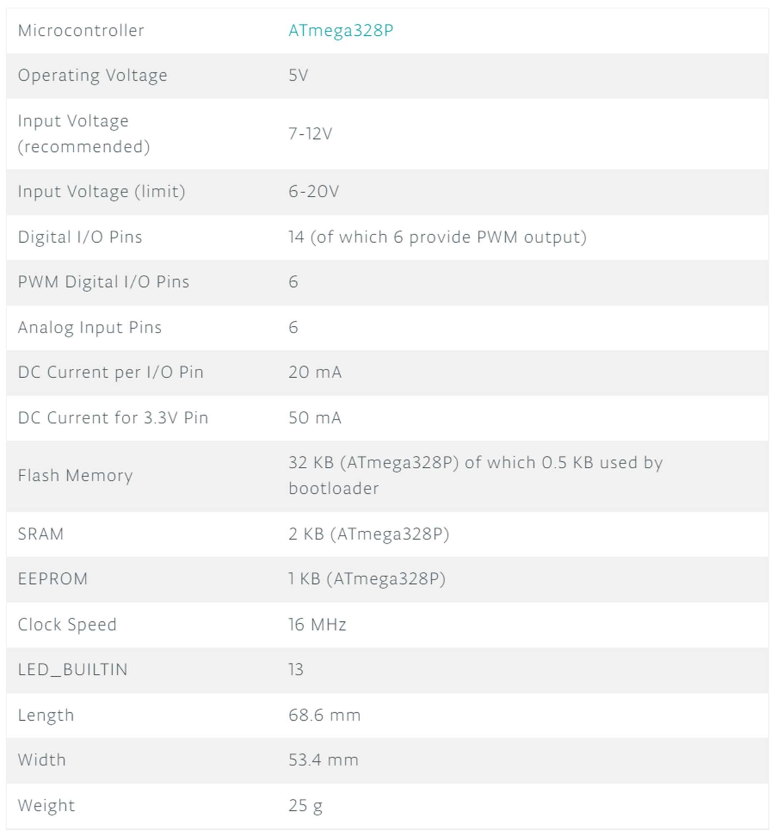

**digitalWrite():**

## Description:

Write a HIGH or a LOW value to a digital pin.

If the pin has been configured as an OUTPUT with pinMode(), its voltage will be set to the corresponding value: 5V (or 3.3V on 3.3V boards) for HIGH, 0V (ground) for LOW.

If the pin is configured as an INPUT, digitalWrite() will enable (HIGH) or disable (LOW) the internal pullup on the input pin.

If you do not set the pinMode() to OUTPUT, and connect an LED to a pin, when calling digitalWrite(HIGH), the LED may appear dim. Without explicitly setting pinMode(), digitalWrite() will have enabled the internal pull-up resistor, which acts like a large current-limiting resistor.

## Syntax:

digitalWrite(pin, value)

## Parameters:

pin: the Arduino pin number. value: HIGH or LOW.

**Circuit Diagram:**

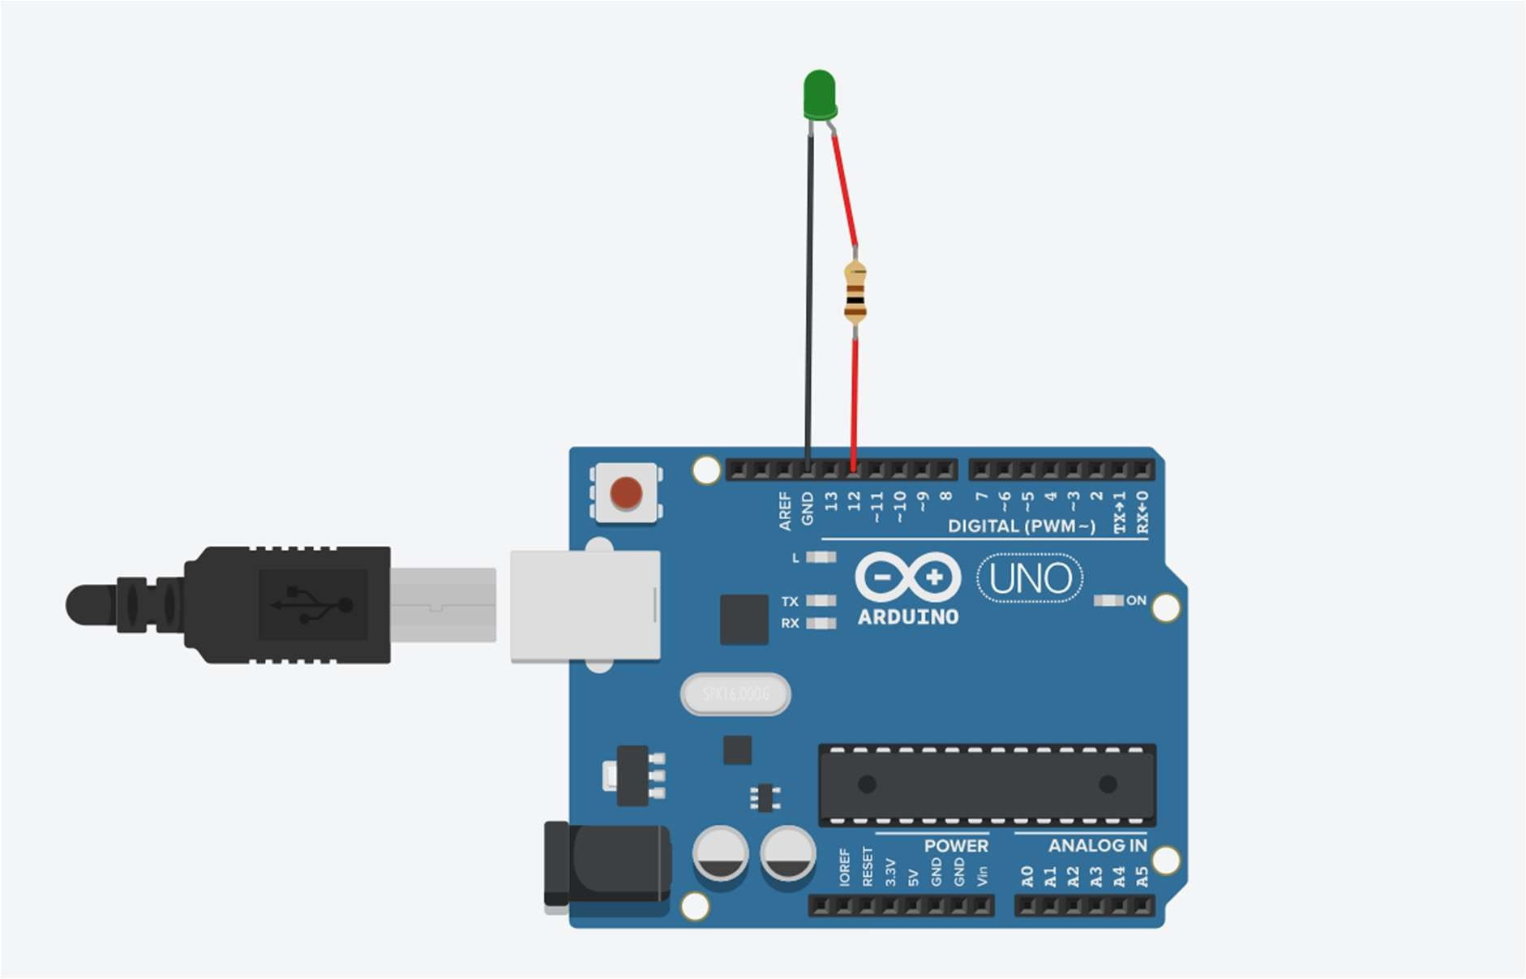

**Program:**

void setup()

{

pinMode(12, OUTPUT);

}

void loop()

{

digitalWrite(12, HIGH); delay(1000); digitalWrite(12, LOW); delay(2000);

}

**Output:**

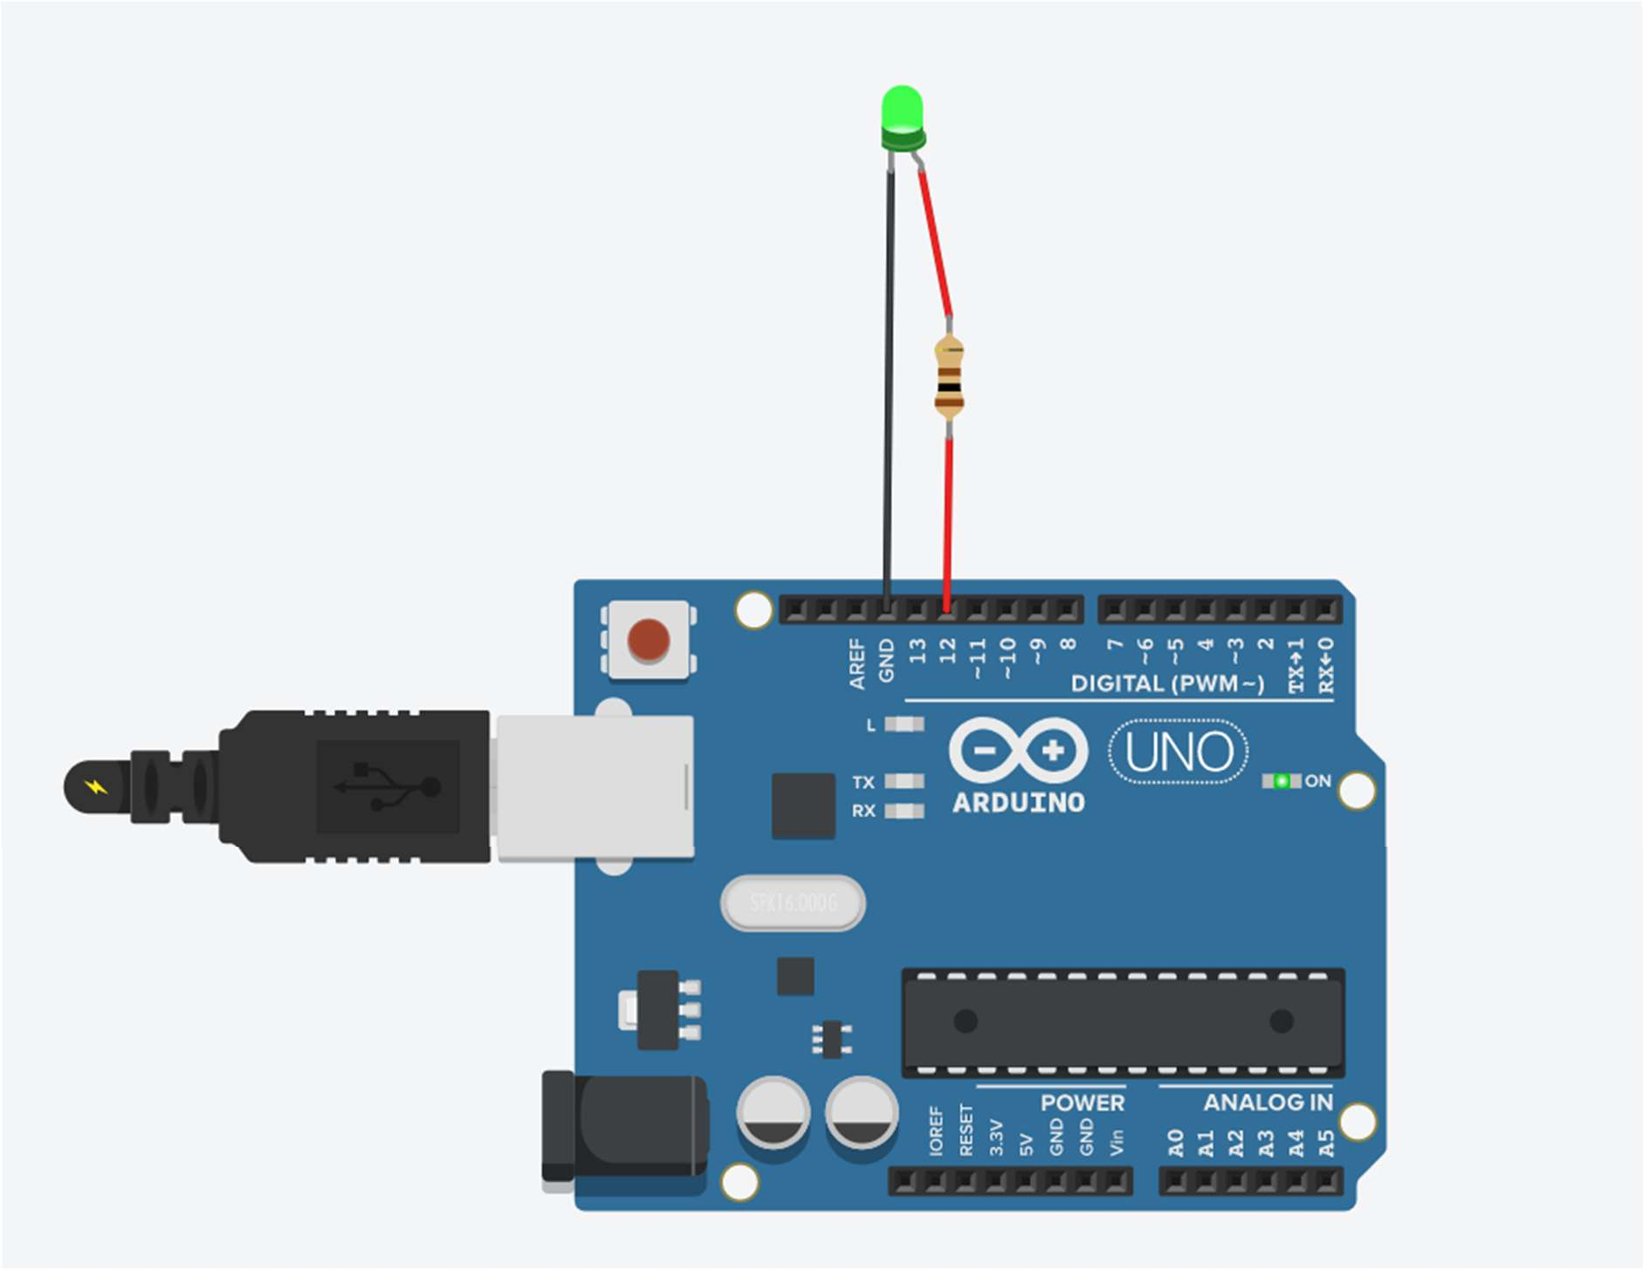

# Practical No. 2

**Aim:** Program to build an Arduino Traffic Light Controller.

**Component:** Arduino Uno, 3 LEDs (Red, Yellow, Green), 3 Resistors of 100 ohm **Theory:** For traffic light controller we have used 3 LEDs and turning ON using some dalay **Circuit Diagram:**

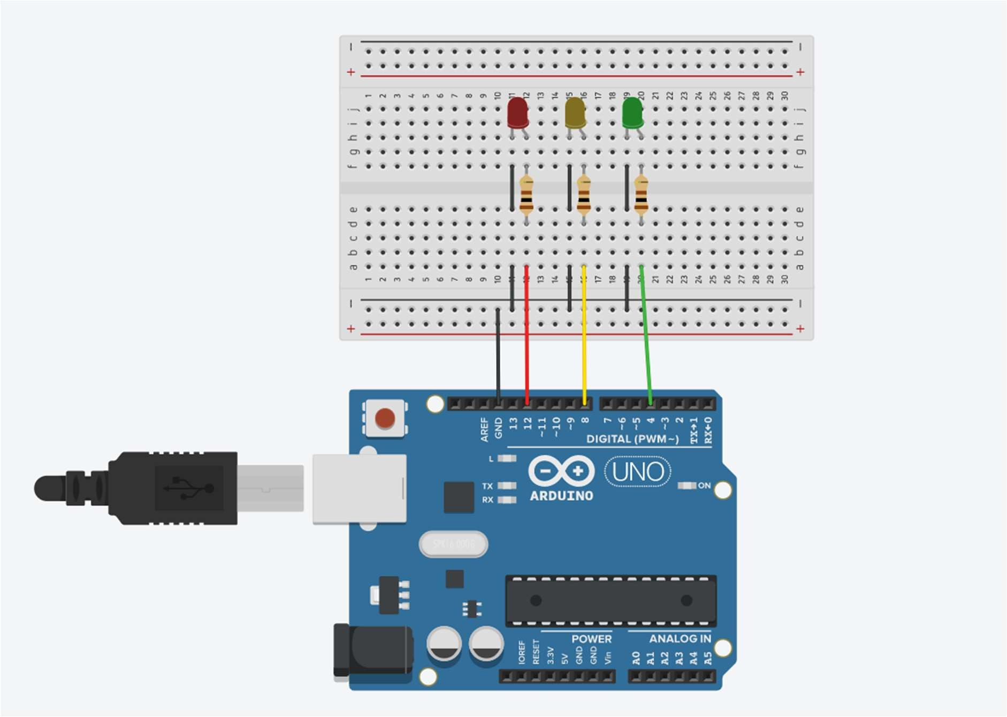

**Program:**

void setup()

{

pinMode(4, OUTPUT); pinMode(8, OUTPUT); pinMode(12, OUTPUT);

}

void loop()

{

digitalWrite(4, LOW);

digitalWrite(8, LOW); digitalWrite(12, HIGH); delay(3000); digitalWrite(4, LOW); digitalWrite(8, HIGH); digitalWrite(12, LOW); delay(1000); digitalWrite(4, HIGH); digitalWrite(8, LOW); digitalWrite(12, LOW); delay(2000);

}

**Output:**

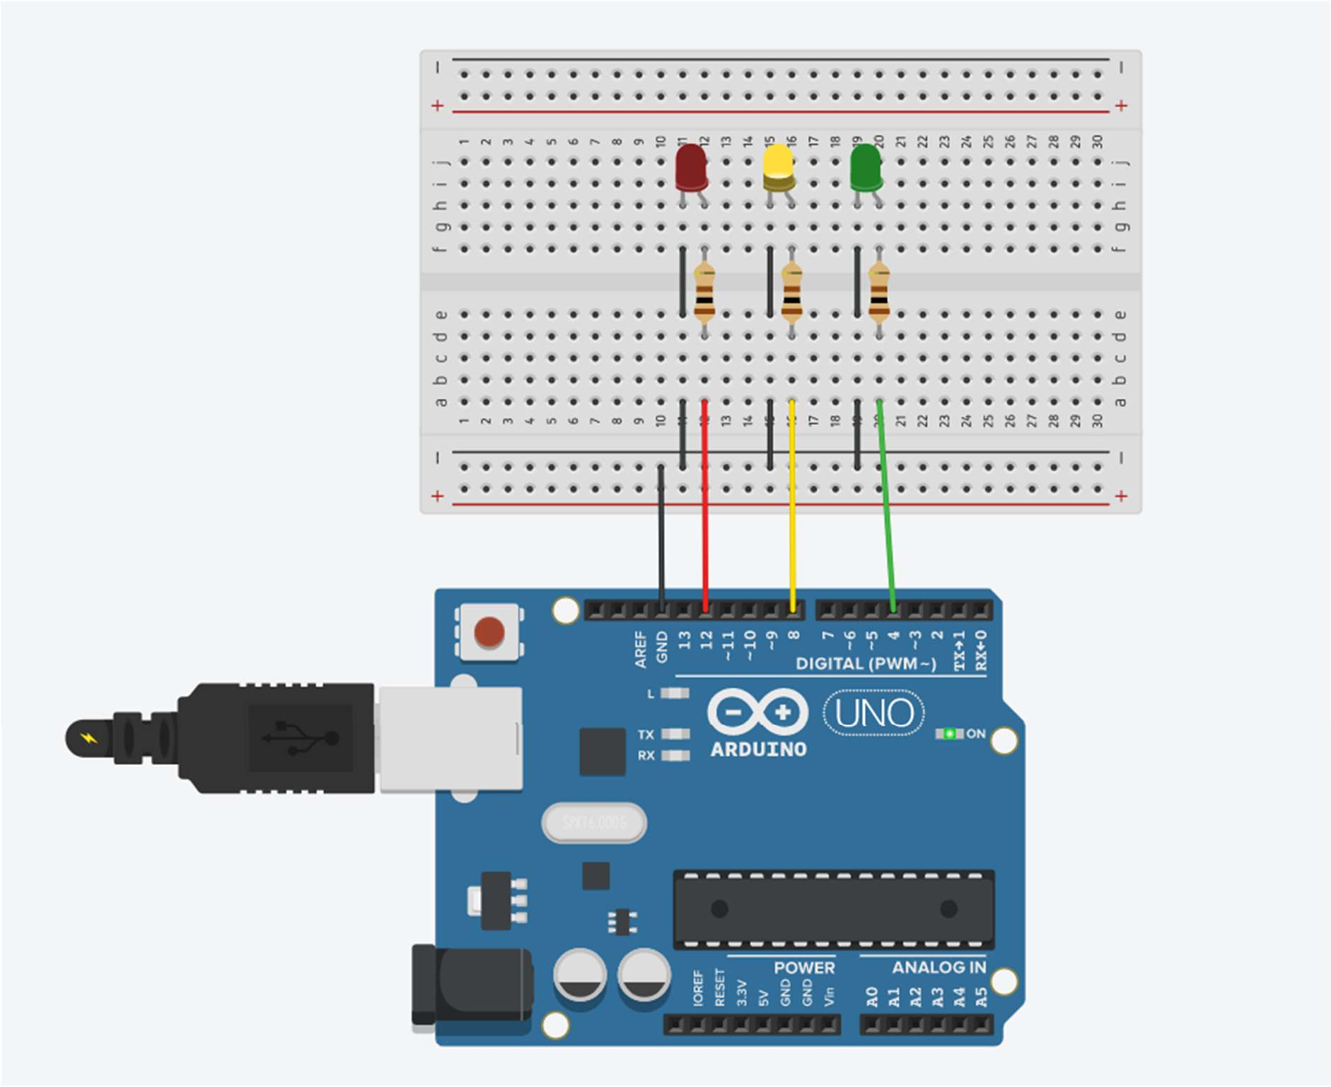

# Practical No. 3

**Aim:** To interface 5 LEDs with Arduino and write a program to blink 6 LEDs, one at a time, in a back-and-forth formation

**Component:** Arduino Uno, 6 different colour LEDs, 6 Resistors of 100 Ω

**Circuit Diagram:**

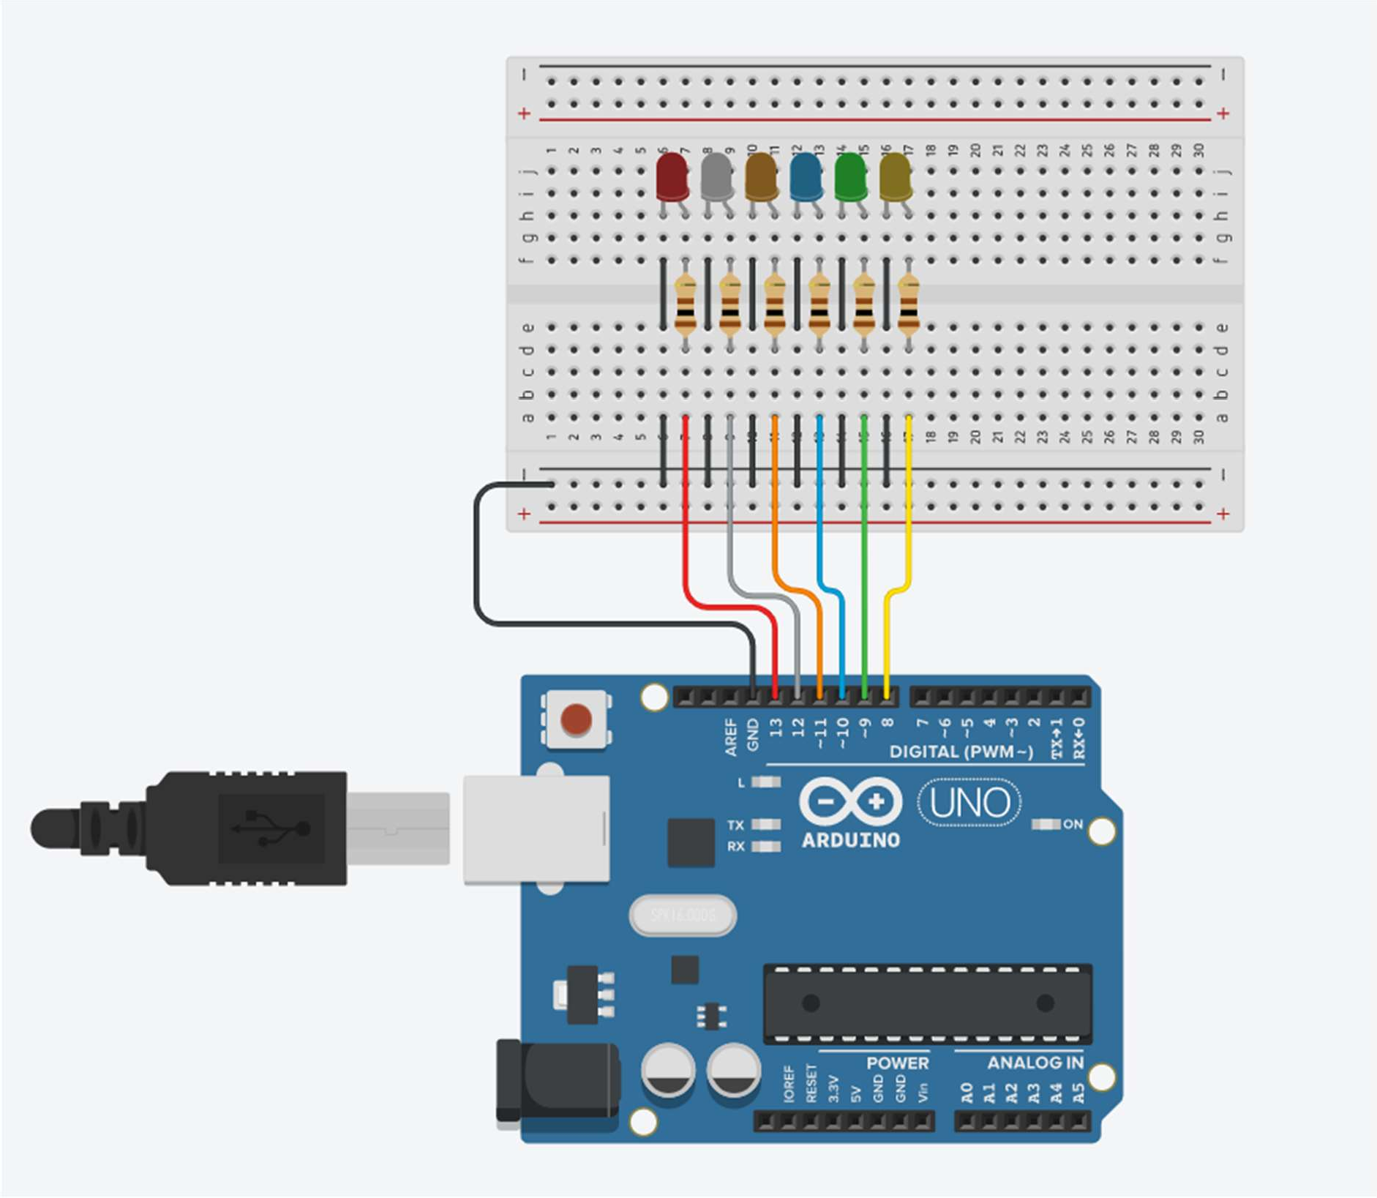

**Program:**

void setup()

{

for(int pin = 8; pin <= 13; pin++) pinMode(pin, OUTPUT);

}

void loop()

{

for(int pin = 8; pin <=13; pin++){ digitalWrite(pin, HIGH); delay(100); digitalWrite(pin, LOW);

}

for(int pin = 13; pin >= 8; pin--){ digitalWrite(pin, HIGH);

delay(100); digitalWrite(pin, LOW);

}

}

**Output:**

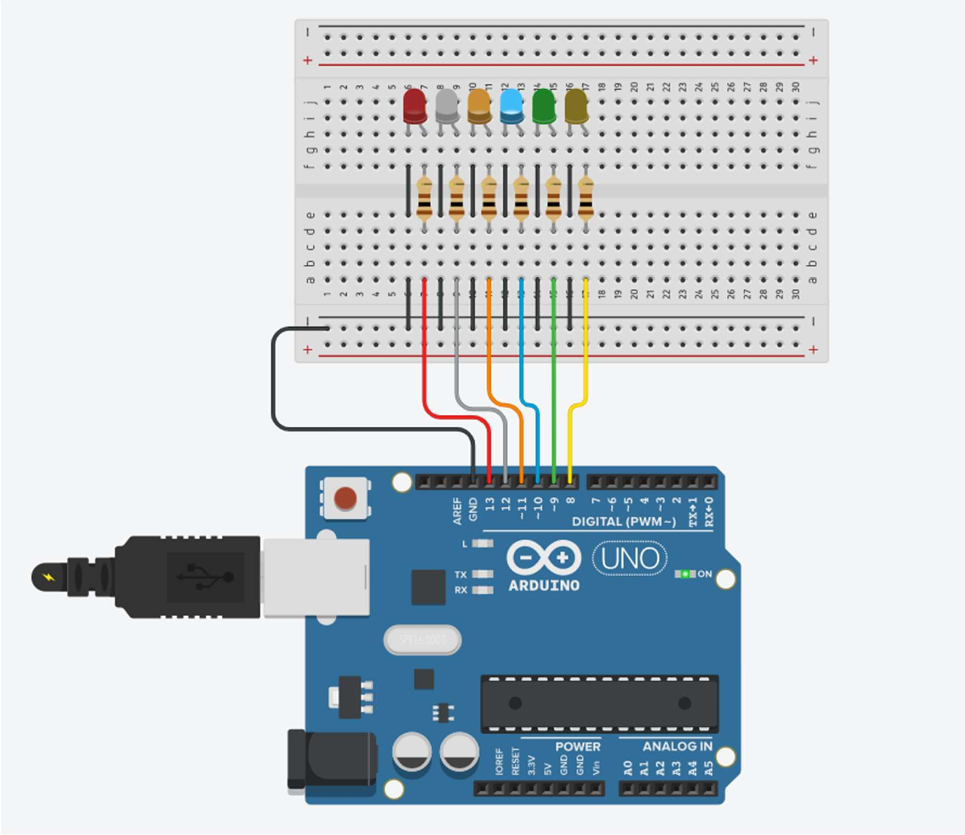

# Practical No. 4

**Aim:** To interface Push button with Arduino and write a program to turn ON LED when push button is pressed.

**Component:** Arduino Uno, 2 Pushbutton, 2 different LEDs, 4 Resistors of 100 Ω

**Theory:**

**Pushbutton: -** The pushbutton is a component that connects two points in a circuit when you press it. The example turns on an LED when you press the button.

**Resistors: -** Resistors are electronic components, which offer resistance against the current flow, or speaking at a deeper level, against the electrons' flow. Resistors, denoted by R, are passive components, which means that they don't generate any electricity at all, but rather reduce voltage and current by dissipating power in the form of heat.

The unit of resistance is ohms (Ω) and resistors are usually built using carbon or metal wire.

## digitalRead()

Reads the value from a specified digital pin, either HIGH or LOW.

## Syntax

digitalRead(pin)

## Parameters

pin: the Arduino pin number you want to read

## Returns

HIGH or LOW

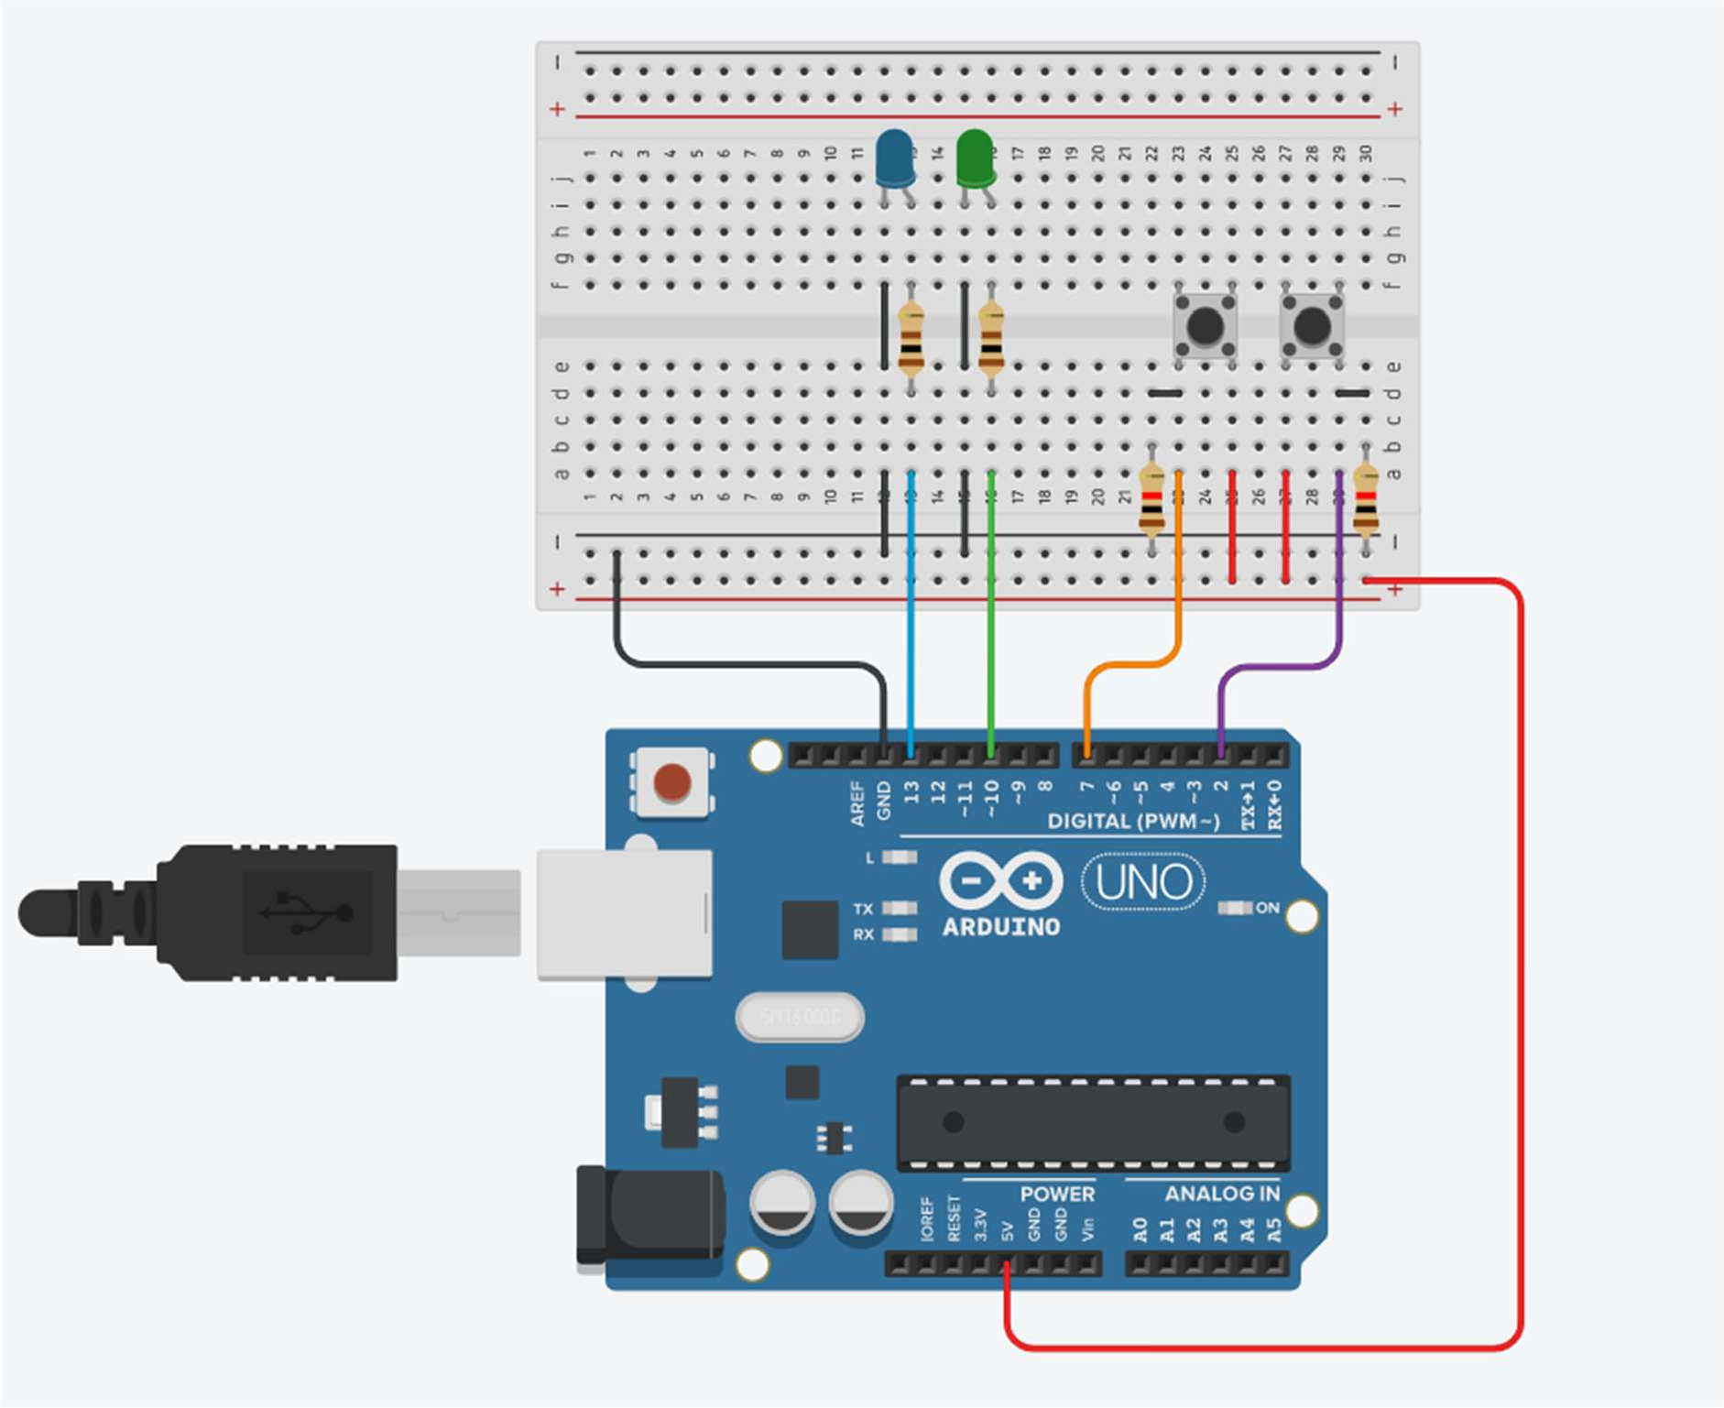**Circuit Diagram:**

**Program:**

int button1 = 2; int button2 = 7; void setup()

{

pinMode(10, OUTPUT); pinMode(13, OUTPUT); pinMode(button1, INPUT); pinMode(button2, INPUT);

}

void loop()

{

int value1 = digitalRead(button1);

int value2 = digitalRead(button2); if(value1 == HIGH) digitalWrite(10, HIGH);

else

digitalWrite(10, LOW);

if(value2 == HIGH) digitalWrite(13, HIGH); else

digitalWrite(13, LOW);

}

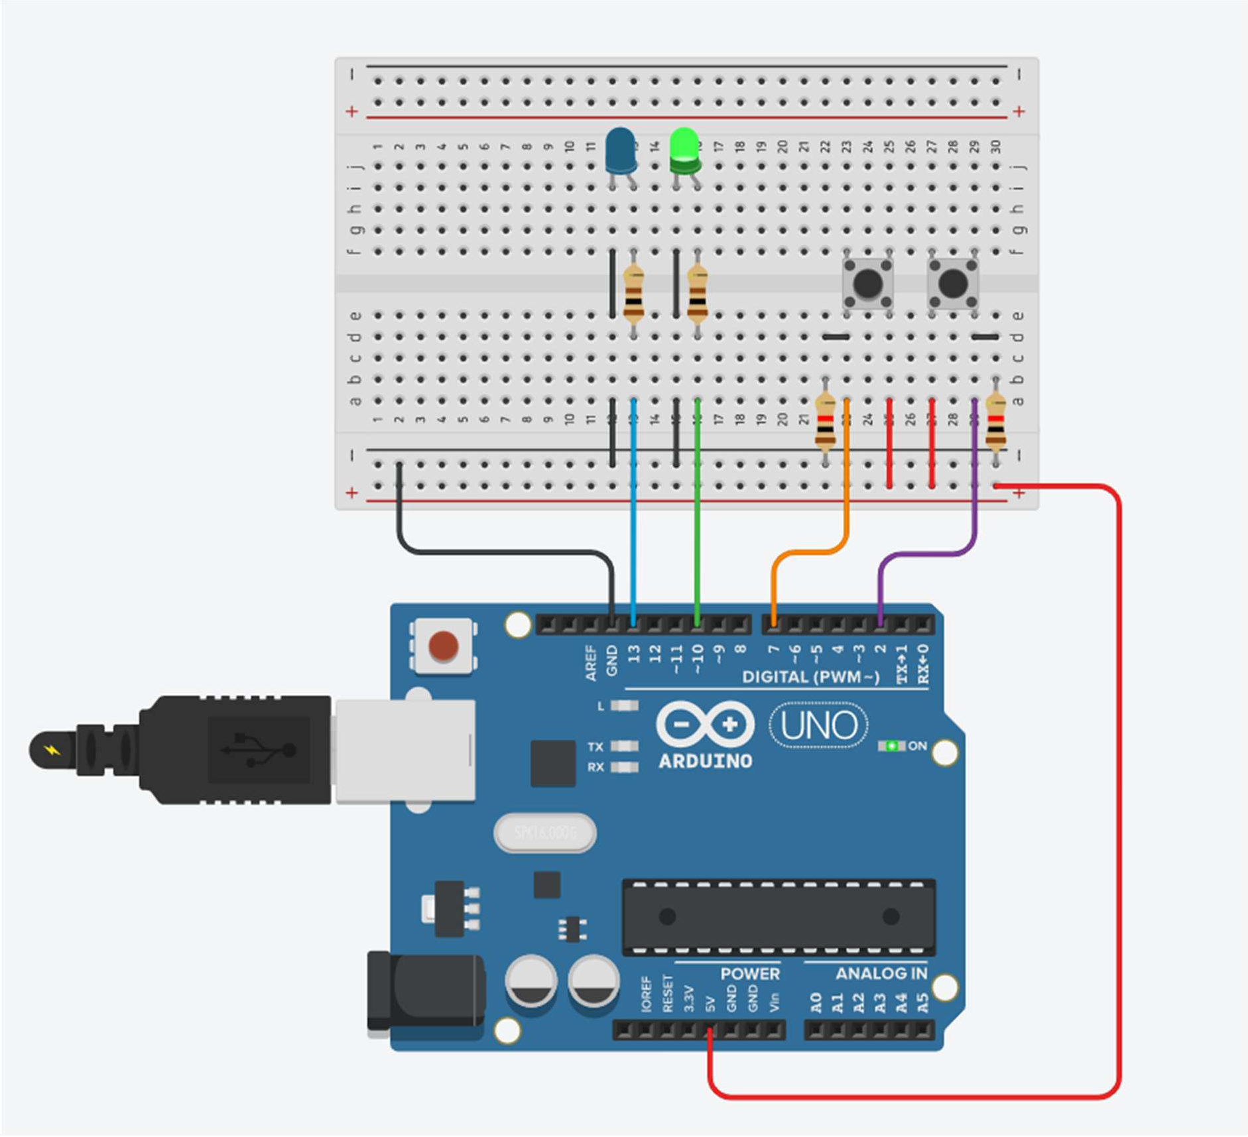**Output:**

# Practical No. 5

**Aim:** To interface two push buttons and two LEDs (RED and GREEN) with Arduino and write a program to turn ON Red LED when buttton1 pressed and turn ON Green LED when button2 pressed**.**

**Components:** Arduino Uno, 1 Red LED , 1 Green LED , Breadboard , 2 Push Button , 4 Resistor of 100 Ω

**Theory:**

**Pushbutton: -** The pushbutton is a component that connects two points in a circuit when you press it. The example turns on an LED when you press the button.

**Resistors: -** Resistors are electronic components, which offer resistance against the current flow, or speaking at a deeper level, against the electrons' flow. Resistors, denoted by R, are passive components, which means that they don't generate any electricity at all, but rather reduce voltage and current by dissipating power in the form of heat.

The unit of resistance is ohms (Ω) and resistors are usually built using carbon or metal wire.

## digitalRead()

Reads the value from a specified digital pin, either HIGH or LOW.

## Syntax

digitalRead(pin)

## Parameters

pin: the Arduino pin number you want to read

## Returns

HIGH or LOW

**Circuit Diagram**:

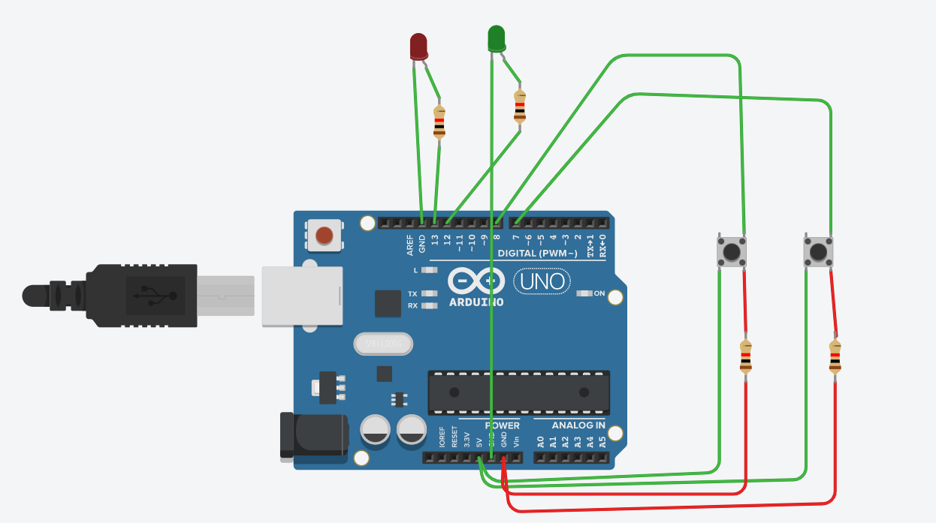

**Program:**

int button1=8;int button2=7;

void setup()

{

pinMode(13, OUTPUT);

pinMode(button1, INPUT);

pinMode(button2, INPUT);

}

void loop()

{

int value1=digitalRead(button1);

if(value1==HIGH)

{

digitalWrite(13,HIGH);

}

else

{

digitalWrite(13,LOW);

}

int value2=digitalRead(button2);

if(value2==HIGH)

{

digitalWrite(12,HIGH);

}

else

{

digitalWrite(12,LOW);

}

}

**Output :**

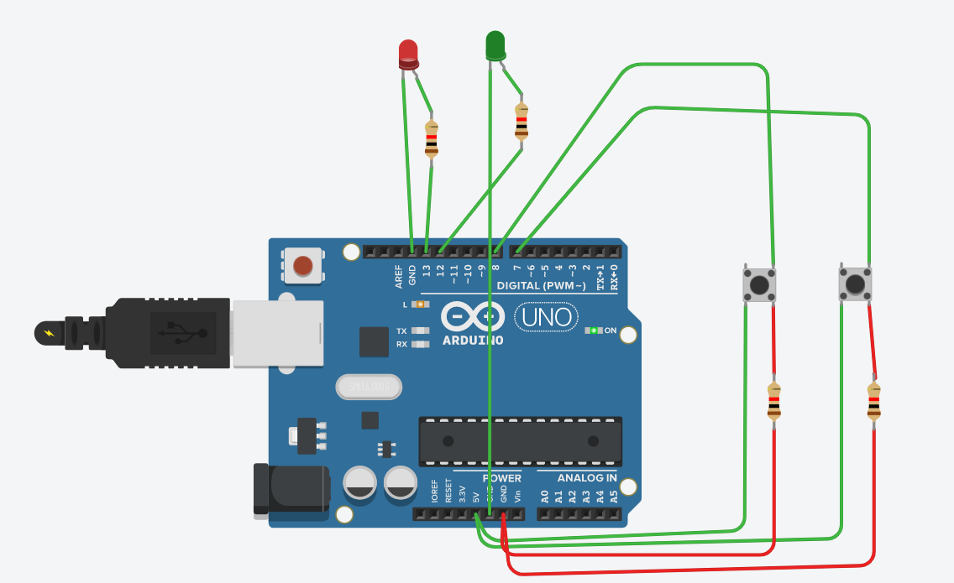

# Practical No. 6

**Aim:** Understanding the ardunio analog write command.

**Component:** Arduino Uno, 1LED, 2 Resistors

**Theory:**

**analogWrite():-**Writes an analog value ([PWM wave](http://arduino.cc/en/Tutorial/PWM)) to a pin. Can be used to light a LED at varying brightnesses or drive a motor at various speeds. After a call to analogWrite(), the pin will generate a steady rectangular wave of the specified duty cycle until the next call to analogWrite() (or a call to digitalRead() or digitalWrite()) on the same pin.

## Syntax

## analogWrite(pin, value)

## Parameters

pin: the Arduino pin to write to. Allowed data types: int.  
value: the duty cycle: between 0 (always off) and 255 (always on).

**Circuit Diagram:**

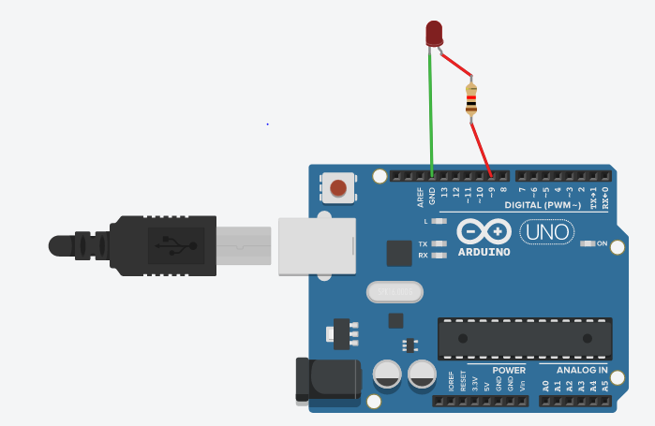

**Program:**

int redPin= 9;

int bright = 12;

void setup()

{

pinMode(redPin, OUTPUT);

}

void loop()

{

analogWrite(redPin, bright);

}

**Output :**

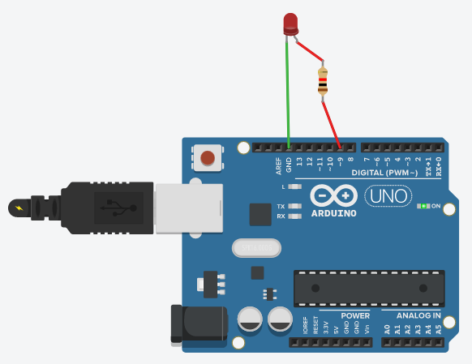

# Practical No. 7

**Aim:** Write a program to feed on LED in and out like on a sleeping Apple comp.

**Component:** Arduino Uno, 1LED, 1 Resistors

**Theory:**

**analogWrite():-**Writes an analog value ([PWM wave](http://arduino.cc/en/Tutorial/PWM)) to a pin. Can be used to light a LED at varying brightnesses or drive a motor at various speeds. After a call to analogWrite(), the pin will generate a steady rectangular wave of the specified duty cycle until the next call to analogWrite() (or a call to digitalRead() or digitalWrite()) on the same pin.

## Syntax

## analogWrite(pin, value)

## Parameters

pin: the Arduino pin to write to. Allowed data types: int.  
value: the duty cycle: between 0 (always off) and 255 (always on).

**Circuit Diagram:**

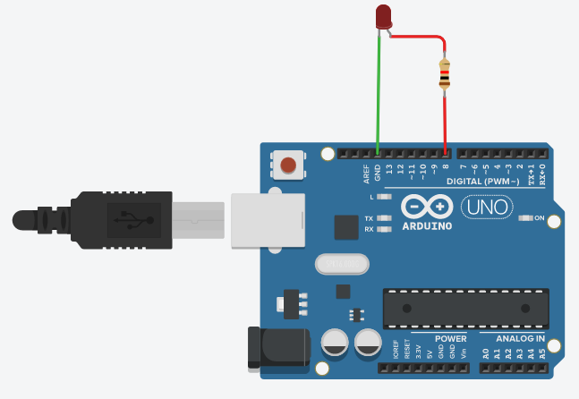

**Program:**

int redPin =8;

int brightness=0;

void setup()

{

pinMode(redPin, OUTPUT);

}

void loop()

{

for(brightness=0;brightness<=255;brightness++)

{

analogWrite(redPin,brightness);

delay(10);

}

for(brightness=0;brightness>=0;brightness++)

{

analogWrite(redPin,brightness);

delay(10);

}

}

**Output:**

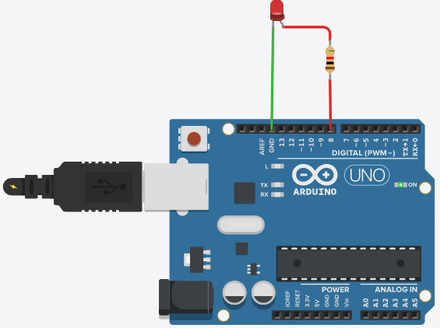

# Practical No. 8

**Aim:** Write a program to play a deep sound if you are entering a no greater than 10.

**Component:** Arduino Uno, 1 Buzzer, 1 Resistors

**Theory:**

**Buzzer: -** A piezo buzzer is pretty sweet. It’s not liked a regular speaker that you might think of. It uses a material that’s piezoelectric, it actually changes shape when you apply electricity to it. By adhering a piezo-electric disc to a thin metal plate, and then applying electricity, we can bend the metal back and forth, which in turn creates noise.The faster you bend the material, the higher the pitch of the noise that’s produced. This rate is called frequency. Again, the higher the frequency, the higher the pitch of the noise we hear.

**tone():-** Generates a square wave of the specified frequency (and 50% duty cycle) on a pin. A duration can be specified, otherwise the wave continues until a call to noTone(). The pin can be connected to a piezo buzzer or other speaker to play tones.

Use of the tone() function will interfere with PWM output on pins 3 and 11

## Syntax

tone(pin, frequency)

tone(pin, frequency, duration)

## Parameters

pin: the Arduino pin on which to generate the tone.

frequency: the frequency of the tone in hertz. Allowed data types: unsigned int.

duration: the duration of the tone in milliseconds (optional).

**noTone():** - Stops the generation of a square wave triggered by tone(). Has no effect if no tone is being generated

**Syntax :** noTone(pin)

**Parameters:**

pin: the Arduino pin on which to stop generating the tone

**Circuit Diagram:**

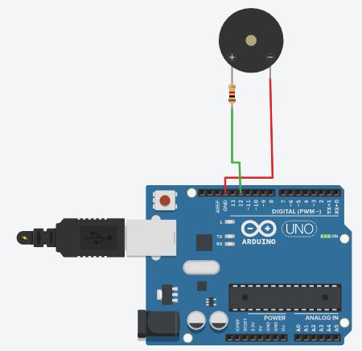

**Program:**

int buzzPin =12;

int mynum;

String msg="Please enter a number";

void setup()

{

Serial.begin(9600);

pinMode(buzzPin, OUTPUT);

}

void loop()

{

Serial.println(msg);

while(Serial.available()==0)

{

}

mynum = Serial.parseInt();

if(mynum>10)

{

tone(buzzPin,1000);

delay(1000); // Wait for 1000 millisecond(s)

noTone(buzzPin);

}

}

**Output:**



# Practical No. 9

**Aim:** To interface Push button, Speaker/buzzer with Arduino and write a program to turn ON LED and generate a note or tone when push button is pressed.

**Component:** Arduino Uno, 1 Pushbutton, 1 Buzzer, 3 Resistors

**Theory:**

**Buzzer: -** A piezo buzzer is pretty sweet. It’s not liked a regular speaker that you might think of. It uses a material that’s piezoelectric, it actually changes shape when you apply electricity to it. By adhering a piezo-electric disc to a thin metal plate, and then applying electricity, we can bend the metal back and forth, which in turn creates noise.

The faster you bend the material, the higher the pitch of the noise that’s produced. This rate is called frequency. Again, the higher the frequency, the higher the pitch of the noise we hear.

**tone():-** Generates a square wave of the specified frequency (and 50% duty cycle) on a pin. A duration can be specified, otherwise the wave continues until a call to noTone(). The pin can be connected to a piezo buzzer or other speaker to play tones.

Only one tone can be generated at a time. If a tone is already playing on a different pin, the call to tone() will have no effect. If the tone is playing on the same pin, the call will set its frequency.

Use of the tone() function will interfere with PWM output on pins 3 and 11 (on boards other than the Mega).

It is not possible to generate tones lower than 31Hz.

## Syntax

tone(pin, frequency)

tone(pin, frequency, duration)

## Parameters

pin: the Arduino pin on which to generate the tone.

frequency: the frequency of the tone in hertz. Allowed data types: unsigned int. duration: the duration of the tone in milliseconds (optional).

**noTone():** - Stops the generation of a square wave triggered by tone(). Has no effect if no tone is being generated.

## Syntax

noTone(pin)

## Parameters

pin: the Arduino pin on which to stop generating the tone

**Circuit Diagram:**

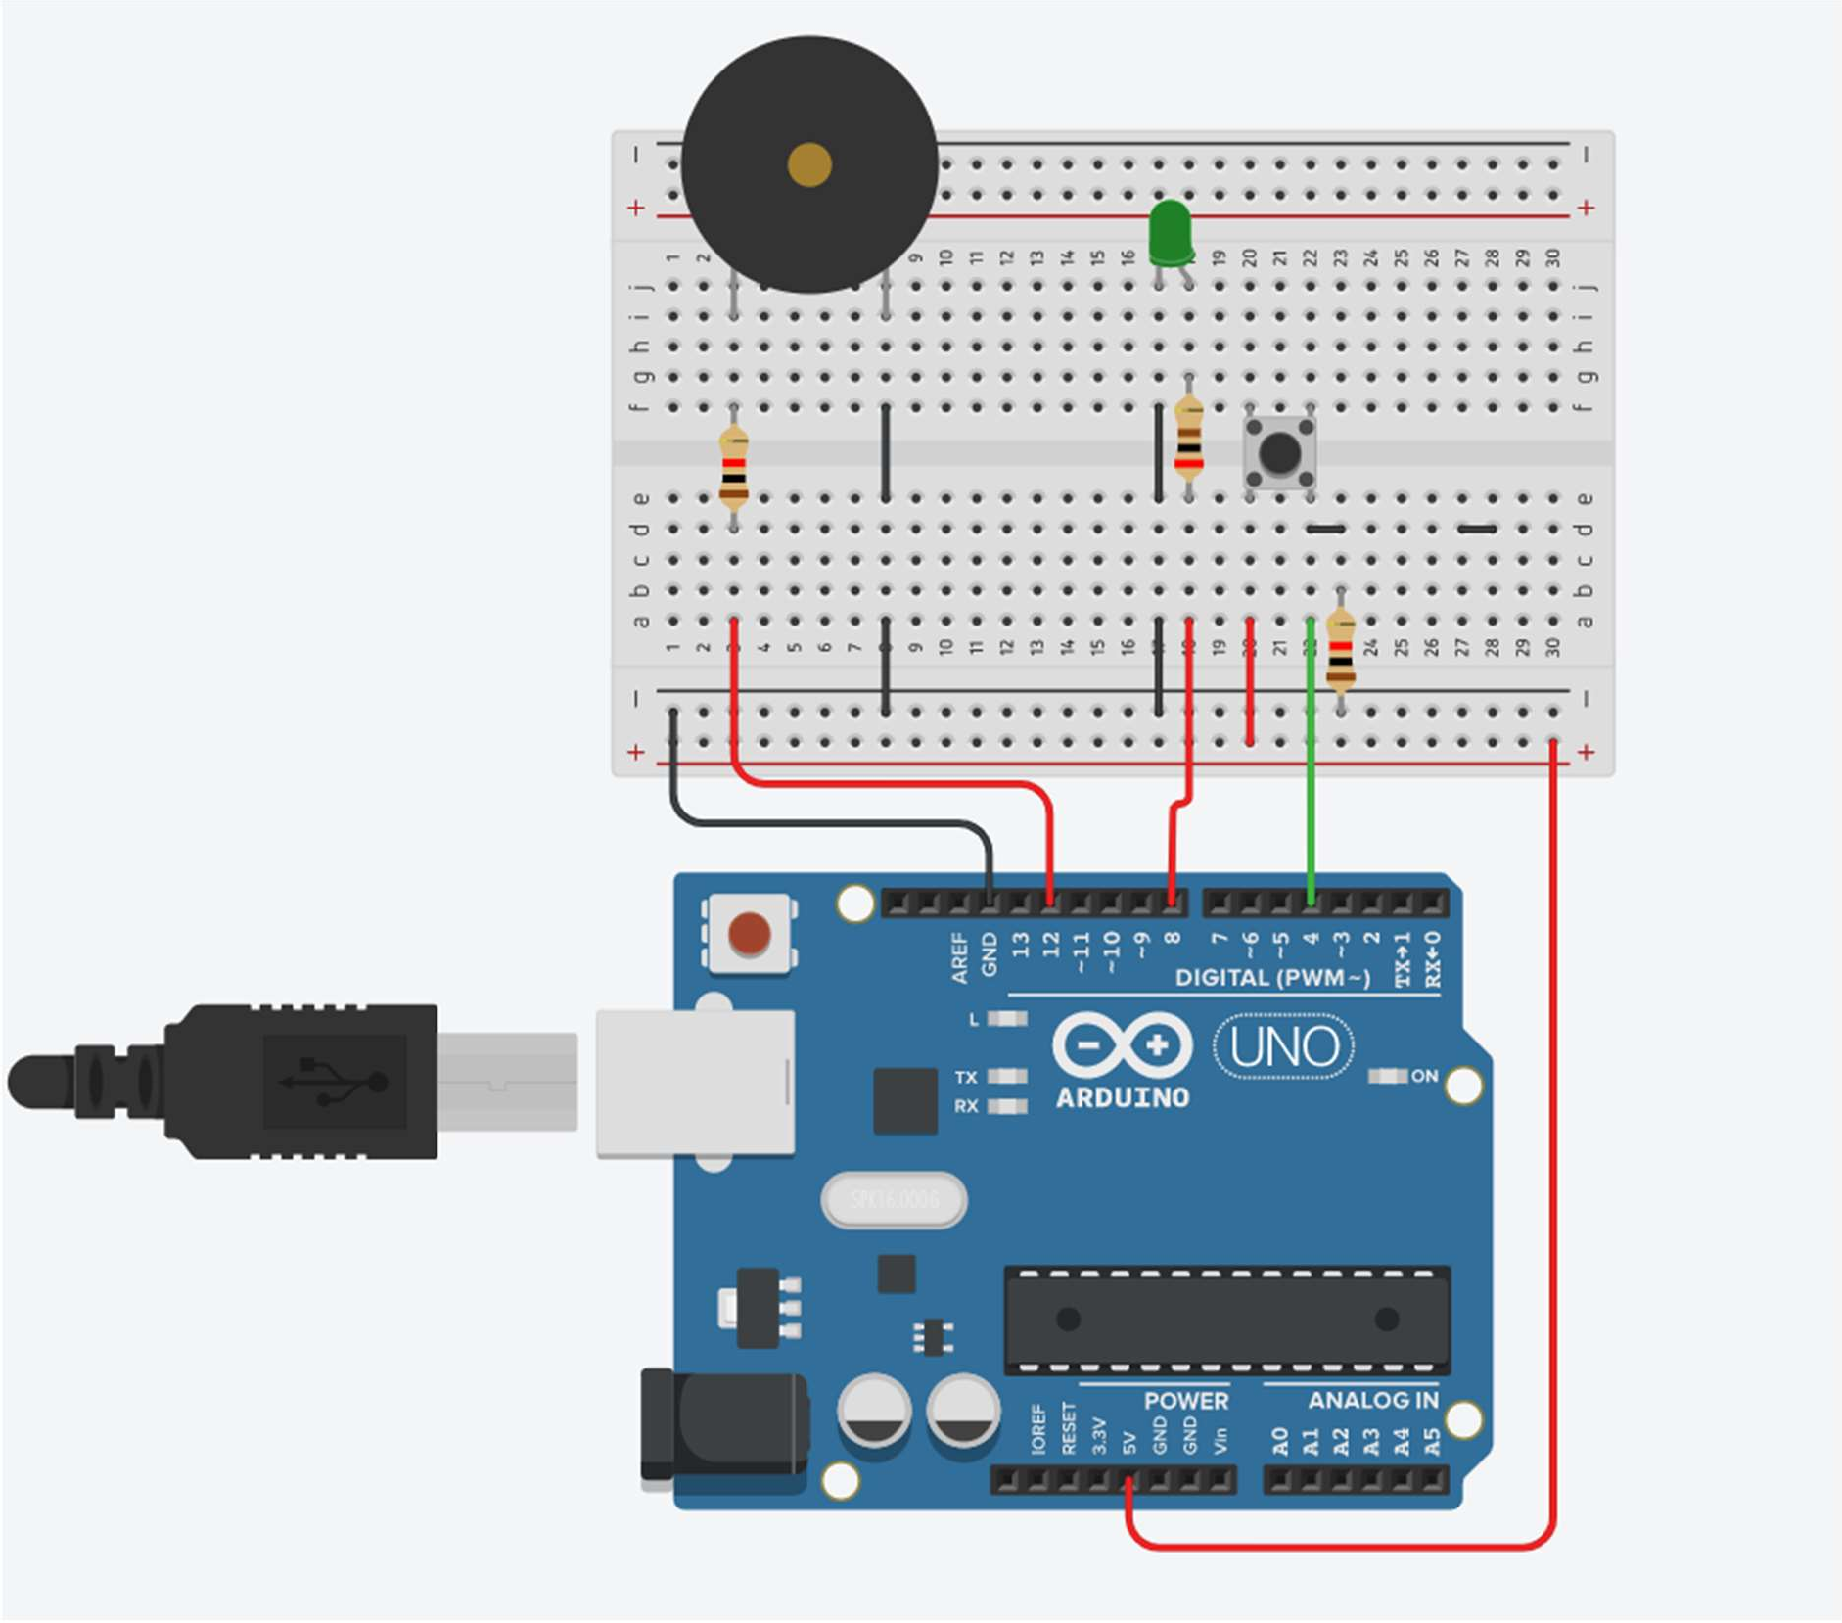

**Program:** int button1 = 4; void setup()

{

pinMode(8, OUTPUT); pinMode(12, OUTPUT); pinMode(button1, INPUT);

}

void loop()

{

int buttonStatus1 = digitalRead(button1);

if(buttonStatus1 == HIGH)

{

digitalWrite(8, HIGH); tone(12,1000);

}

else

{

digitalWrite(8, LOW); noTone(12);

}

}

**Output:**

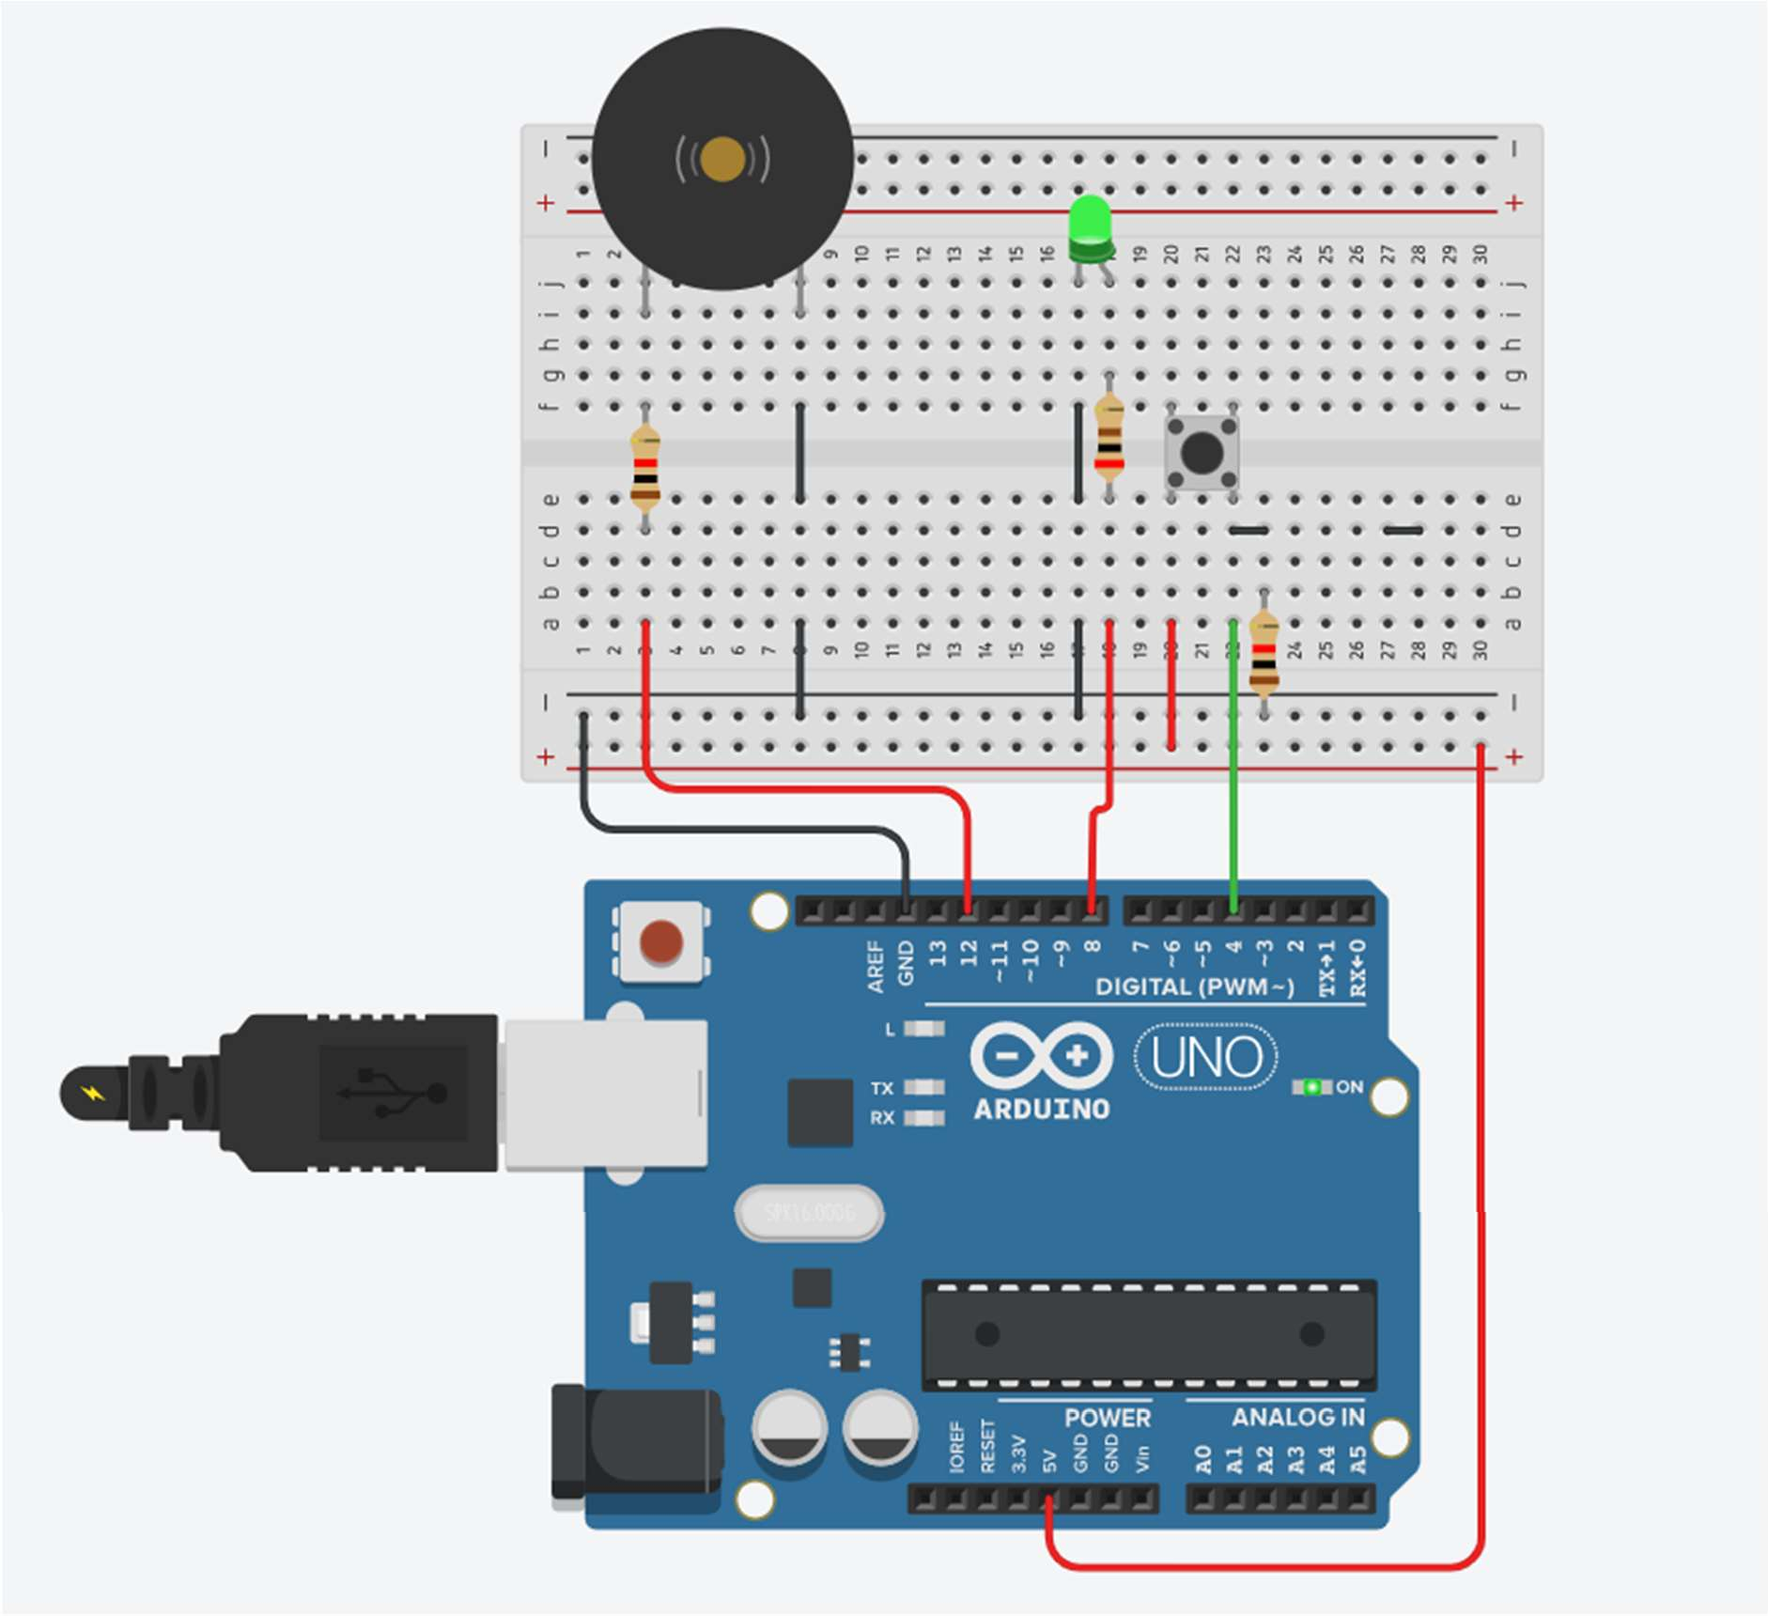

# Practical No. 10

**Aim:** To interface 2 Push buttons, a Speaker with Arduino and write a program to turn ON LED and generate 2 different notes on two button keyboards.

**Component:** Arduino Uno, 1 LED, 2 Pushbuttons, 1 Buzzer, 4 Resistors.

**Circuit Diagram:**

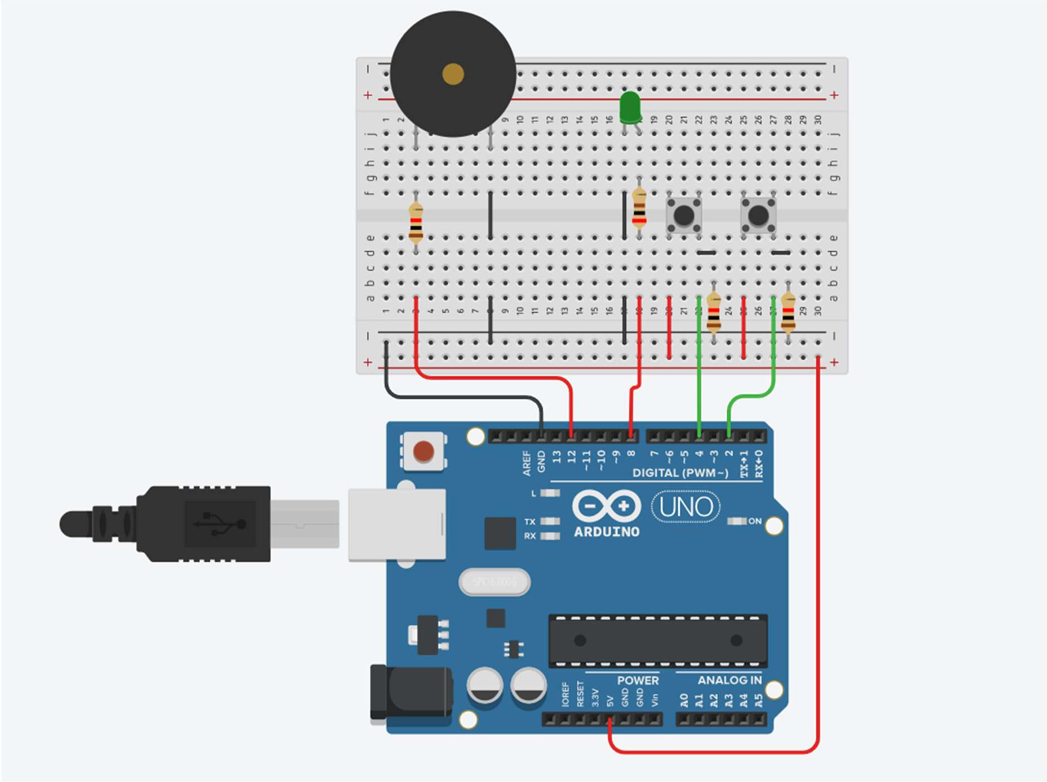

**Program:** int button1 = 4; int button2 = 2; void setup()

{

pinMode(8, OUTPUT); pinMode(12, OUTPUT); pinMode(button1, INPUT); pinMode(button2, INPUT);

}

void loop()

{

int buttonStatus1 = digitalRead(button1); int buttonStatus2 = digitalRead(button2); if(buttonStatus1 == HIGH)

{

digitalWrite(8, HIGH); tone(12,1000);

}

else if(buttonStatus2 == HIGH)

{

digitalWrite(8, HIGH); tone(12,2000);

}

else

{

digitalWrite(8, LOW); noTone(12);

}

}

**Output:**

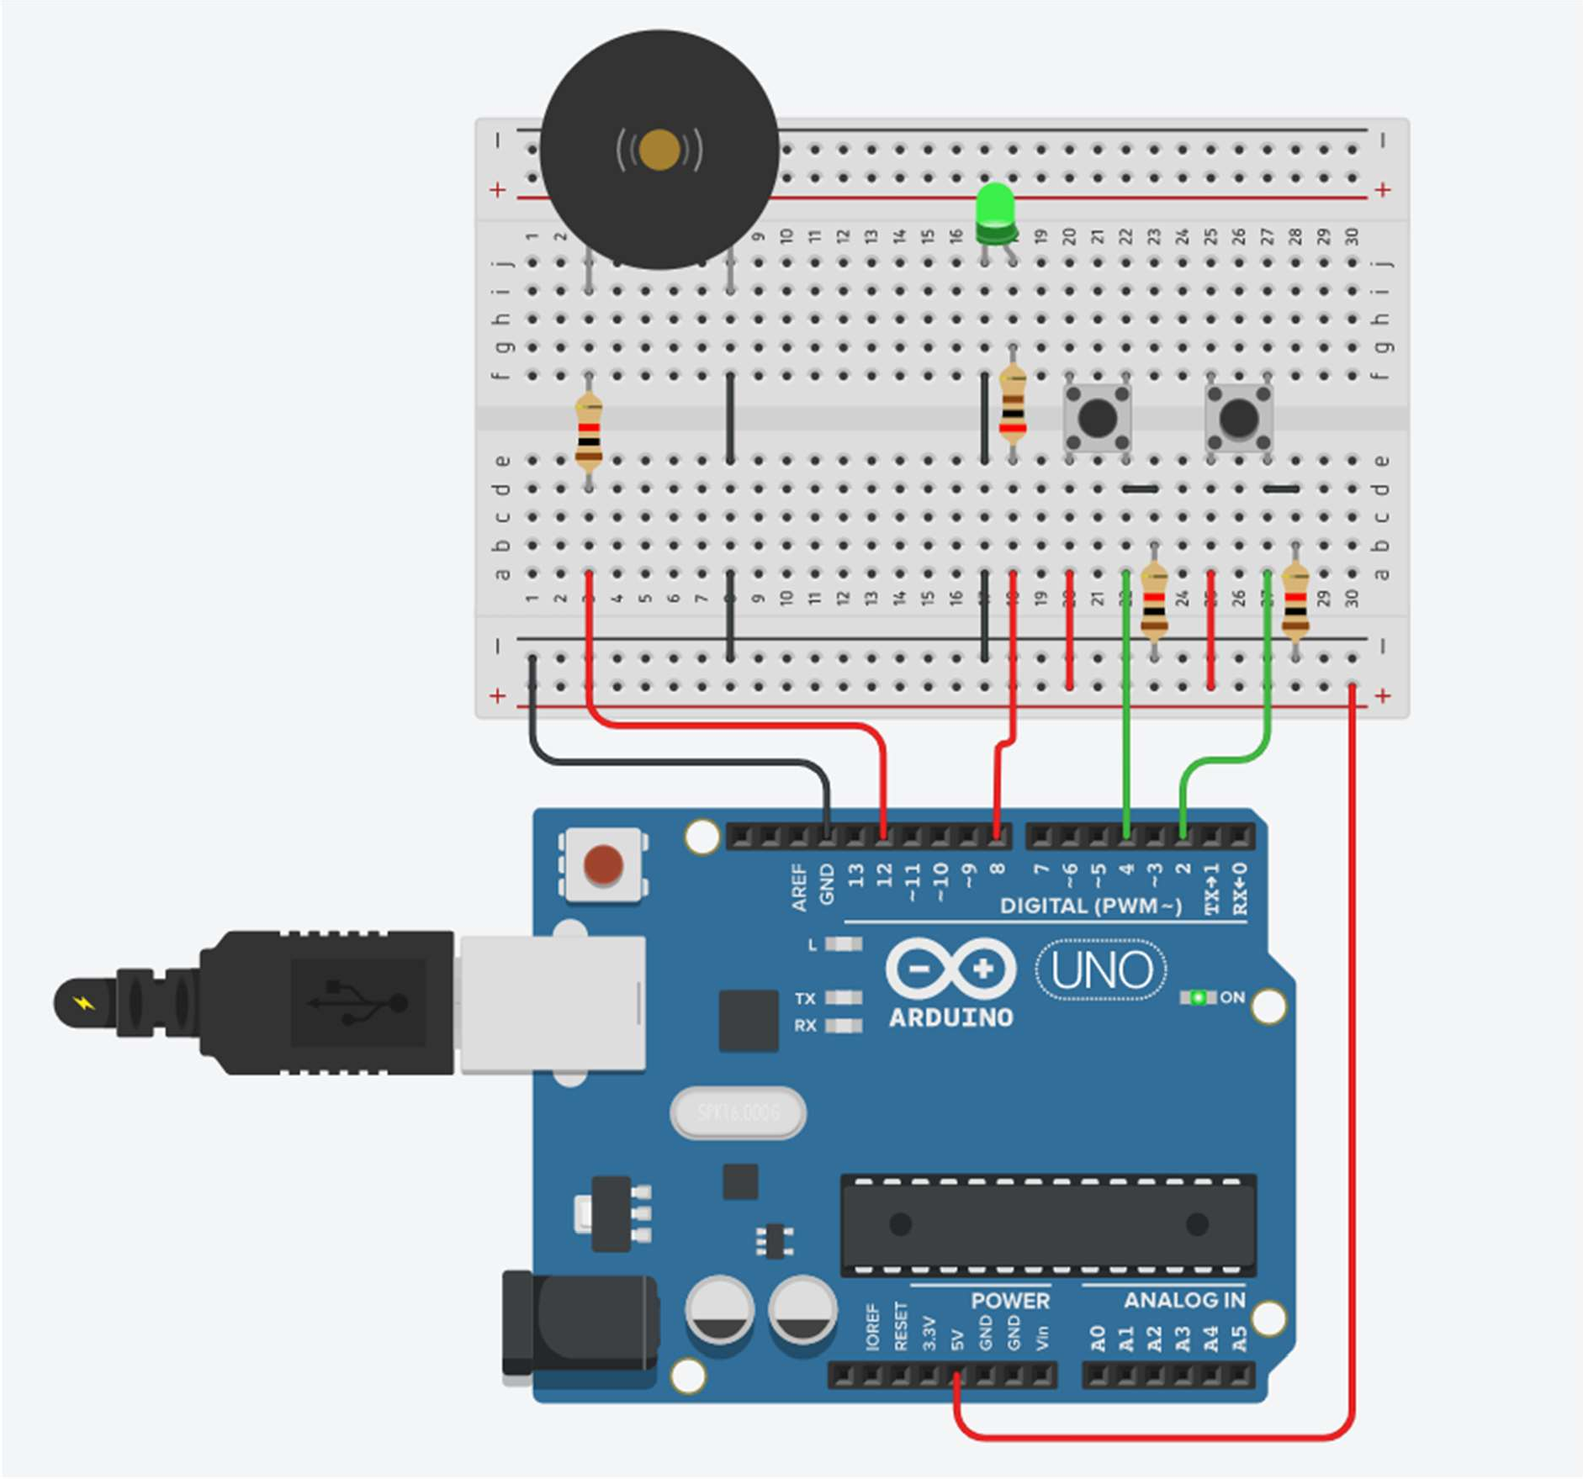

# Practical No. 11

**Aim:** To interface Seven Segment Display (SSD) with Arduino and write a program to blink SSD.

**Component:** Arduino Uno, Cathode 7 Segment Display, 7 Resistors of 115 Ω

**Theory:**

**The 7 Segment display: -** The 7-segment display, also written as “seven segment display”, consists of seven LEDs (hence its name) arranged in a rectangular fashion as shown. Each of the seven LEDs is called a segment because when illuminated the segment forms part of a numerical digit (both Decimal and Hex) to be displayed. An additional 8th LED is sometimes used within the same package thus allowing the indication of a decimal point, (DP) when two or more 7-segment displays are connected together to display numbers greater than ten.

Each one of the seven LEDs in the display is given a positional segment with one of its connection pins being brought straight out of the rectangular plastic package. These individually LED pins are labelled from a through to g representing each individual LED. The other LED pins are connected together and wired to form a common pin.

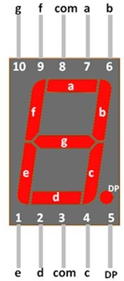

**Circuit Diagram:**

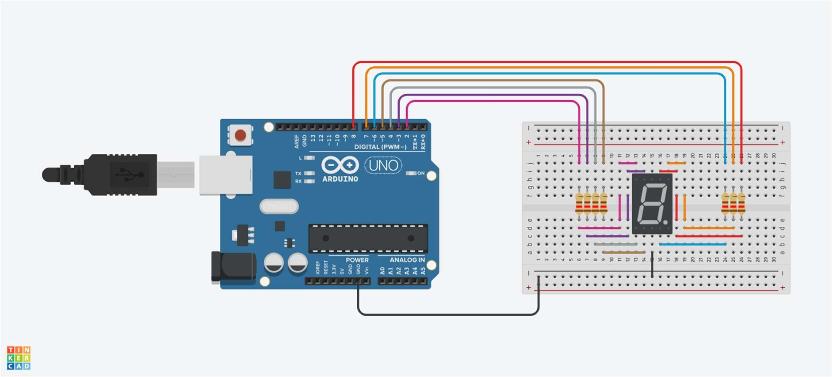

**Program:**

void setup()

{

pinMode(2, OUTPUT); pinMode(3, OUTPUT); pinMode(4, OUTPUT); pinMode(5, OUTPUT); pinMode(6, OUTPUT); pinMode(7, OUTPUT); pinMode(8, OUTPUT);

}

void loop()

{

digitalWrite(2, HIGH); digitalWrite(3, HIGH); digitalWrite(4, HIGH); digitalWrite(5, HIGH); digitalWrite(6, HIGH); digitalWrite(7, HIGH); digitalWrite(8, HIGH);

delay(500); // Wait for 500 millisecond(s) digitalWrite(2, LOW);

digitalWrite(3, LOW); digitalWrite(4, LOW); digitalWrite(5, LOW); digitalWrite(6, LOW); digitalWrite(7, LOW); digitalWrite(8, LOW);

delay(300); // Wait for 300 millisecond(s)}

**Output:**

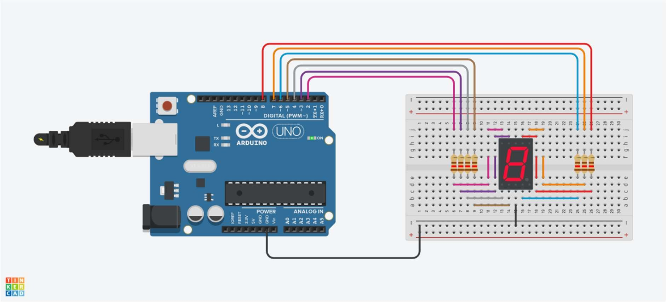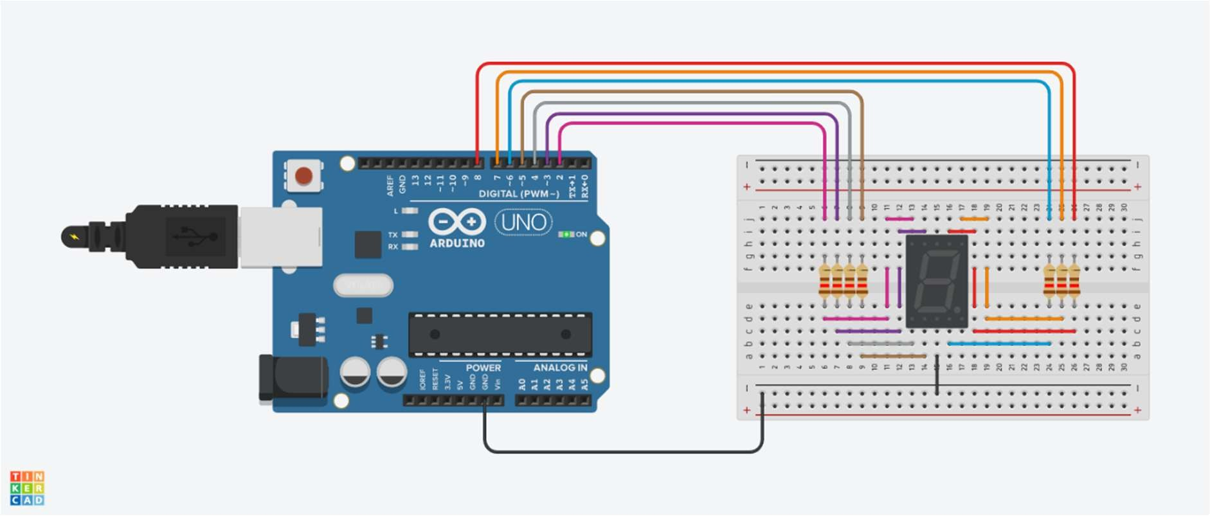

# Practical No. 12

**Aim:** To interface Seven Segment Display (SSD) with Arduino and write a program to print numbers from 1 to 4 on SSD.

**Component:** Arduino Uno, Cathode 7 Segment Display, 7 Resistors of 115 Ω

**Circuit Diagram:**

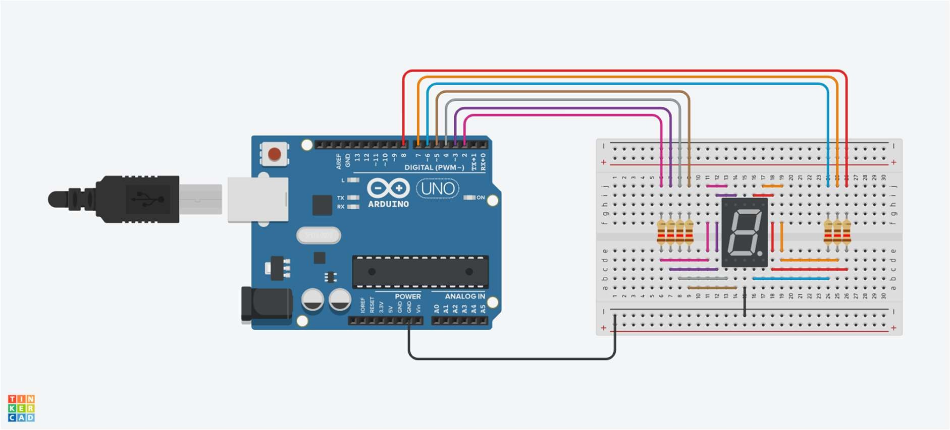

**Program:**

void setup()

{

pinMode(2,OUTPUT); pinMode(3,OUTPUT); pinMode(4,OUTPUT); pinMode(5,OUTPUT); pinMode(6,OUTPUT); pinMode(7, OUTPUT); pinMode(8, OUTPUT);

}

void loop()

{

digitalWrite(2, LOW); digitalWrite(3, HIGH);

digitalWrite(4,HIGH); digitalWrite(5,HIGH); digitalWrite(6,HIGH); digitalWrite(7,HIGH); digitalWrite(8, HIGH);

delay(2000); // Wait for 2000 millisecond(s) digitalWrite(2, LOW);

digitalWrite(3,LOW); digitalWrite(4,LOW);

digitalWrite(5,LOW); digitalWrite(6,HIGH); digitalWrite(7,HIGH);digitalWrite(8, LOW);

delay(2000); // Wait for 2000 millisecond(s) digitalWrite(2, HIGH);

digitalWrite(3,LOW); digitalWrite(4,HIGH); digitalWrite(5,HIGH); digitalWrite(6,LOW); digitalWrite(7, HIGH); digitalWrite(8, HIGH);

delay(2000); // Wait for 2000 millisecond(s) digitalWrite(2, HIGH);

digitalWrite(3,LOW); digitalWrite(4,LOW); digitalWrite(5, HIGH); digitalWrite(6,HIGH); digitalWrite(7, HIGH); digitalWrite(8,HIGH);

delay(2000); // Wait for 2000 millisecond(s)

digitalWrite(2, HIGH); digitalWrite(3, HIGH); digitalWrite(4, LOW); digitalWrite(5, LOW); digitalWrite(6, HIGH); digitalWrite(7, HIGH); digitalWrite(8, LOW);

delay(2000); // Wait for 2000 millisecond(s)

}

**Output:**

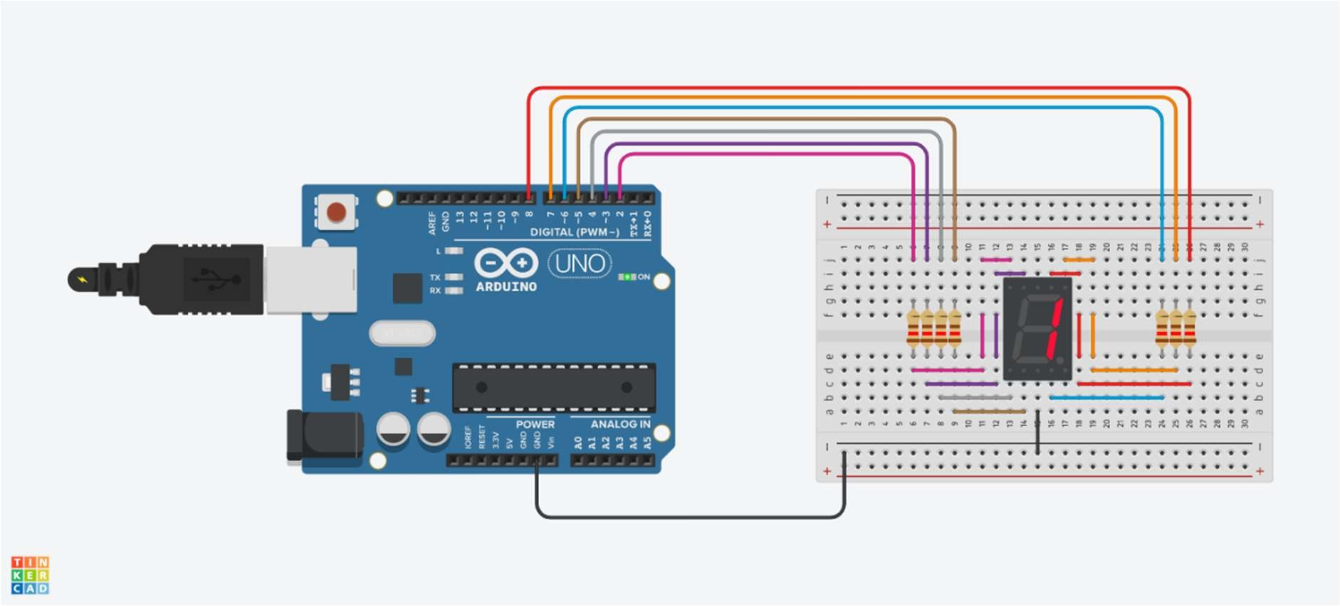

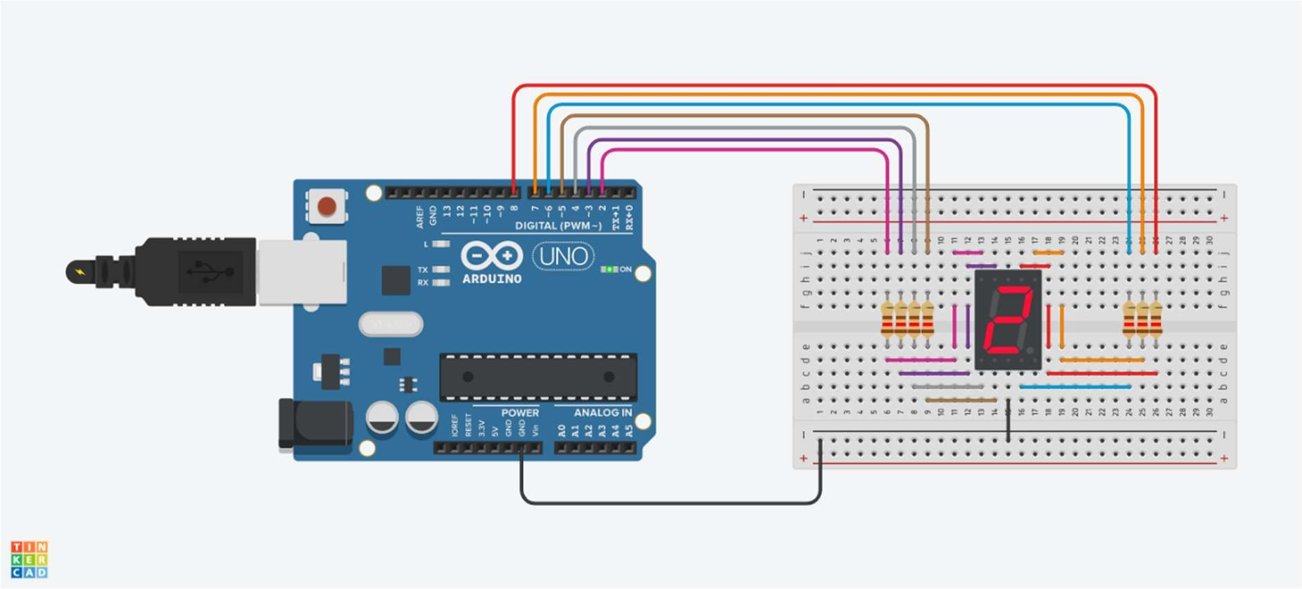

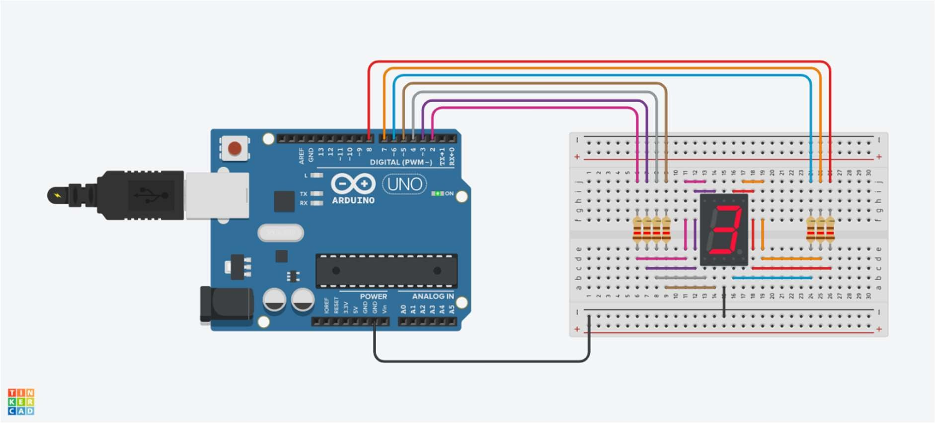

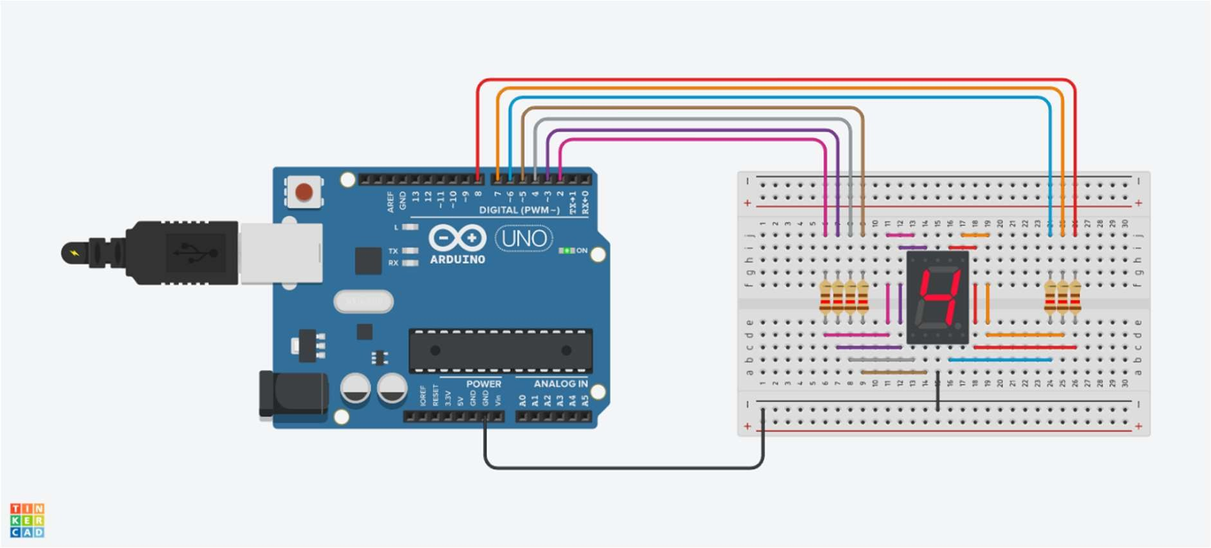

# Practical No. 13

**Aim:** To interface a seven segment display (SSD) with Arduino and WAP to display countdown from nine with one-second delay, on the seven segment display.

**Components Required**: - Arduino Board, 1SSD

### **Program**:

// C++ code

//

int num_Array[10][7]={{0,0,0,0,0,1,0},//0

{1,0,0,1,1,1,1},//1

{0,0,1,0,0,0,1},//2

{0,0,0,0,1,0,1},//3

{1,0,0,1,1,0,0},//4

{0,1,0,0,1,0,0},//5

{0,1,0,0,0,0,0},//6

{0,0,0,1,1,1,1},//7

{0,0,0,0,0,0,0},//8

{0,0,0,0,1,0,0}

};

void num_display(int);

void setup()

{

pinMode(2, OUTPUT); pinMode(3, OUTPUT); pinMode(4, OUTPUT); pinMode(5, OUTPUT); pinMode(6, OUTPUT); pinMode(7, OUTPUT); pinMode(8, OUTPUT);

}

void loop()

{

for(int count=10;count>0;--count)

{

delay(1000); num_display(count-1);

}

}

void num_display(int number)

{

int pin=2;

for(int j=0;j<7;j++)

{

digitalWrite(pin,num_Array[number][j]); pin++;

}

}

### **Output:**

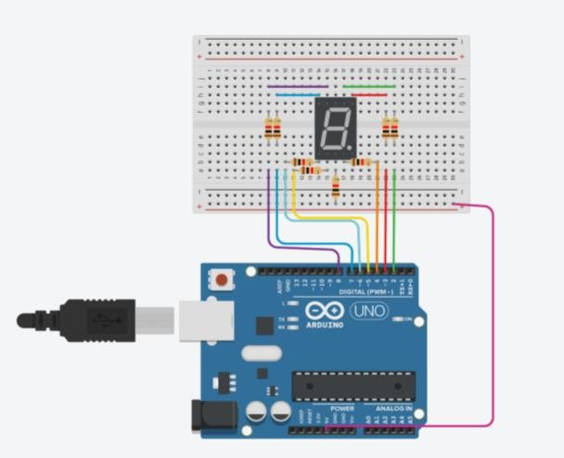

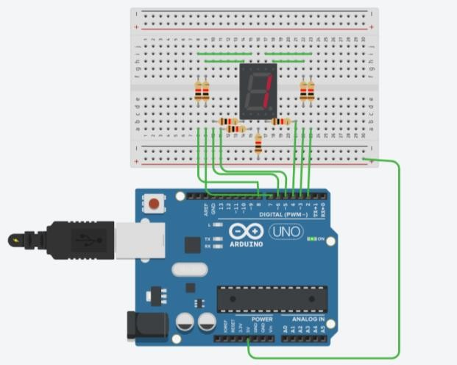

# Practical No. 14

**Aim:** To interface LED’s, potentiometer with Arduino and write a program to turn on or off LEDs by turning the potentiometer

**Components:** Arduino Uno, 250 kΩ Potentiometer, 100 Ω Resistor, Red LED.

**Theory:**

A potentiometer is a three-terminal resistor with a sliding or rotating contact that forms an adjustable voltage divider.[1] If only two terminals are used, one end and the wiper, it acts as a variable resistor or rheostat.

The measuring instrument called a potentiometer is essentially a voltage divider used for measuring electric potential (voltage); the component is an implementation of the same principle, hence its name.

Potentiometers are commonly used to control electrical devices such as volume controls on audio equipment. Potentiometers operated by a mechanism can be used as position transducers, for example, in a joystick. Potentiometers are rarely used to directly control significant power (more than a watt), since the power dissipated in the potentiometer would be comparable to the power in the controlled load.

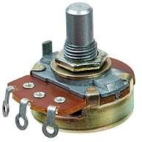

**Circuit Diagram:**

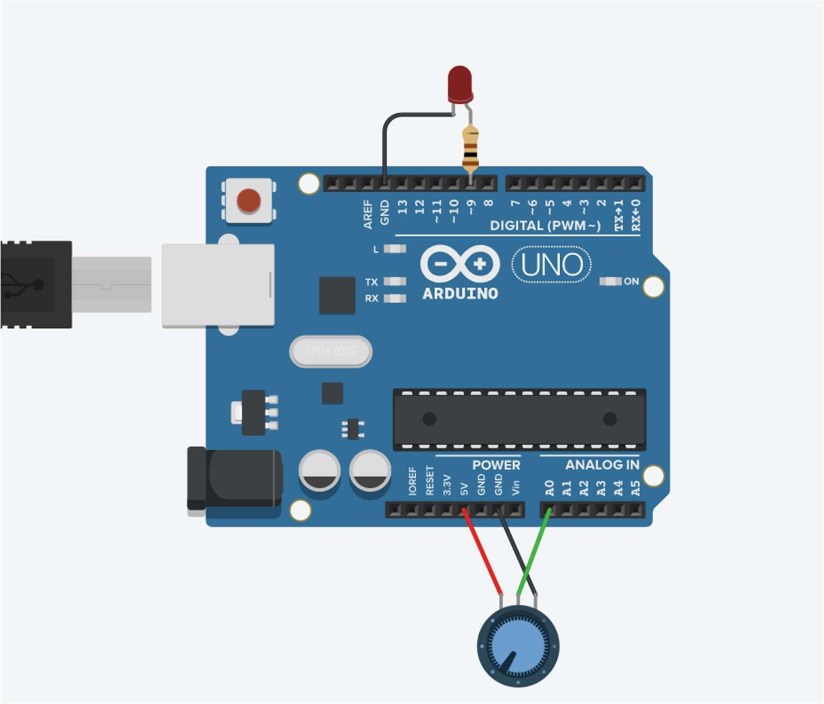

**Program:**

int sensorValue = 0;

void setup() { pinMode(A0, INPUT); pinMode(9, OUTPUT); Serial.begin(9600);

}

void loop()

{

sensorValue = analogRead(A0); if (sensorValue >= 500) digitalWrite(9,HIGH);

else

digitalWrite(9,LOW);

delay(2); // Wait for 2 millisecond(s)

}

**Output:**

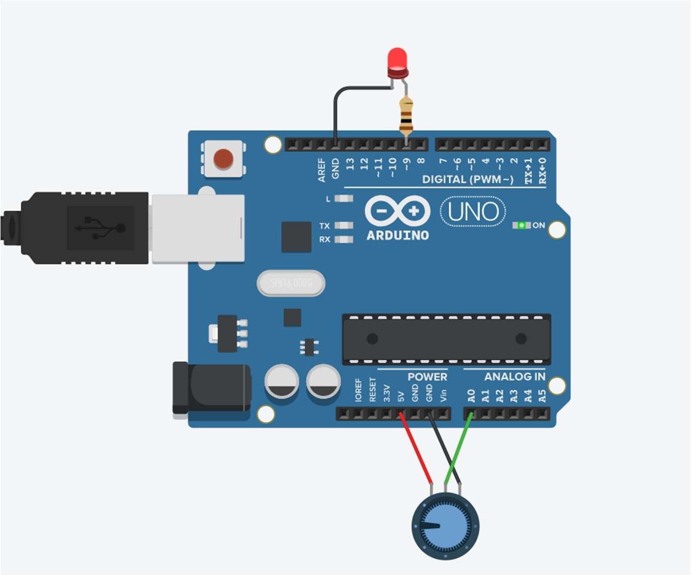

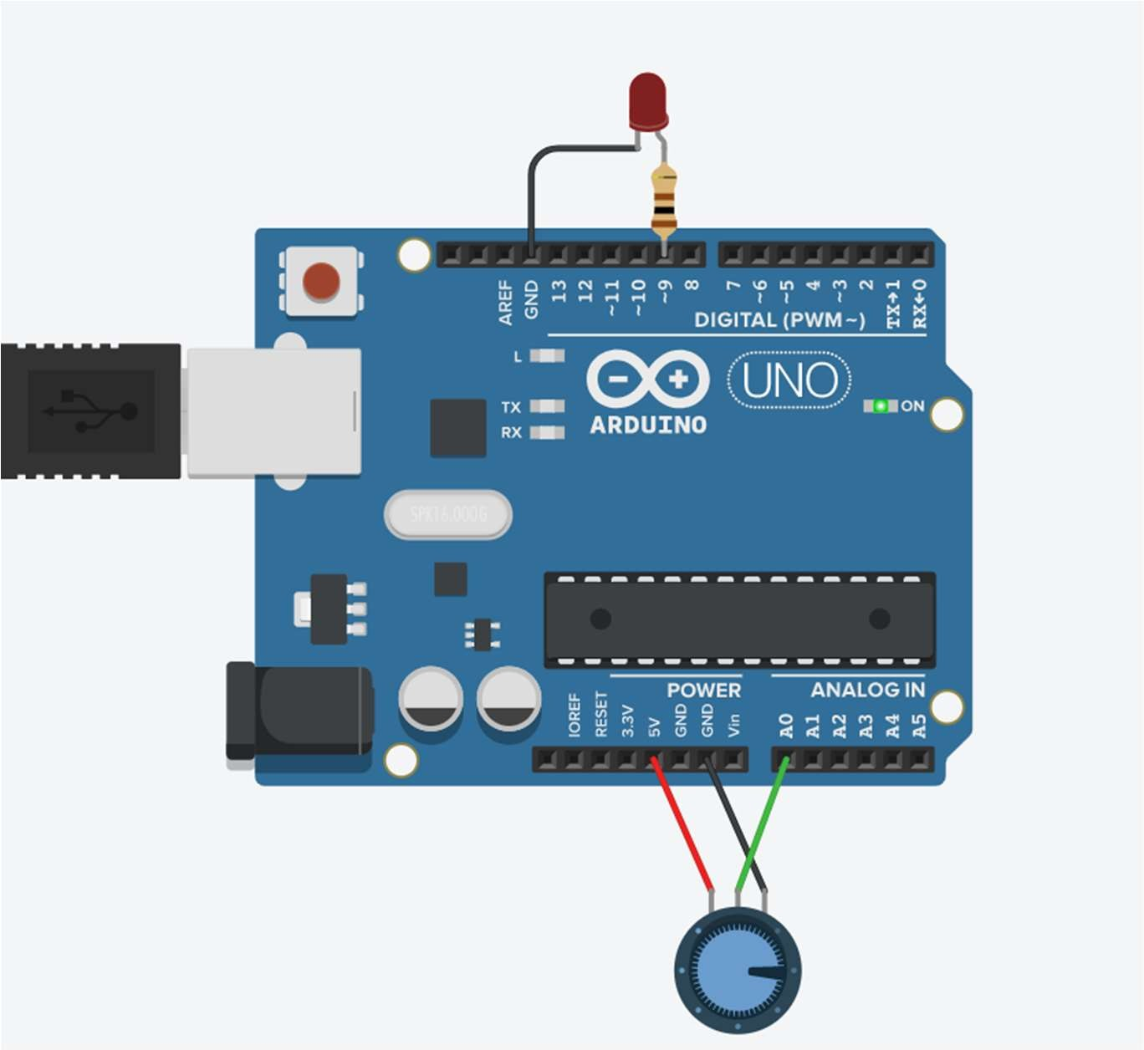

# Practical No. 15

**Aim:** To interface LCD, potentiometer with Arduino and write a program to display message on LCD.

**Components:** Arduino Uno, LCD 16 x 2, 100 Ω Potentiometer, 1 kΩ Resistor

**Theory:**

## LCD:

The term LCD stands for liquid crystal display. It is one kind of electronic display module used in an extensive range of applications like various circuits & devices like mobile phones, calculators, computers, TV sets, etc. These displays are mainly preferred for multi-segment light-emitting diodes and seven segments. The main benefits of using this module are inexpensive; simply programmable, animations, and there are no limitations for displaying custom characters, special and even animations, etc.

LCD 16×2 Pin Diagram

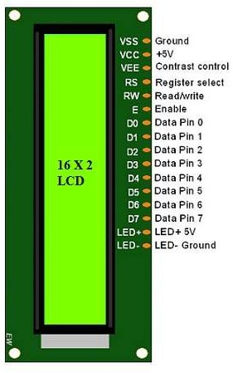

The 16×2 LCD pinout is shown below.

**Pin1** (Ground/Source Pin): This is a GND pin of display, used to connect the GND terminal of the microcontroller unit or power source.

**Pin2** (VCC/Source Pin): This is the voltage supply pin of the display, used to connect the supply pin of the power source.

**Pin3** (V0/VEE/Control Pin): This pin regulates the difference of the display, used to connect a changeable POT that can supply 0 to 5V.

**Pin4** (Register Select/Control Pin): This pin toggles among command or data register, used to connect a microcontroller unit pin and obtains either 0 or 1(0 = data mode, and 1 = command mode).

**Pin5** (Read/Write/Control Pin): This pin toggles the display among the read or writes operation, and it is connected to a microcontroller unit pin to get either 0 or 1 (0 = Write Operation, and 1 = Read Operation).

**Pin 6** (Enable/Control Pin): This pin should be held high to execute Read/Write process, and it is connected to the microcontroller unit & constantly held high.

**Pins 7-14** (Data Pins): These pins are used to send data to the display. These pins are connected in two-wire modes like 4-wire mode and 8-wire mode. In 4-wire mode, only four pins are connected to the microcontroller unit like 0 to 3, whereas in 8-wire mode, 8-pins are connected to microcontroller unit like 0 to 7.

**Pin15** (+ve pin of the LED): This pin is connected to +5V

**Pin 16** (-ve pin of the LED): This pin is connected to GND.

**Circuit Diagram:**

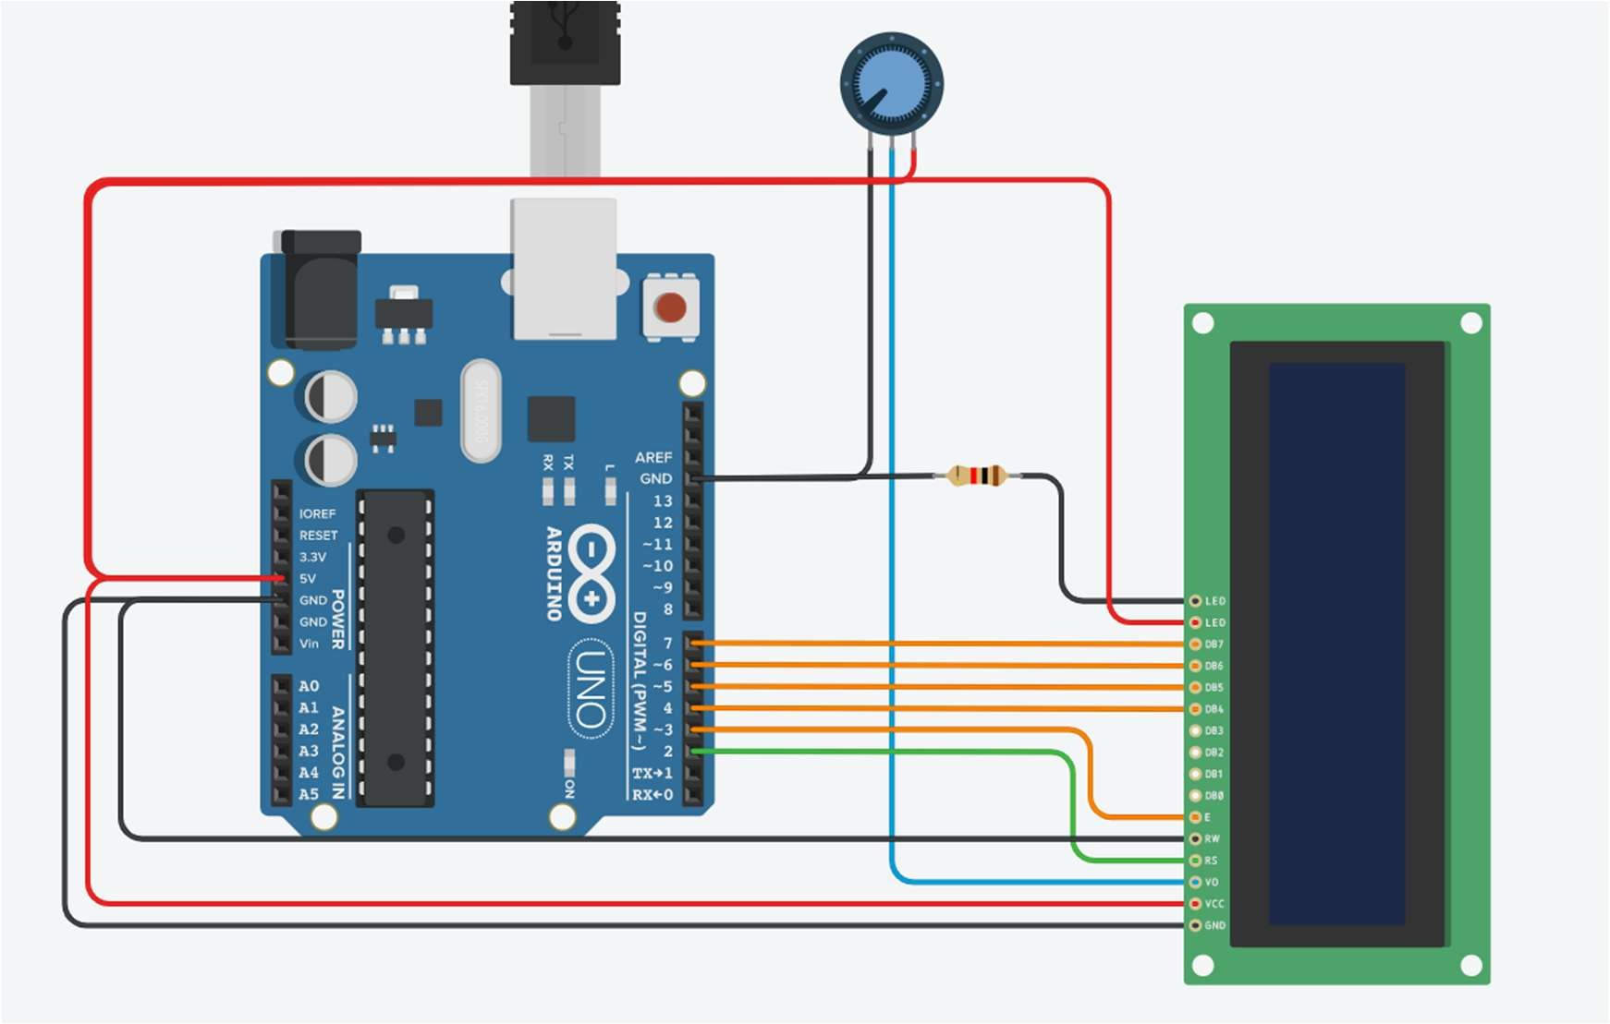

**Program:**

#include <LiquidCrystal.h>

LiquidCrystal lcd(2,3,4,5,6,7); void setup()

{

lcd.begin(16,2);

lcd.clear();//start with a blank screen lcd.setCursor(0,0);//set the cursor to col 0 and row 0 lcd.print("Welcome");

}

void loop()

{

}

**Output:**

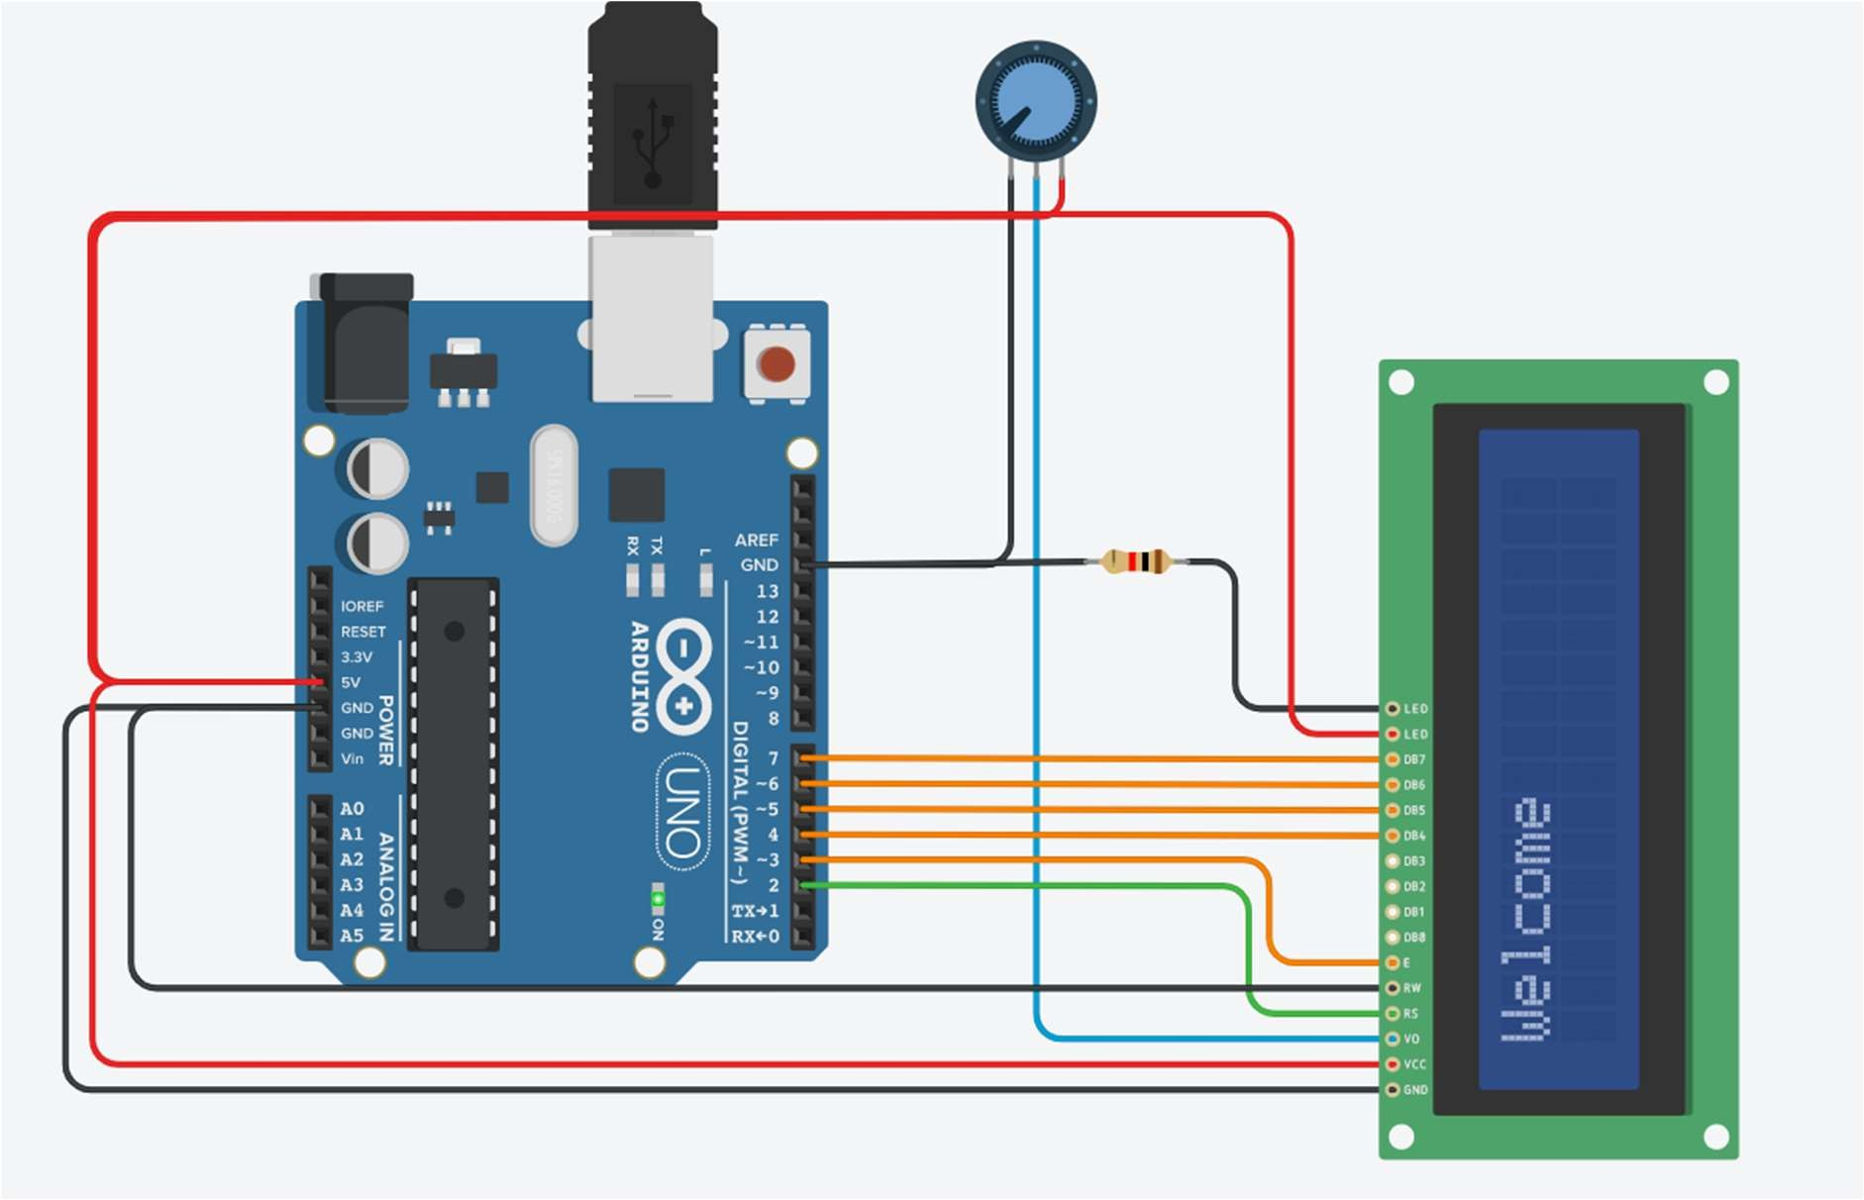

# Practical No. 16

**Aim:** To interface LCD, push button, potentiometer with Arduino and write a program to display the no. of times (count) the push button is pressed on LCD and display message on LCD when push button is pressed.

**Components:** Arduino Uno, LCD 16 x 2, 100 Ω Potentiometer, 2pcs. 1 kΩ Resistor, Pushbutton

**Circuit Diagram:**

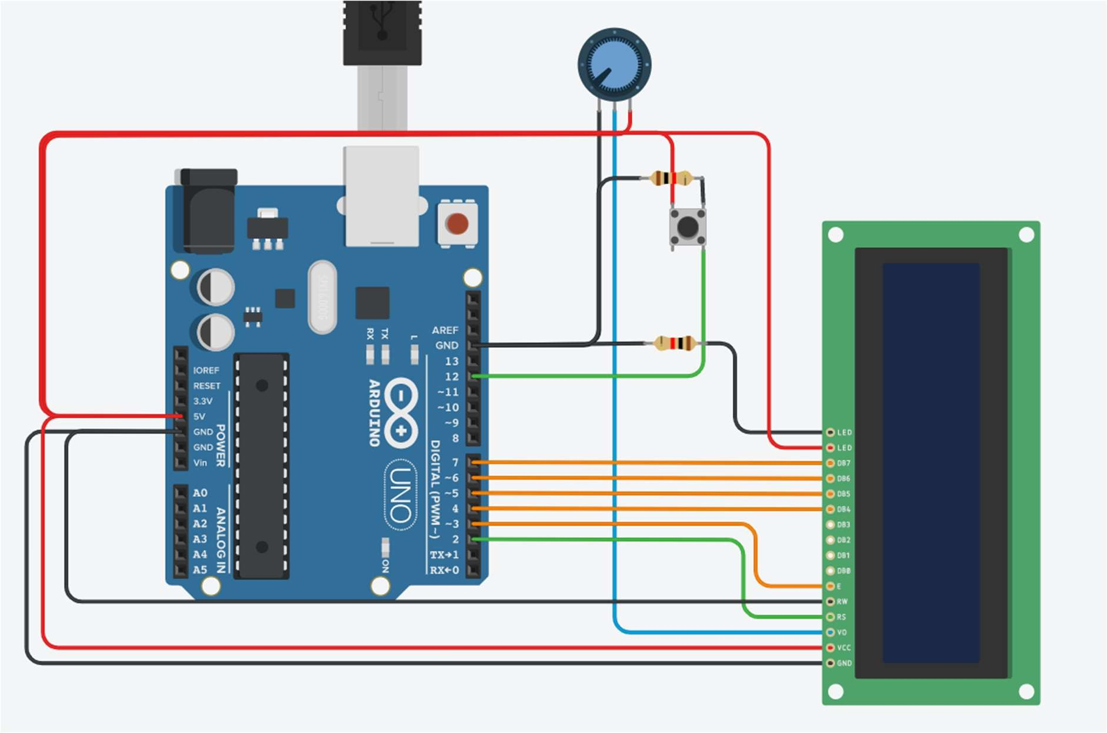

**Program:**

#include <LiquidCrystal.h> int button1 = 12;

int count = 0;

LiquidCrystal lcd(2,3,4,5,6,7); void setup()

{

lcd.begin(16,2);

}

void loop()

{

int buttonStatus1 = digitalRead(button1); if(buttonStatus1 == HIGH) {

count = count+1; lcd.setCursor(0,1); lcd.print("Welcome");

}

else { lcd.clear(); }

lcd.setCursor(0,0); lcd.print("Count = "); lcd.print(count); delay(125);

}

**Output:**

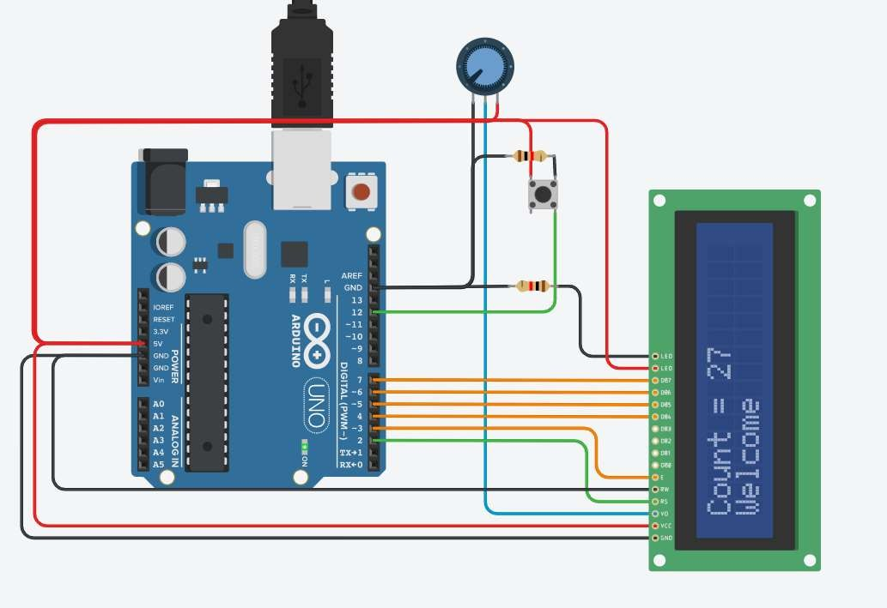

# Practical No. 17

**Aim:** To interface sensor with Arduino board write a program to print the temperature in °C and °F on the serial monitor.

**Component:** Arduino Uno, Temperature Sensor [TMP36]

**Theory:**

TMP36 is a temperature sensor chip which generates an analog voltage at the output which is linearly proportional to the Celsius temperature. Then convert this voltage into temperature based on a 10 mV/°C scale factor. It has a shutdown capability which limits the output current to less than 0.5 µA. It provides a supply current of up to 50 µA.

This sensor provides a highly precise temperature in centigrade. Most importantly, it produces output in dc voltage that we can measure easily with the help of any bare metal microcontrollers such as Arduino Uno, STM32F4, PIC16F877A. On top of that, Celsius’s temperature and an output voltage change linearly which makes it easy to compensate temperature/Voltage variations. Having a linear relationship is helpful. Because we will not require any external calibration circuit. Furthermore, it offers a very low output impedance. In short, it is very easy to interface this sensor with ADCs or microcontrollers having built-in ADCs.

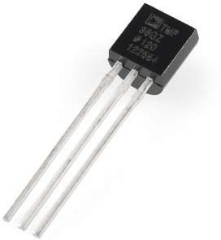

**Circuit Diagram:**

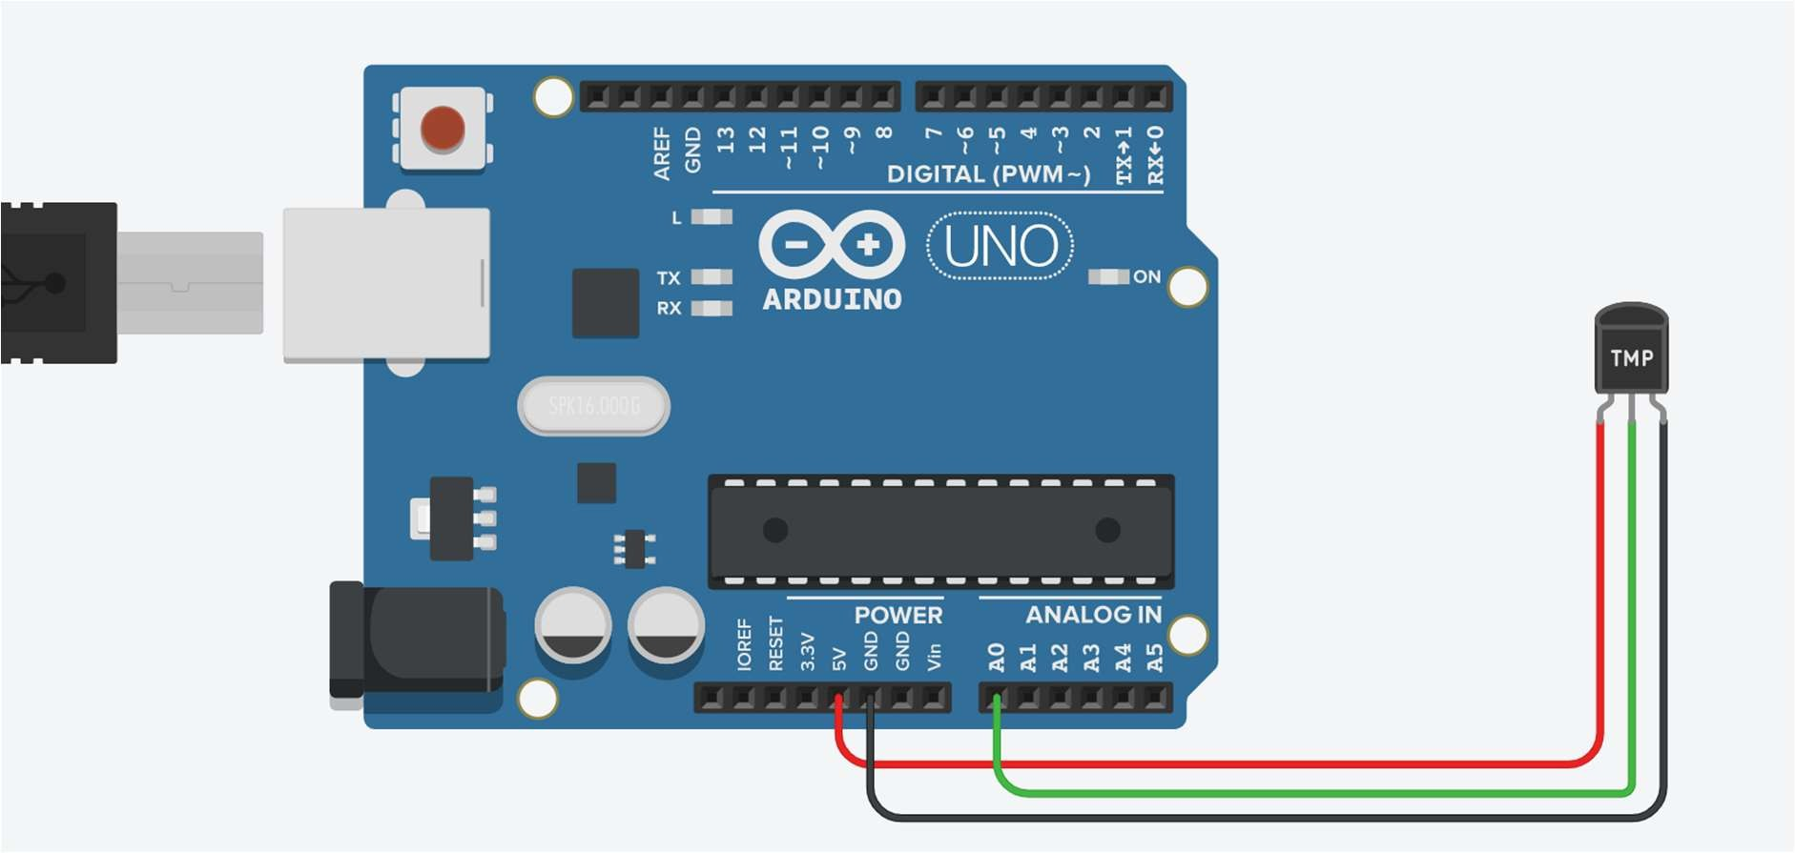

**Program:**

void setup()

{

Serial.begin(9600);

}

void loop()

{

int sensorValue = analogRead(A0); float volt = (5.0 / 1024) * sensorValue; delay(2000);

float tempC = (volt - 0.5) * 100; Serial.print("Temperate in Celsius"); Serial.print(tempC);

float tempF = (tempC * 9/5) + 32; Serial.print("\nTemperate in Fahrenheit "); Serial.println(tempF);

}

**Output:**

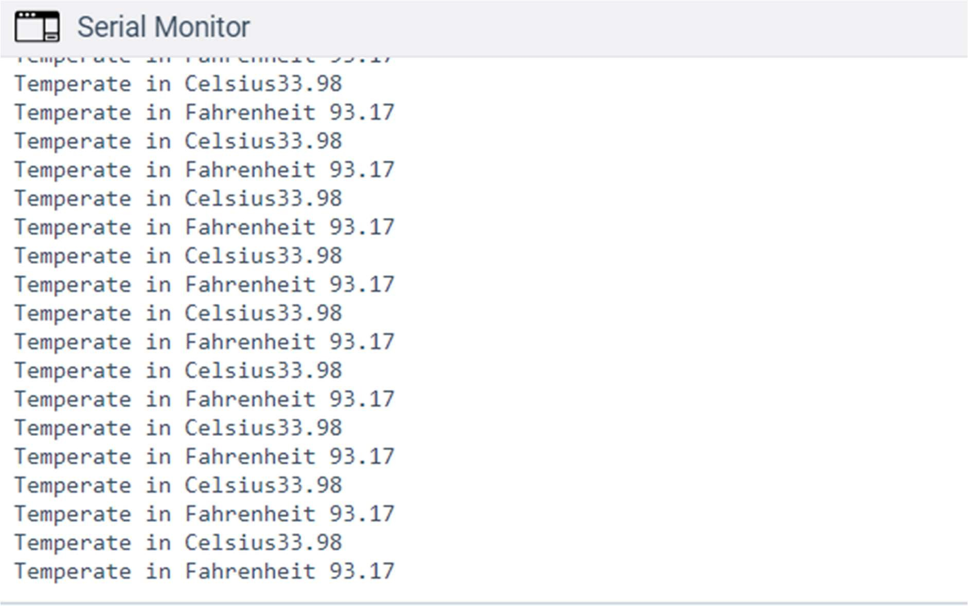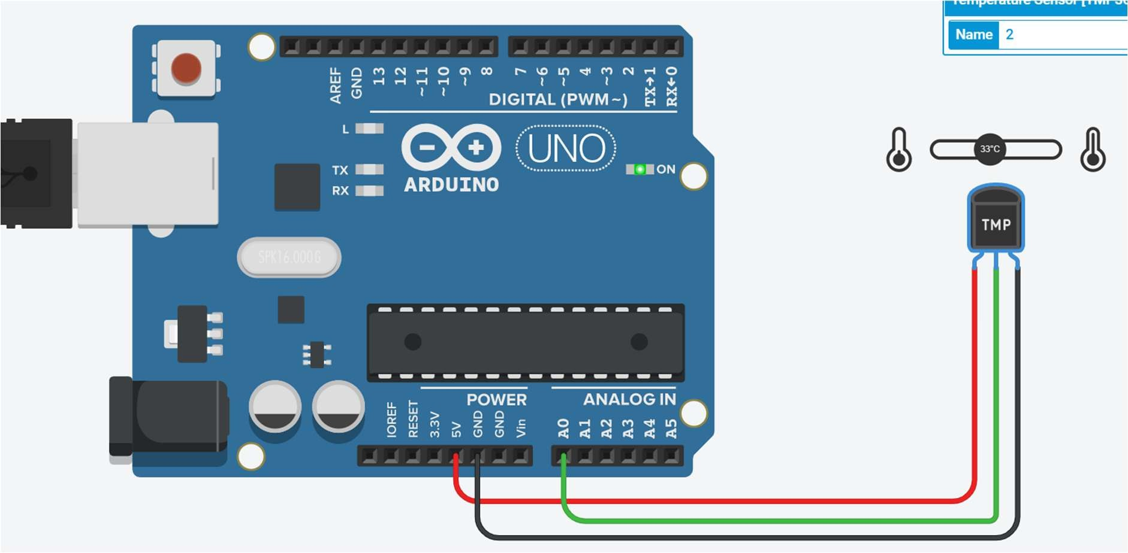

# Practical No. 18

**Aim:** To interface sensor with Arduino and write a program to display temperature in °C and °F on the LCD board and potentiometer.

**Component:** LCD 16 x 2, 0.2 kΩ Resistor, Temperature Sensor [TMP36], 100 Ω Potentiometer

**Theory:**

**Circuit Diagram:**

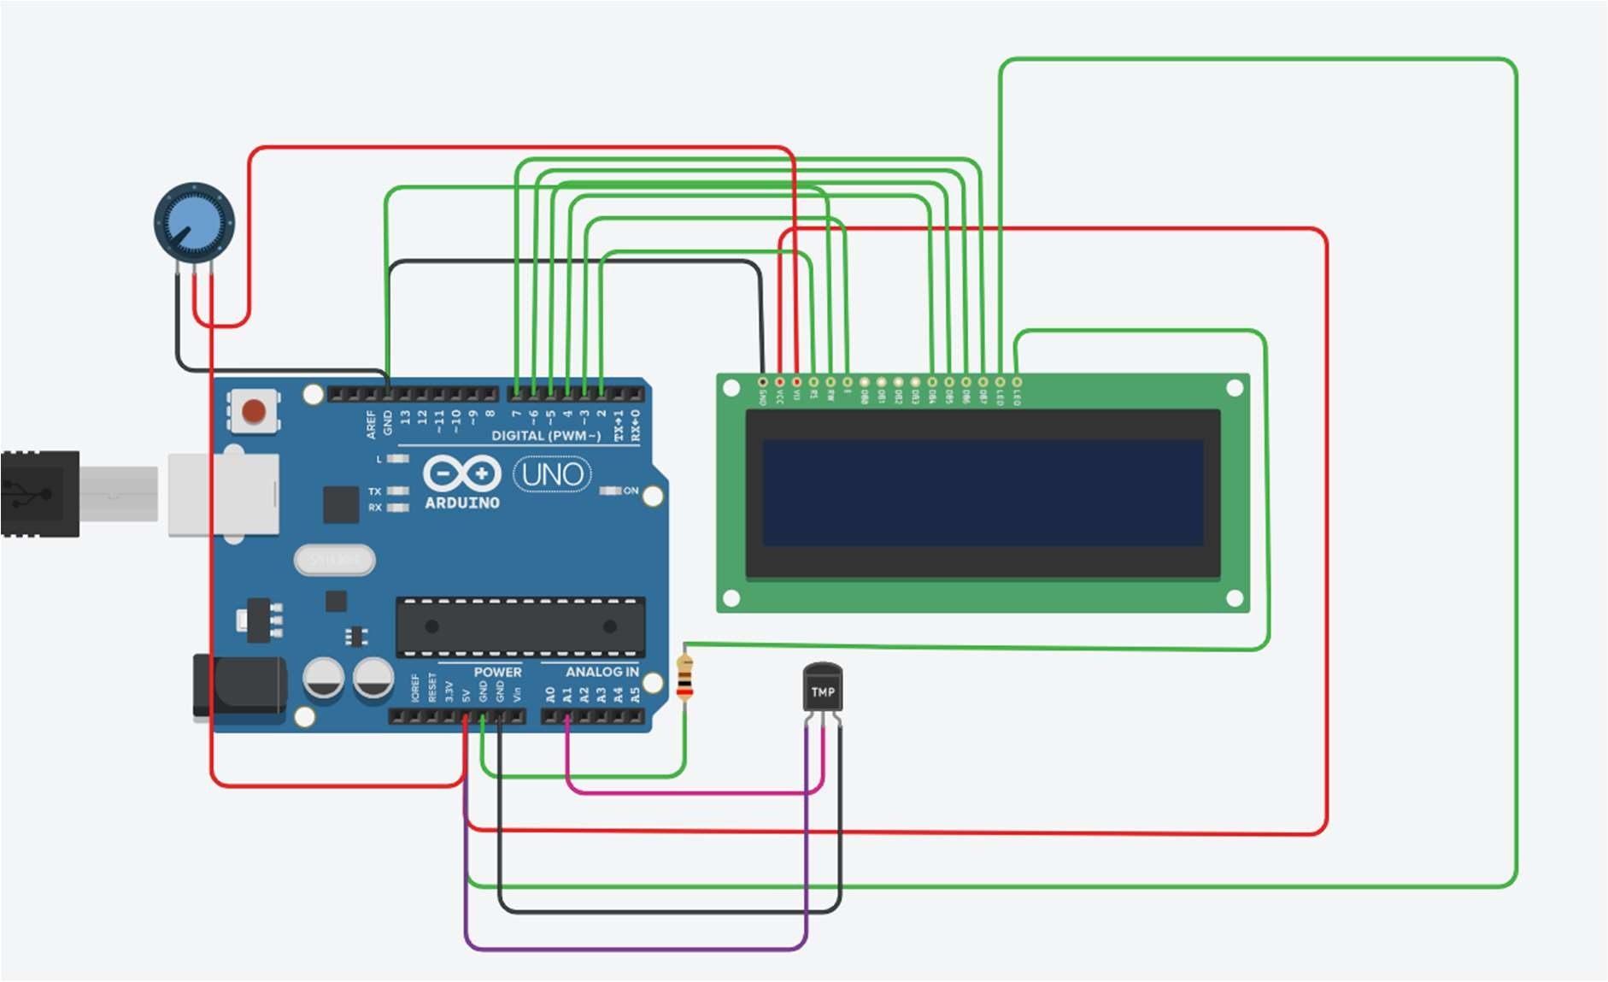

**Program:**

#include <LiquidCrystal.h> LiquidCrystal lcd(2,3,4,5,6,7); void setup()

{

pinMode(A1,INPUT); lcd.begin(16,2);

lcd.print("Temp F :");

}

void loop()

{

lcd.setCursor(10,0);

int sensorValue = analogRead(A1); float volts = (5.0/1024) * sensorValue; float tempC = (volts - 0.5) * 100;

float tempF = (tempC * 9/5 ) + 32; lcd.print(tempF); lcd.setCursor(0,1); lcd.print("Temp C :"); lcd.setCursor(10,1); lcd.print(tempC);

}

**Output:**

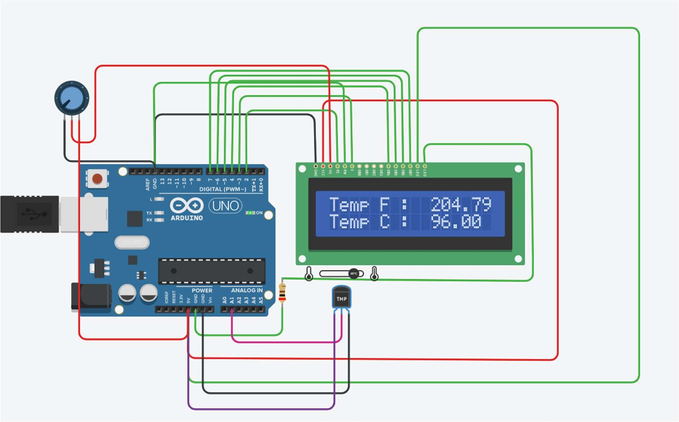

# Practical No. 19

**Aim:** To interface LED, Photo resistor (LDR) with Arduino and write a program to increase and decrease the brightness of the LED based on the amount of light present.

**Components:** Photoresistor, Arduino Uno, Red LED, 1 kΩ Resistor, 100 Ω Resistor.

**Theory:**

A photoresistor (also known as a light-dependent resistor, LDR, or photo-conductive cell) is a passive component that decreases resistance with respect to receiving luminosity (light) on the component's sensitive surface. The resistance of a photoresistor decreases with increase in incident light intensity; in other words, it exhibits photoconductivity. A photoresistor can be applied in light-sensitive detector circuits and light-activated and dark-activated switching circuits acting as a resistance semiconductor. In the dark, a photoresistor can have a resistance as high as several megaohms (MΩ), while in the light, a photoresistor can have a resistance as low as a few hundred ohms. If incident light on a photoresistor exceeds a certain frequency, photons absorbed by the semiconductor give bound electrons enough energy to jump into the conduction band. The resulting free electrons (and their hole partners) conduct electricity, thereby lowering resistance. The resistance range and sensitivity of a photoresistor can substantially differ among dissimilar devices. Moreover, unique photoresistors may react substantially differently to photons within certain wavelength bands.

A photoelectric device can be either intrinsic or extrinsic. An intrinsic semiconductor has its own charge carriers and is not an efficient semiconductor, for example, silicon. In intrinsic devices, the only available electrons are in the valence band, and hence the photon must have enough energy to excite the electron across the entire bandgap. Extrinsic devices have impurities, also called dopants, added whose ground state energy is closer to the conduction band; since the electrons do not have as far to jump, lower energy photons (that is, longer wavelengths and lower frequencies) are sufficient to trigger the device. If a sample of silicon has some of its atoms replaced by phosphorus atoms (impurities), there will be extra electrons available for conduction. This is an example of an extrinsic semiconductor.

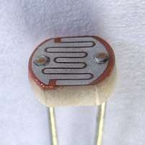

**Circuit Diagram:**

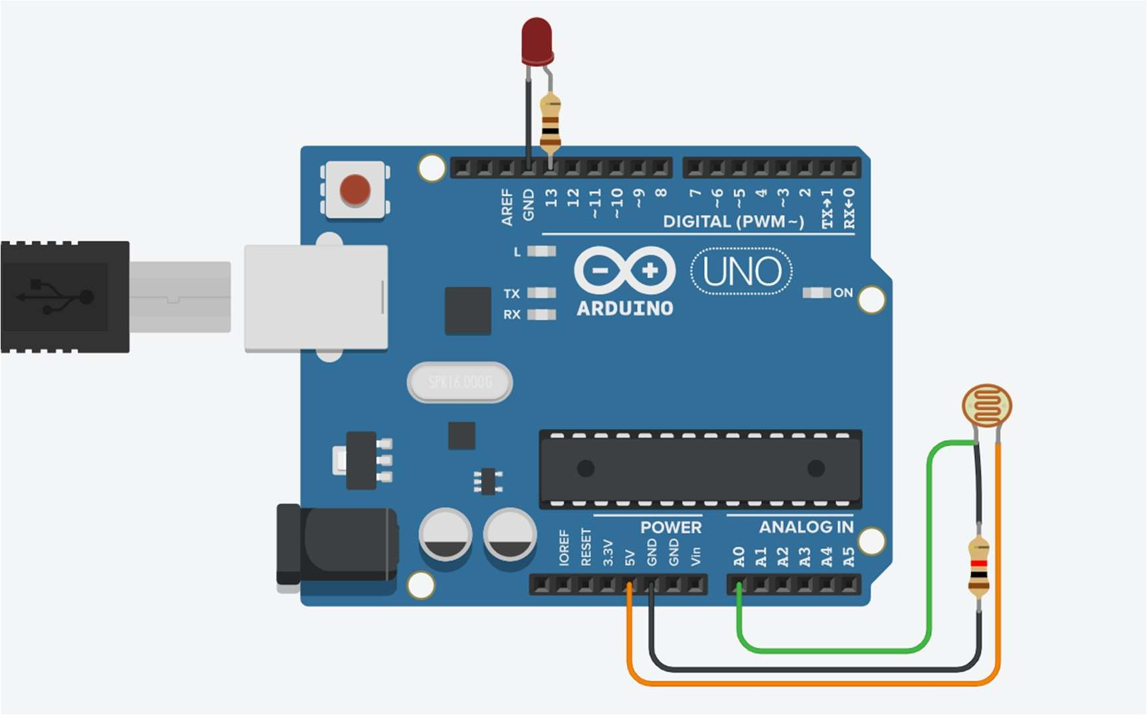

**Program:**

int ldrPin = A0; int ledPin = 13;

int sensorValue = 0; void setup()

{

pinMode(ledPin, OUTPUT); Serial.begin(9600);

}

void loop()

{

sensorValue = analogRead(ldrPin); Serial.println(sensorValue);

if(sensorValue <= 500) digitalWrite(ledPin, HIGH);

else

digitalWrite(ledPin, LOW);

}

**Output:**

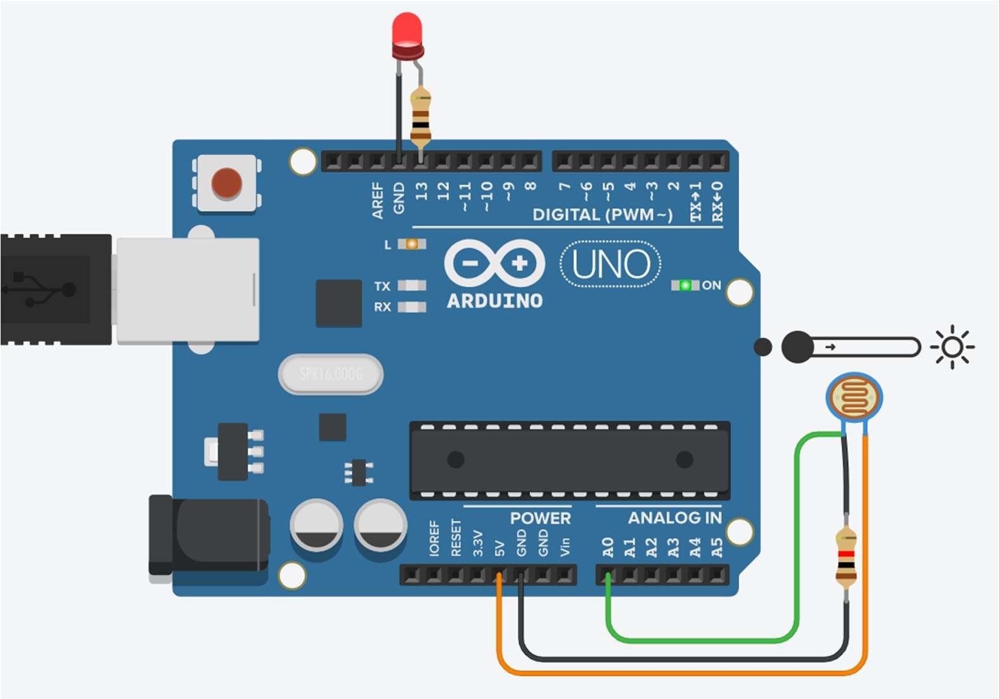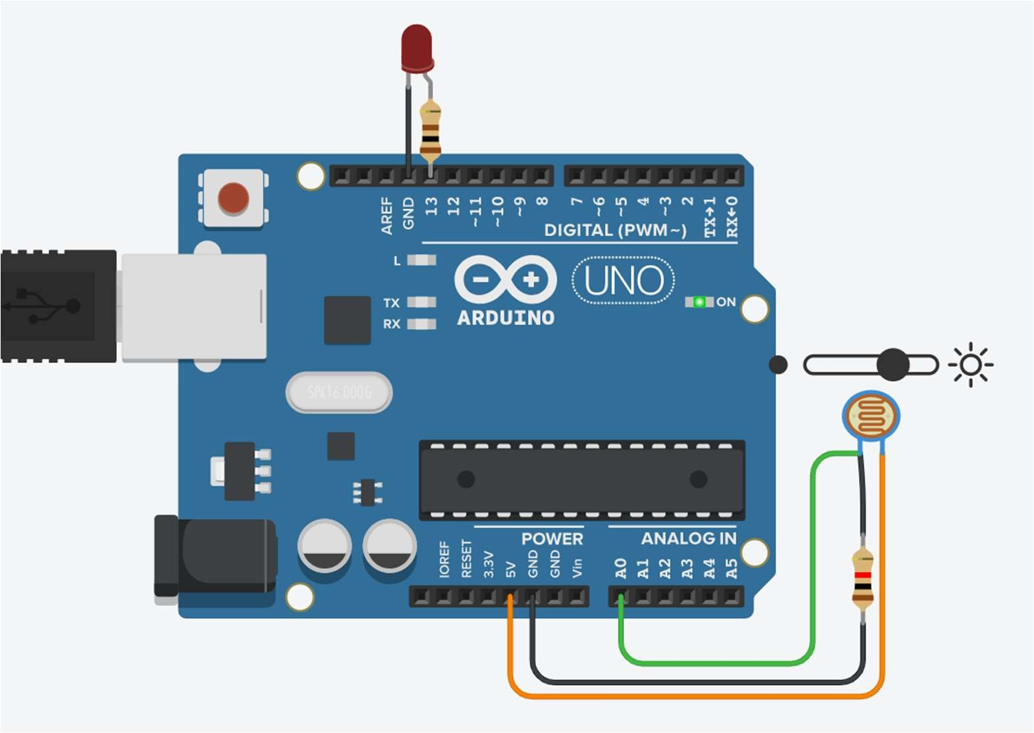

# Practical No. 20

**Aim:** To interface servo motor with Arduino , write a program to sweep a servo back and forth through its full range of motion.

**Component:** Arduino Uno, Positional Micro Servo

**Theory:**

A servomotor is a rotary actuator or linear actuator that allows for precise control of angular or linear position, velocity and acceleration.[1] It consists of a suitable motor coupled to a sensor for position feedback. It also requires a relatively sophisticated controller, often a dedicated module designed specifically for use with servomotors.

A servomotor is a closed-loop servomechanism that uses position feedback to control its motion and final position. The input to its control is a signal (either analogue or digital) representing the position commanded for the output shaft.

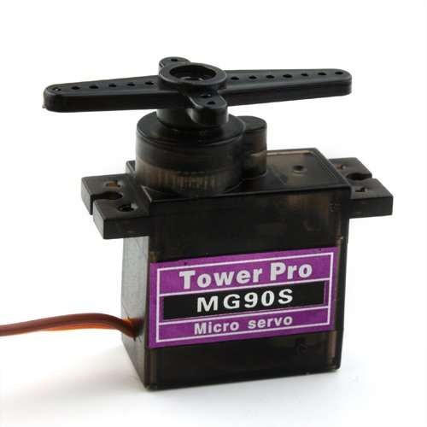The motor is paired with some type of position encoder to provide position and speed feedback. In the simplest case, only the position is measured. The measured position of the output is compared to the command position, the external input to the controller. If the output position differs from that required, an error signal is generated which then causes the motor to rotate in either direction, as needed to bring the output shaft to the appropriate position. As the positions approach, the error signal reduces to zero and the motor stops.

**Circuit Diagram:**

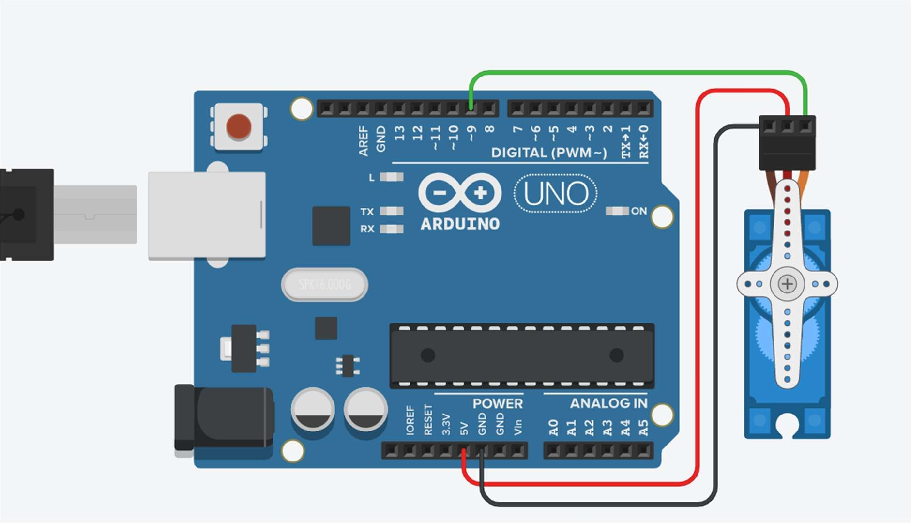

**Program:**

#include <Servo.h>

int servoPin = 9; int servoPos = 45;

int servoInitalPos = 180; Servo myServo;

void setup()

{

myServo.attach(servoPin);

}

void loop()

{

int pos = 0; int dtwait=15;

for(pos = 0; pos < 180; pos += 1) { myServo.write(pos); delay(dtwait);

}

for(pos = 180; pos>=1; pos -= 1) { myServo.write(pos); delay(dtwait);

}

}

**Output:**

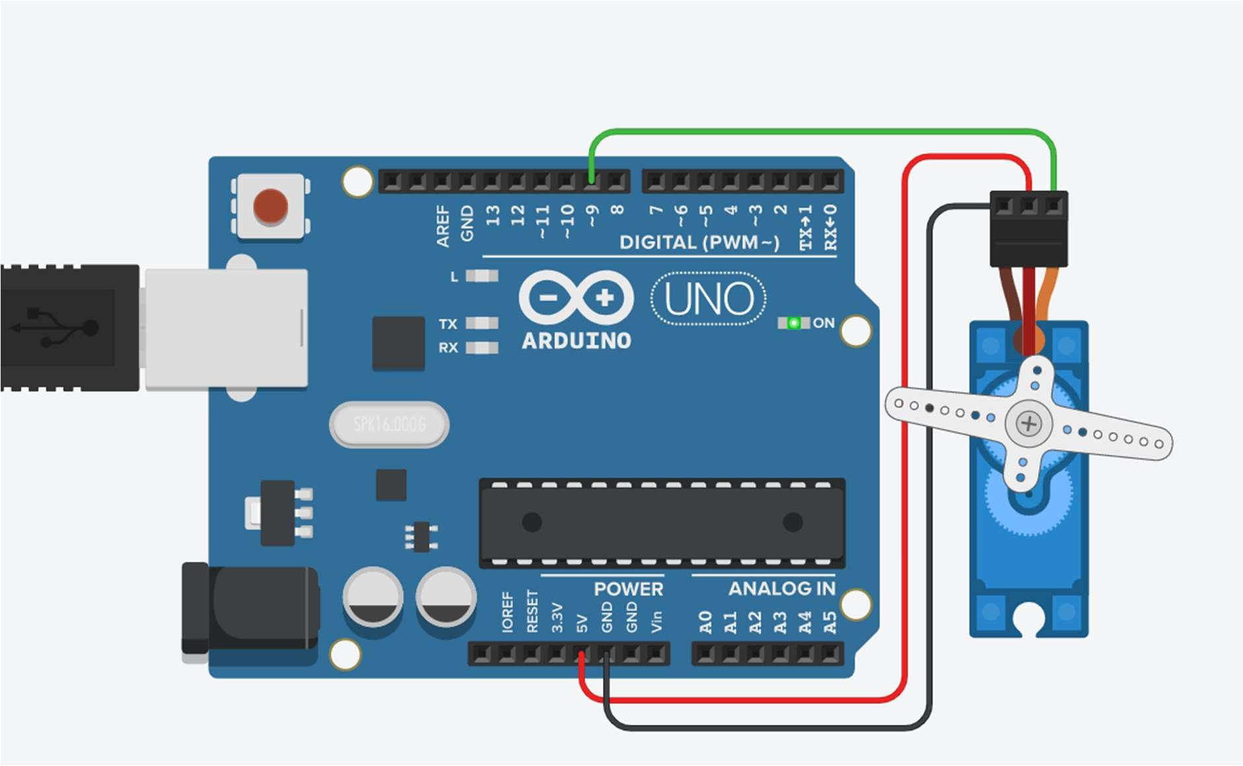

# Practical No. 21

**Aim:** To interface servo motor, Photo resistor (LDR) ,3LEDs with Arduino , write a program to sweep a servo back and forth through its full range of motion depending on light also run on the LED

**Component:**

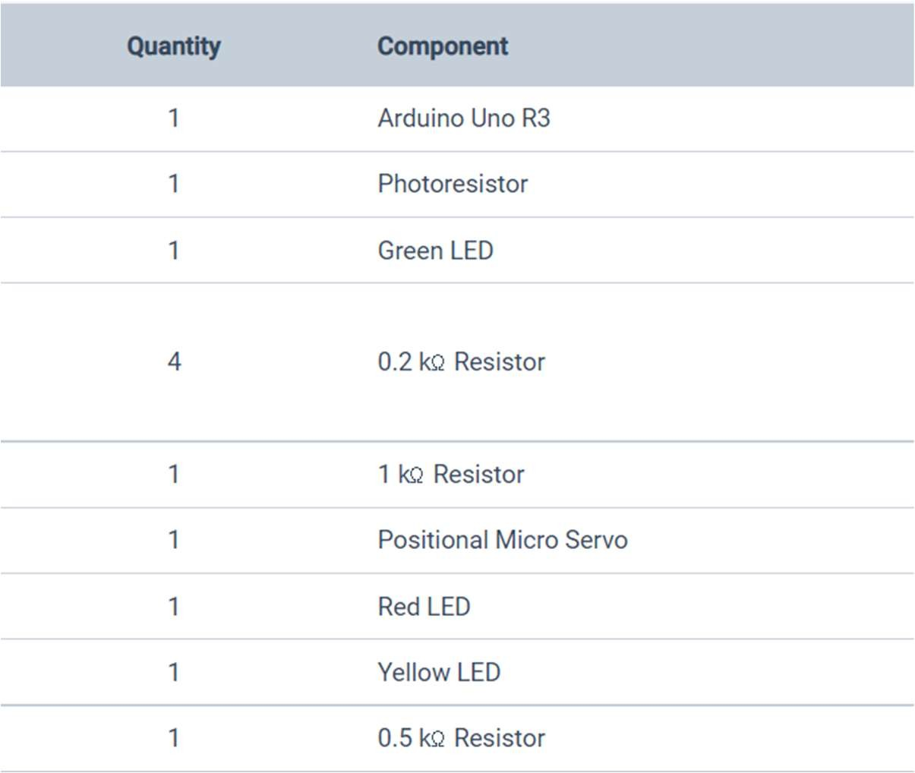

**Theory:**

**Circuit Diagram:**

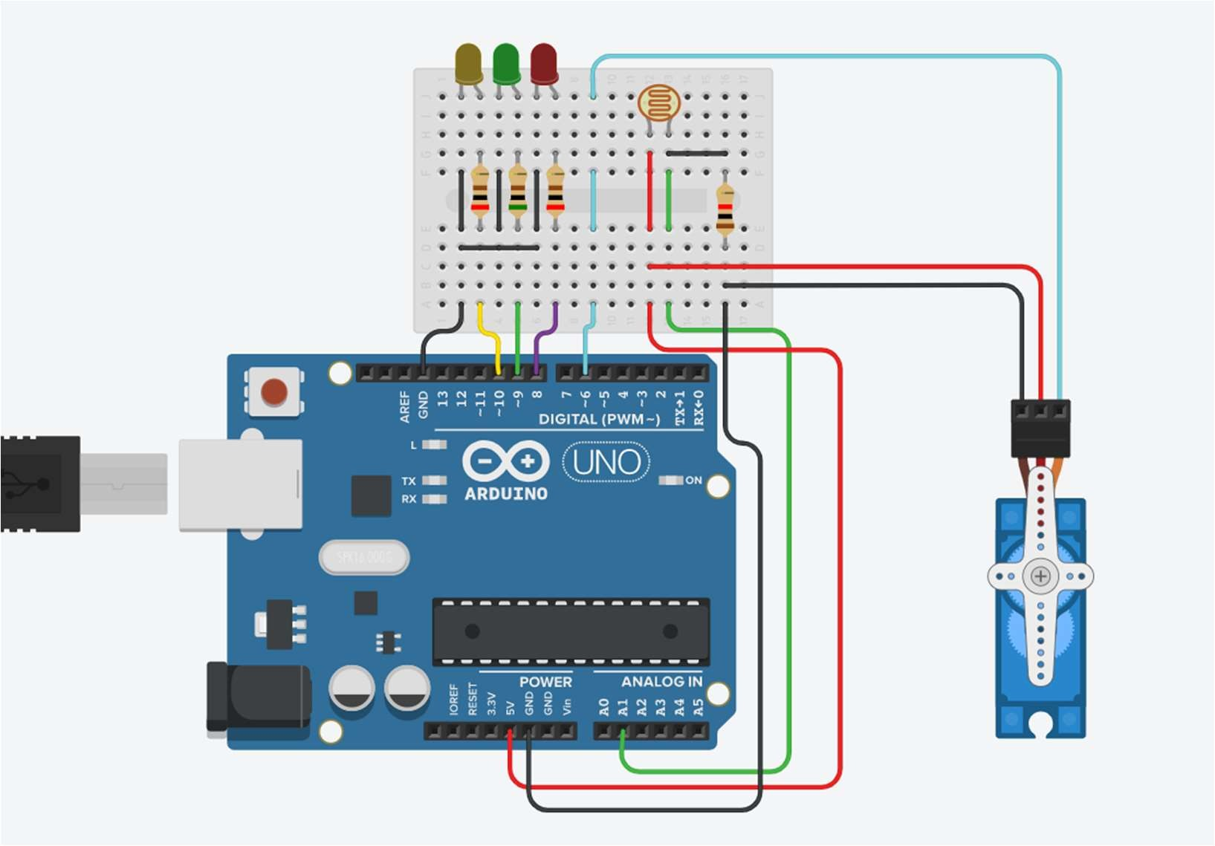

**Program:**

#include <Servo.h>

int servoPin = 6; int servoPos = 0; int red = 8;

int green = 9; int yellow = 10; Servo myServo;

void setup()

{

pinMode(red, OUTPUT); pinMode(green, OUTPUT); pinMode(yellow, OUTPUT); myServo.attach(servoPin); Serial.begin(9600);

}

void loop()

{

Serial.println(analogRead(A1)); Serial.println(analogRead(A1));

if (analogRead(A1) <= 700 && analogRead(A1) >595){ digitalWrite(red, HIGH);

digitalWrite(green, LOW); digitalWrite(yellow, LOW); myServo.write(180);

}

else if (analogRead(A1) <= 595 && analogRead(A1) > 200)

{

digitalWrite(red, LOW); digitalWrite(green, HIGH); digitalWrite(yellow, LOW); myServo.write(90);

}

else

{

digitalWrite(red, LOW); digitalWrite(green, LOW); digitalWrite(yellow, HIGH); myServo.write(0);

}

}

**Output:**

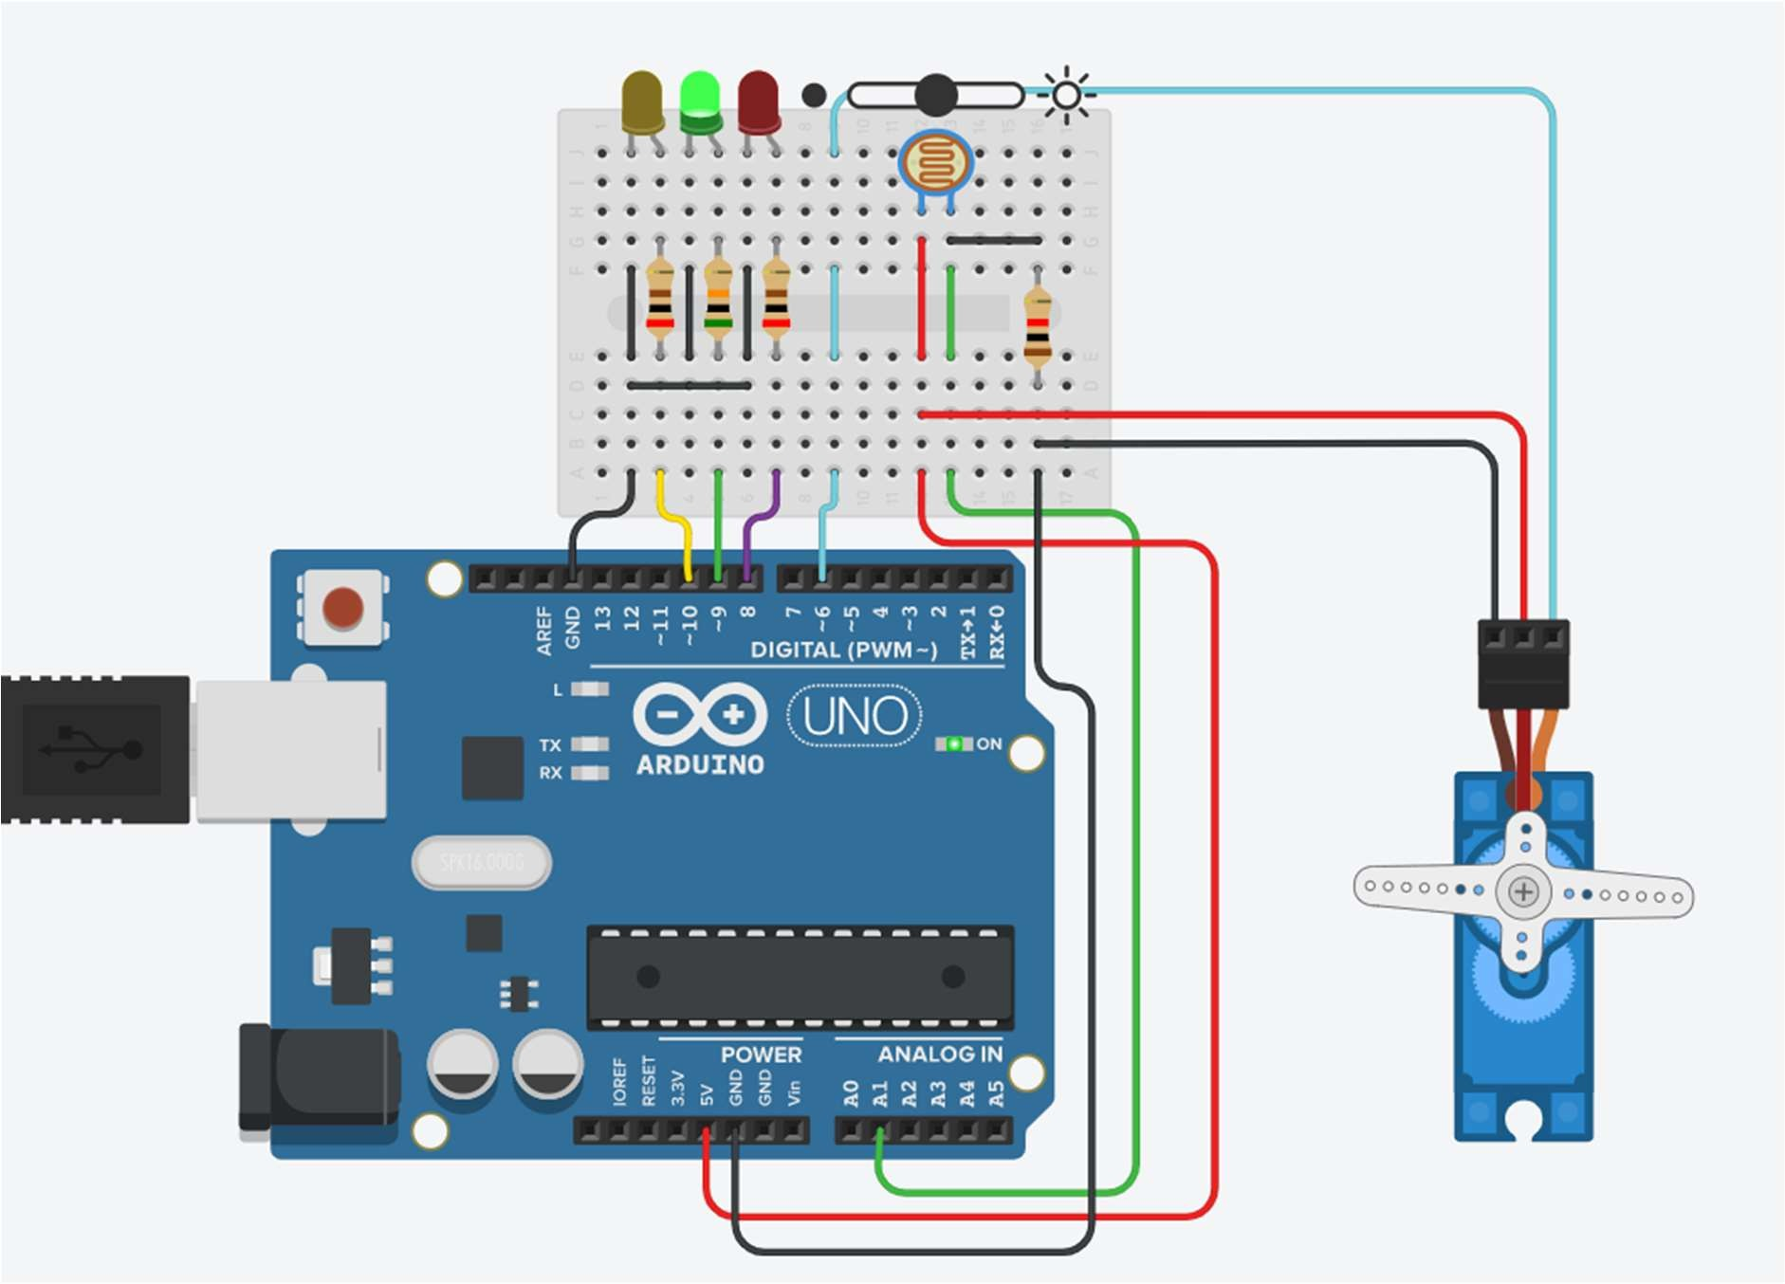

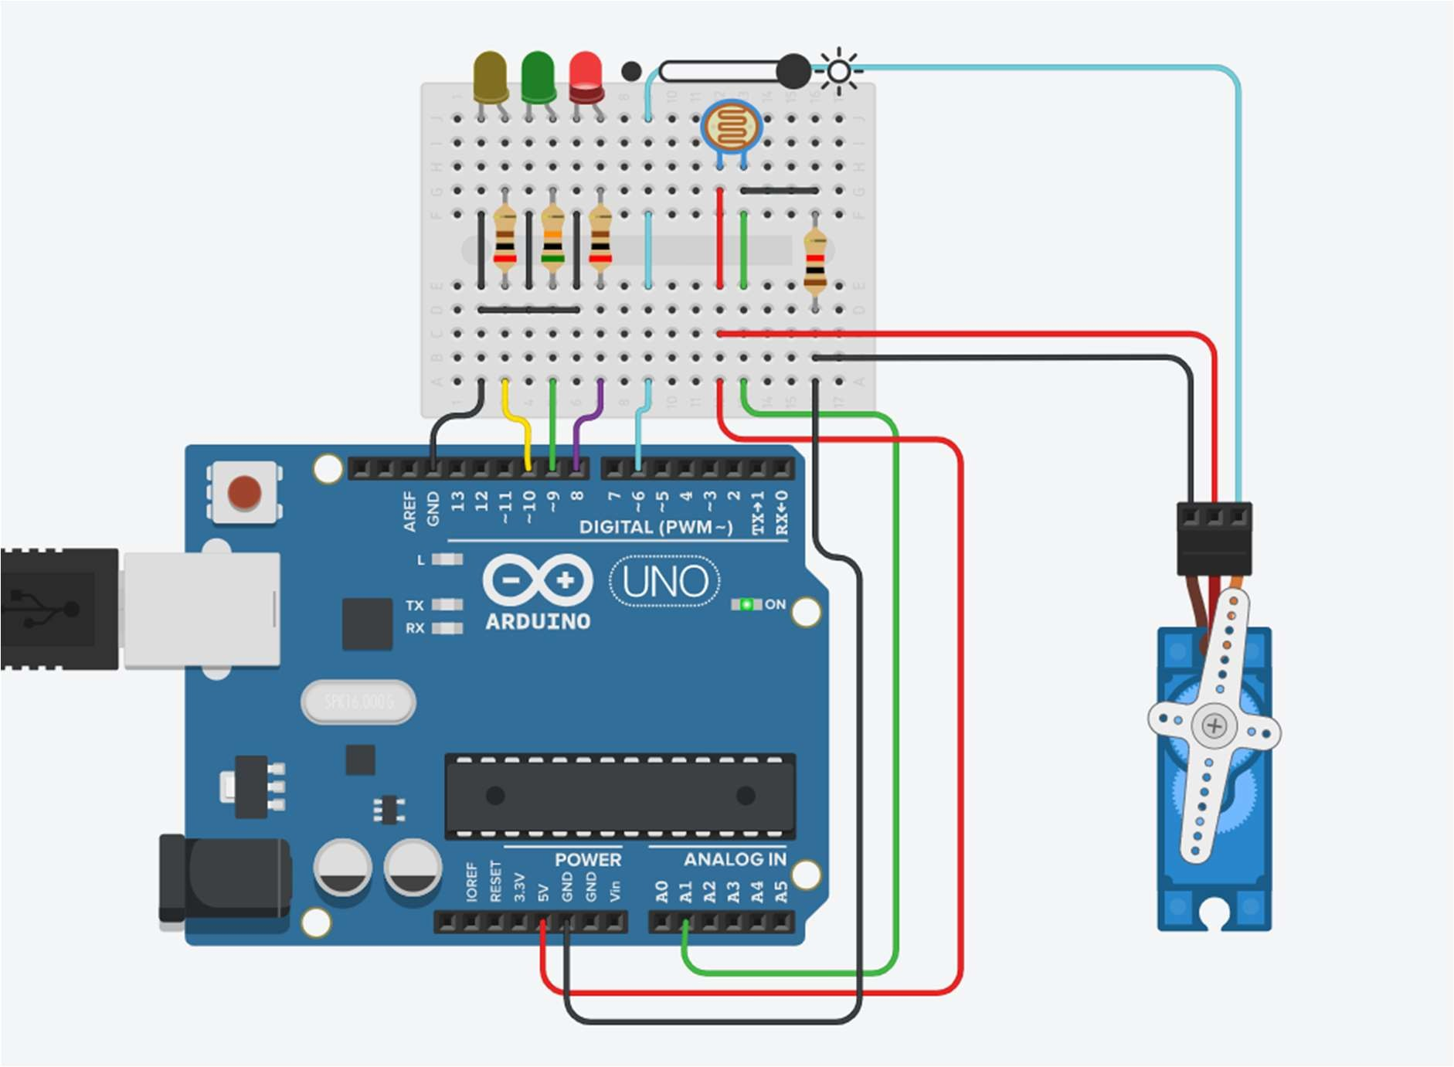

# Practical No. 22

**Aim:** To interface Ultrasonic sensor with Arduino and write a program to display object distance(in inch/cm) in serial monitor depending on sound detection.

**Component:** Arduino Uno, Ultrasonic Distance Sensor

**Theory:**

An ultrasonic sensor is an instrument that measures the distance to an object using ultrasonic sound waves.

An ultrasonic sensor uses a transducer to send and receive ultrasonic pulses that relay back information about an object’s proximity.

High-frequency sound waves reflect from boundaries to produce distinct echo patterns

Ultrasonic sensors work by sending out a sound wave at a frequency above the range of human hearing. The transducer of the sensor acts as a microphone to receive and send the ultrasonic sound. Our ultrasonic sensors, like many others, use a single transducer to send a pulse and to receive the echo. The sensor determines the distance to a target by measuring time lapses between the sending and receiving of the ultrasonic pulse.

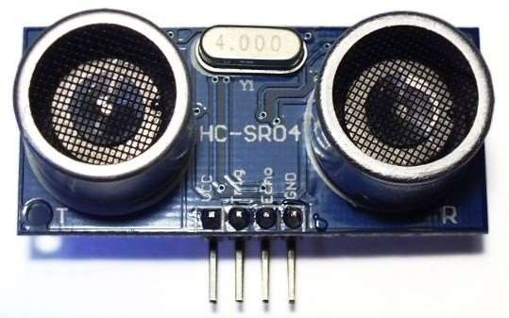

**Circuit Diagram:**

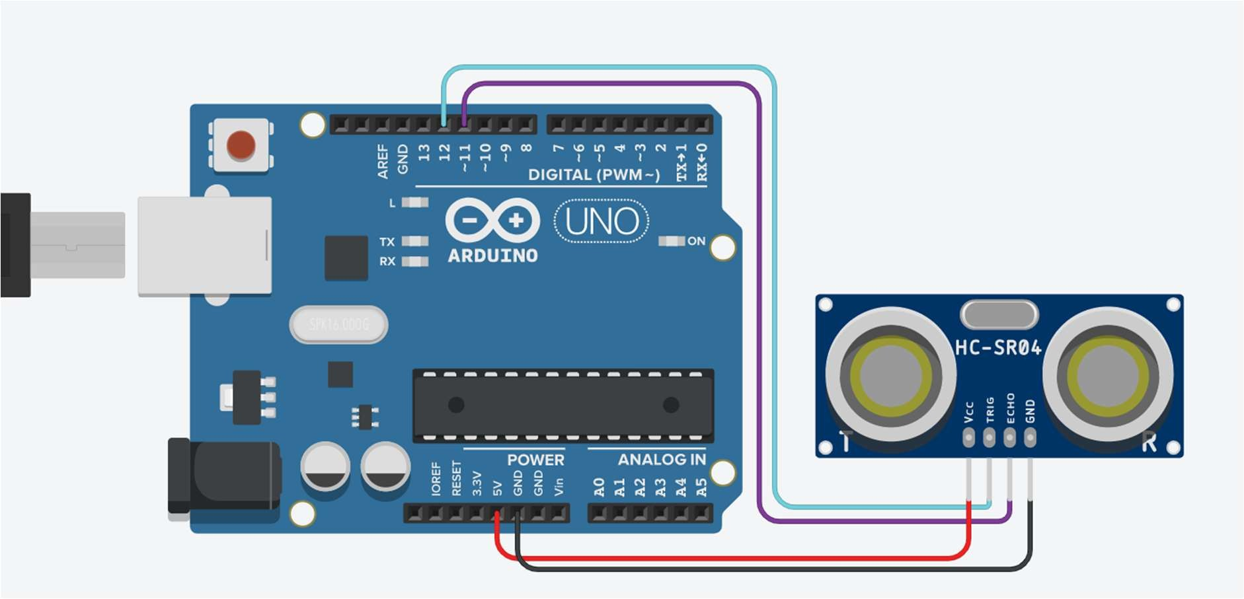

**Program:** int trig = 12; int echo = 11; int travelTime; int distance;

int distanceInch;

void setup()

{

pinMode(trig, OUTPUT); pinMode(echo, INPUT); Serial.begin(9600);

}

void loop()

{

digitalWrite(trig , LOW); delayMicroseconds(10); digitalWrite(trig , HIGH); delay(10); digitalWrite(trig , LOW);

travelTime = pulseIn(echo,HIGH); delay(20);

distance = (travelTime / 2) * 0.0343; distanceInch = ( travelTime / 2)* 0.013464 ; Serial.print("Distance in CM "); Serial.println(distance); Serial.print("Distance in INCHES "); Serial.println(distanceInch);

}

**Output:**

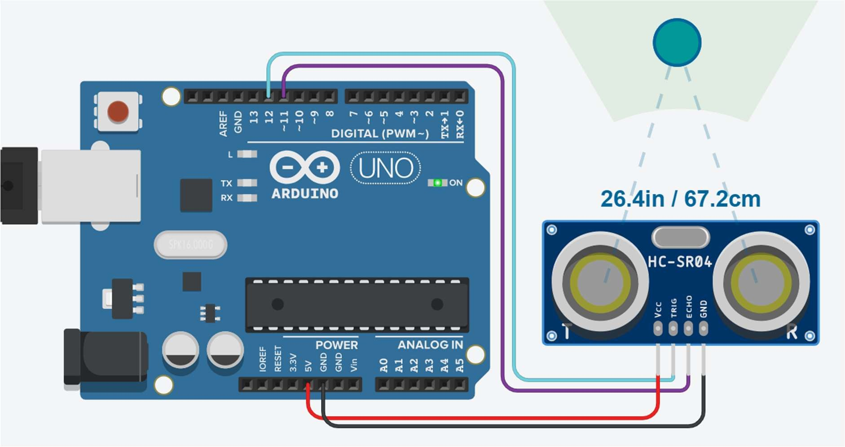

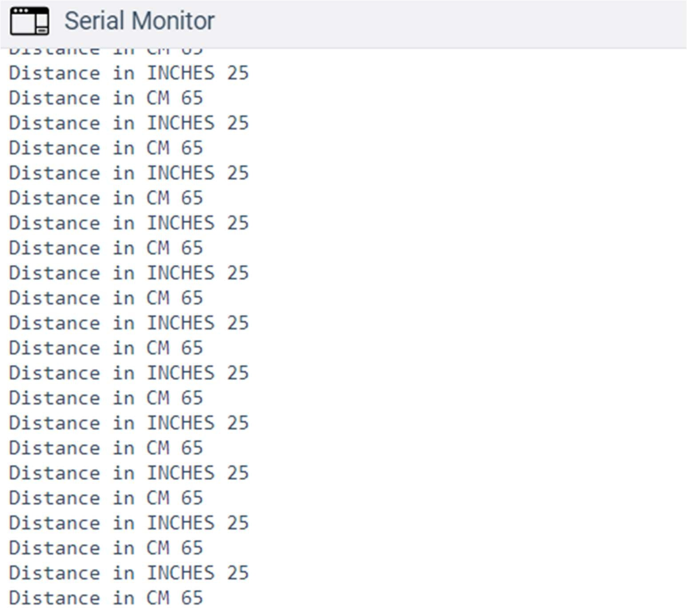

# Practical No. 23

**Aim:** To interface PIR sensor with Arduino and write a program to turn on and off LED depending on motion detection.

**Component:** Arduino Uno, PIR Sensor, Red LED, 100 Ω Resistor

**Theory:**

PIR sensors are more complicated than many of the other sensors explained in these tutorials (like photocells, FSRs and tilt switches) because there are multiple variables that affect the sensors input and output. To begin explaining how a basic sensor works, we'll use this rather nice diagram

The PIR sensor itself has two slots in it, each slot is made of a special material that is sensitive to IR. The lens used here is not really doing much and so we see that the two slots can 'see' out past some distance (basically the sensitivity of the sensor). When the sensor is idle, both slots detect the same amount of IR, the ambient amount radiated from the room or walls or outdoors. When a warm body like a human or animal passes by, it first intercepts one half of the PIR sensor, which causes a positive differential change between the two halves.

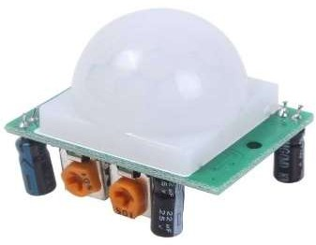When the warm body leaves the sensing area, the reverse happens, whereby the sensor generates a negative differential change. These change pulses are what is detected.

**Circuit Diagram:**

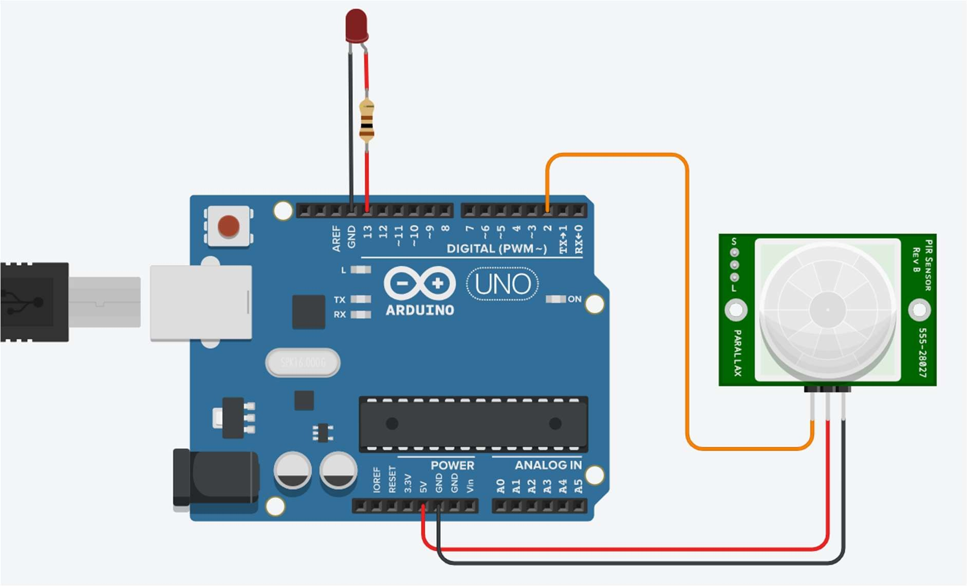

**Program:**

void setup()

{

pinMode(13, OUTPUT); pinMode(2, INPUT);

}

void loop()

{

int sensorMotion = digitalRead(2); if (sensorMotion == HIGH) digitalWrite(13, HIGH);

else

digitalWrite(13, LOW);

}

**Output:**

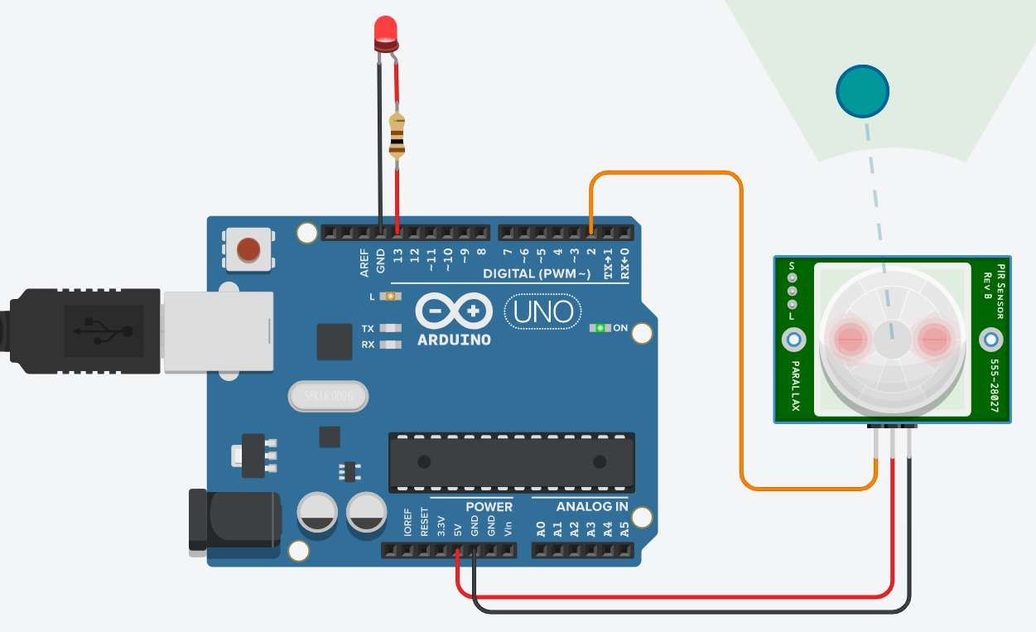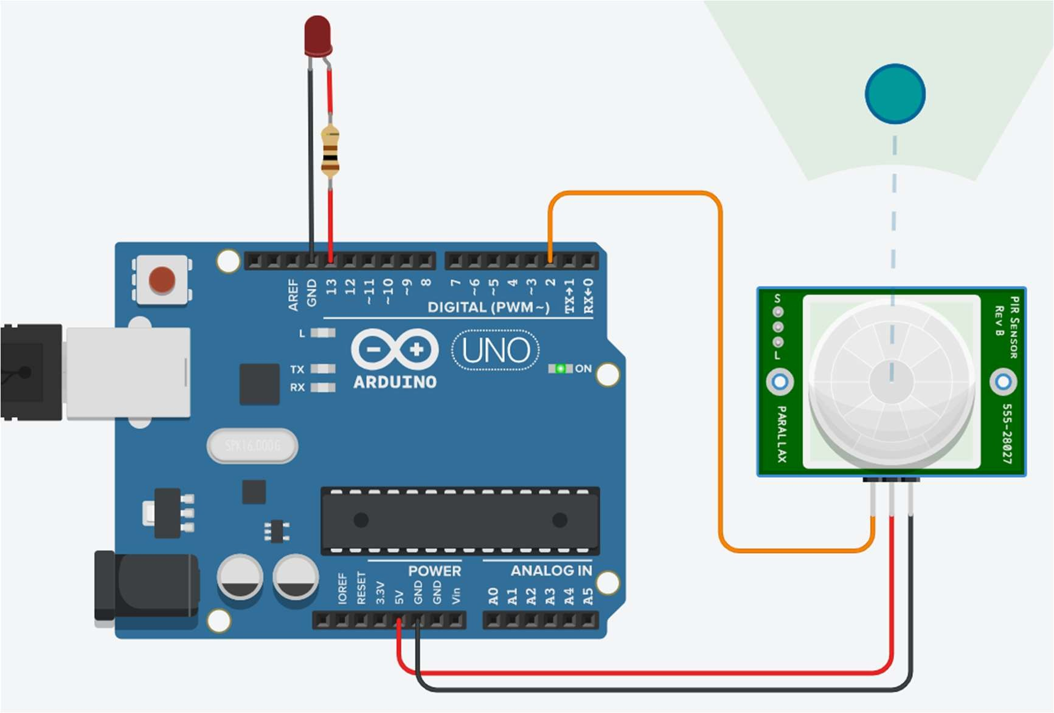

**Practical 24**

**Aim:** Write a program to control one DC motors with Arduino **Components Required**: - Arduino Board, 1 DC Motors

## Theory:

DC Motor:

A direct current (DC) motor is a type of electric machine that converts electrical energy into mechanical energy. DC motors take electrical power through direct current, and convert this energy into mechanical rotation.

DC motors use magnetic fields that occur from the electrical currents generated, which powers the movement of a rotor fixed within the output shaft. The output torque and speed depend upon both the electrical input and the design of the motor.

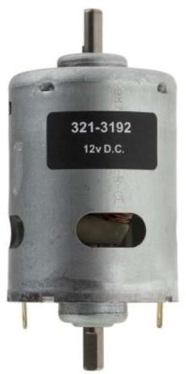

## Circuit Diagram:

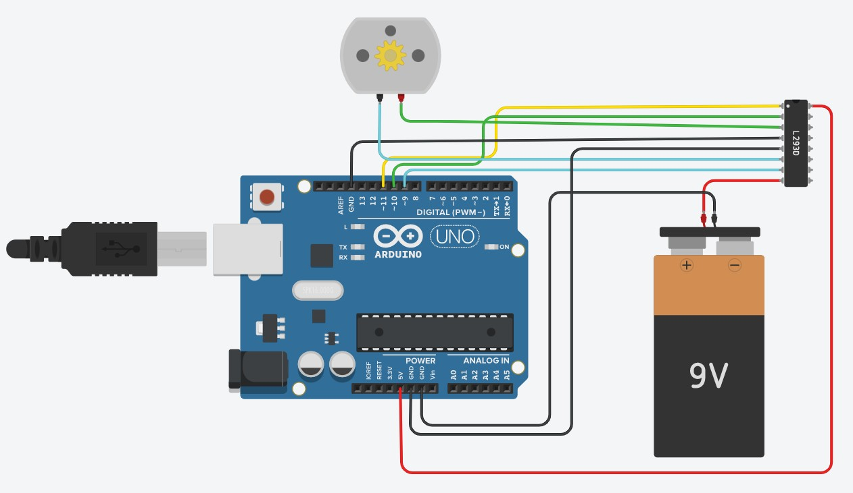

### **Program :**

// C++ code

//

int speedPin=11; int dir1=10;

int dir2=9;

int speedPin1=3;

//motor speed is 0 to 255

//motor will rotate with analog

//speed 100 void setup()

{

pinMode(speedPin,OUTPUT); pinMode(dir1,OUTPUT); pinMode(dir2,OUTPUT);

}

void loop()

{

// set direction digitalWrite(dir1,HIGH); digitalWrite(dir2,LOW); analogWrite(speedPin,255);

//analogWrite(speedPin,100); delay(25);

}

### Output:

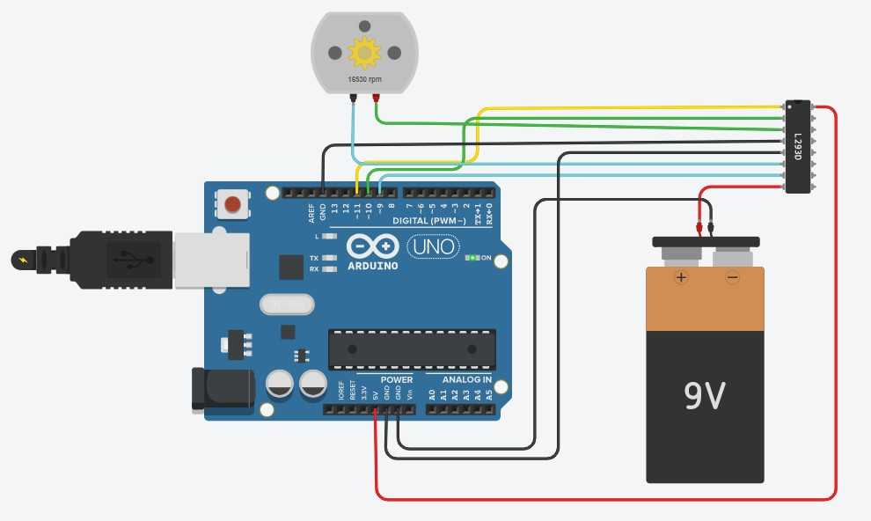

# Practical No. 25

**Aim:** Write a program to control two DC motors with Arduino.

**Component:**

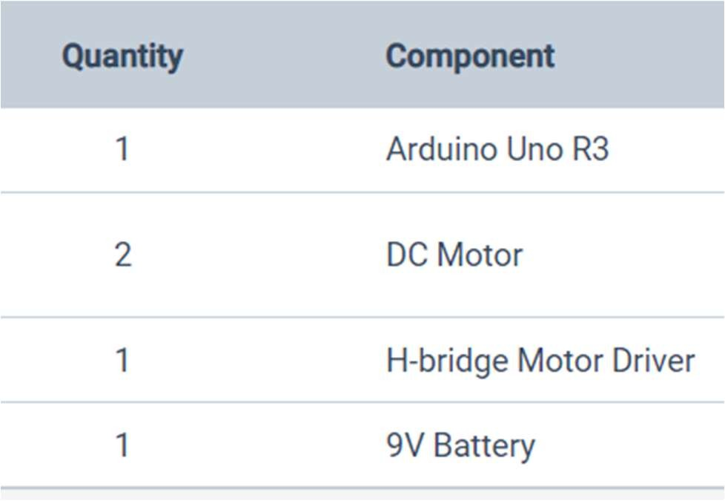

**Theory:**

## DC Motor:

A direct current (DC) motor is a type of electric machine that converts electrical energy into mechanical energy. DC motors take electrical power through direct current, and convert this energy into mechanical rotation.

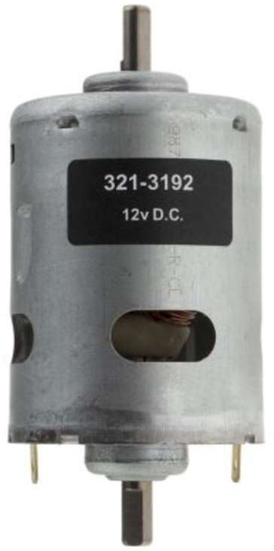

**Circuit Diagram:**

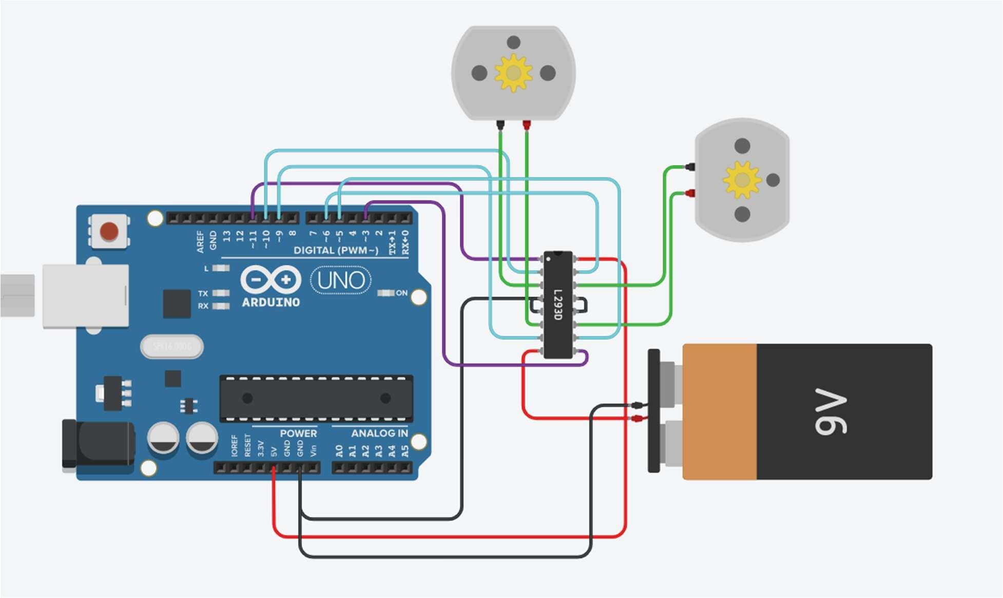

**Program:**

int speedPin = 11; int speedPin2 = 3; int dir1= 9;

int dir2= 10;

int dir3= 5;

int dir4= 6;

void setup()

{

pinMode(speedPin, OUTPUT); pinMode(speedPin2, OUTPUT); pinMode(dir1, OUTPUT); pinMode(dir2, OUTPUT); pinMode(dir3, OUTPUT); pinMode(dir4, OUTPUT);

}

void loop()

{

digitalWrite(dir1, HIGH); digitalWrite(dir2, LOW); digitalWrite(dir3, LOW); digitalWrite(dir4, HIGH); analogWrite(speedPin,100); analogWrite(speedPin2,100);

}

**Output:**

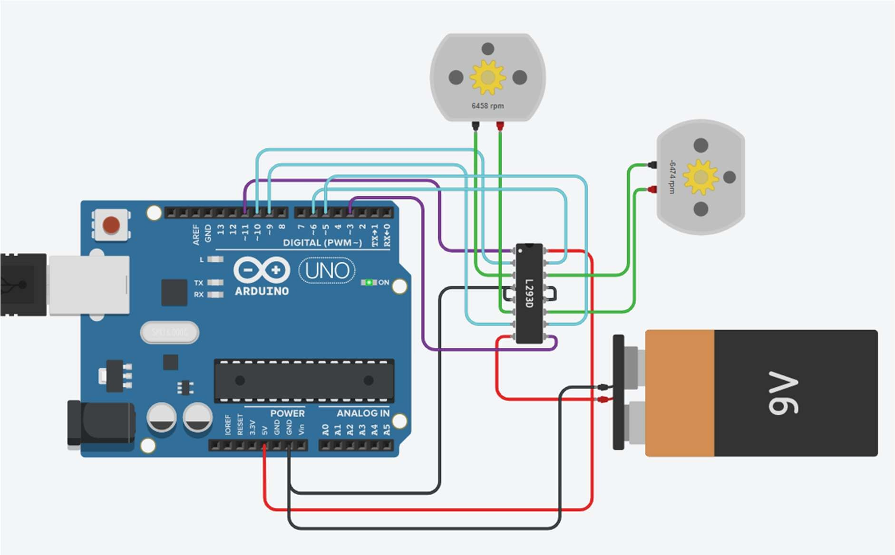

# Practical No. 26

**Aim:** Upload data on Thingspeak cloud manually.

**Component:**

**Theory:**

**Steps:**

1. **Create Channel on Thingspeak**

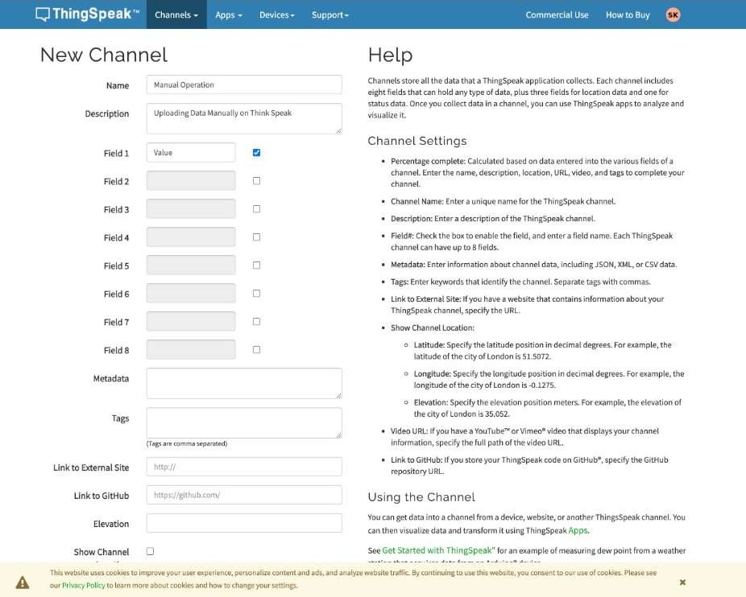

1. **Manual Operation**

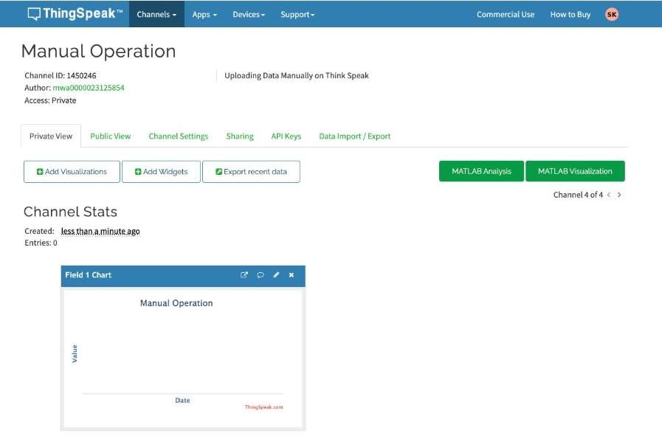

1. **Click on API Keys**

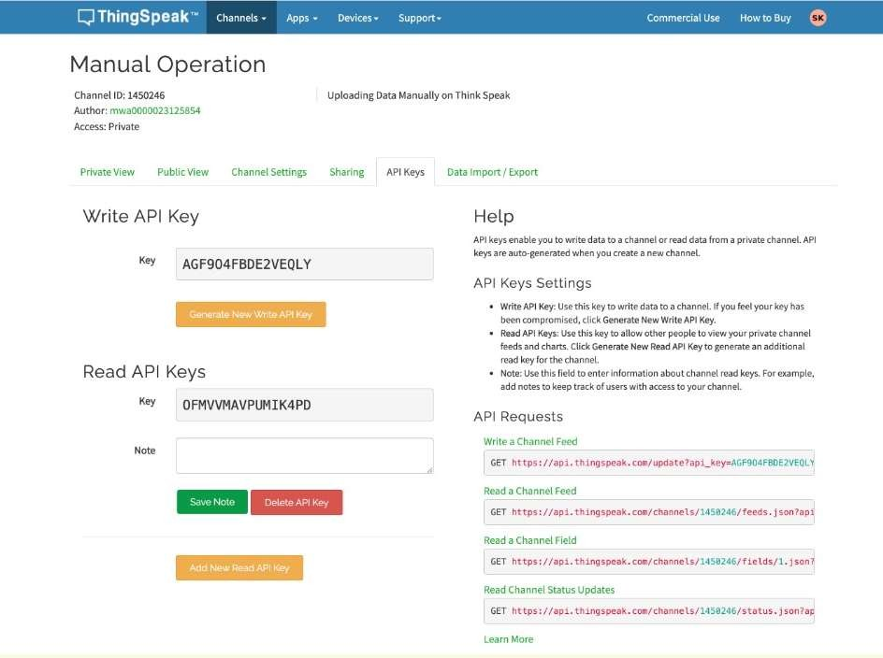

1. **Calling the API by passing values in URL**

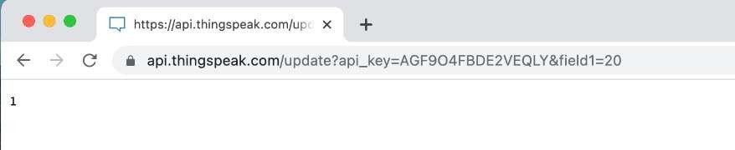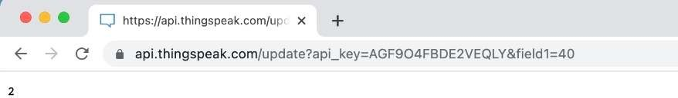

1. **Click on Private View to view the graph for passed values**

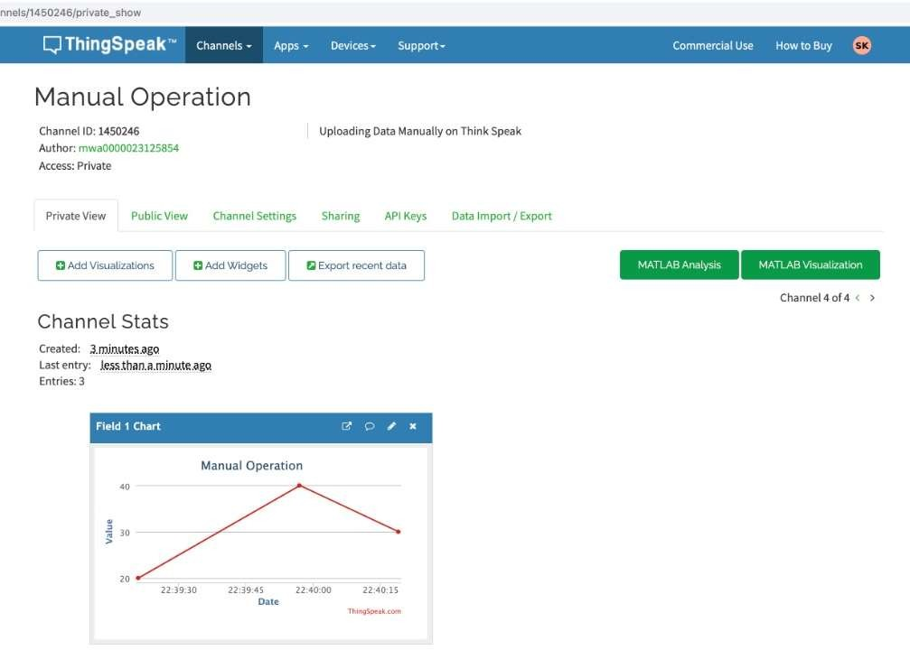

# Practical No. 27

**Aim:** To update readings to Thingspeak from Arduino using Tinkercad.

**Component:**

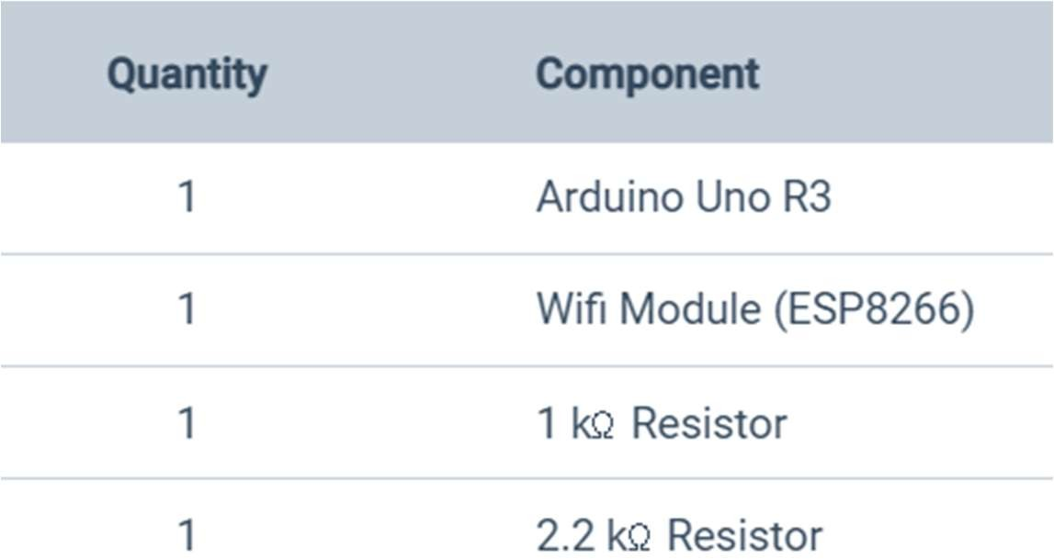

**Theory:**

ThingSpeak is an open-source Internet of Things (IoT) application and API to store and retrieve data from things using the HTTP and MQTT protocol over the Internet or via a Local Area Network. ThingSpeak enables the creation of sensor logging applications, location tracking applications, and a social network of things with status updates.

**Circuit Diagram:**

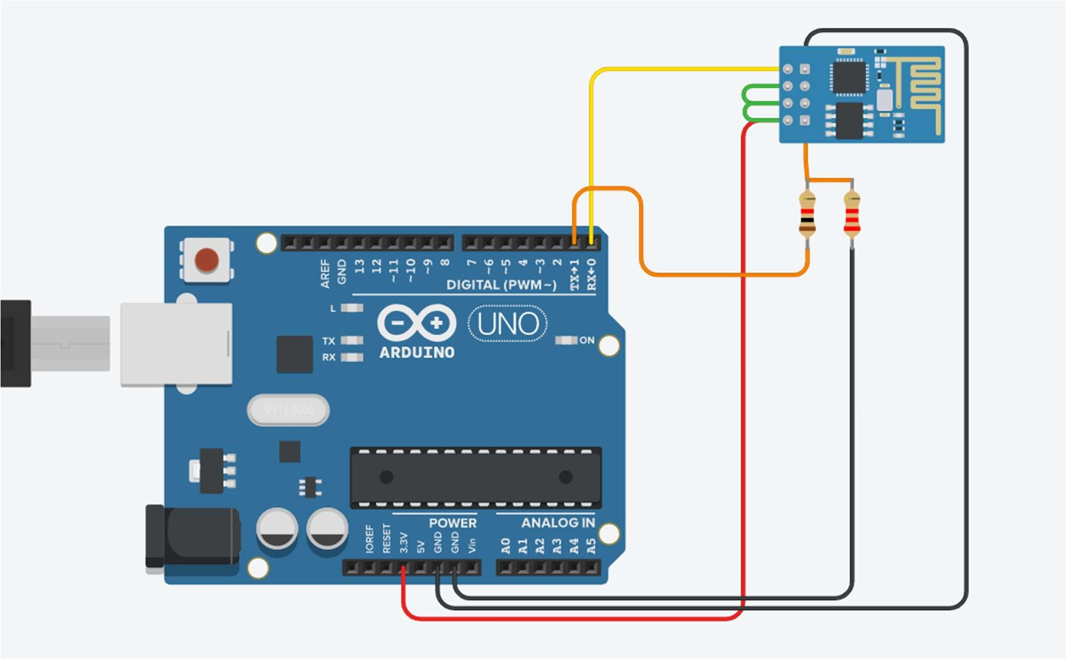

**Program:**

void setup() {

Serial.begin(115200); pinMode(A0, INPUT); delay(1000);

Serial.println("AT+CWJAP=\"Simulator Wifi\",\"\"\r\n"); delay(3000);

}

void loop() {

int senseValue = analogRead(A0);

float volt = (senseValue/1020.0) * 4.9; //Volts float float tempC = (volt -0.5) * 100; //Celcius Serial.println(tempC);

Serial.println("AT+CIPSTART=\"TCP\",\"api.thingspeak.com\",80\r\n"); delay(5000);

int len = 65; Serial.print("AT+CIPSEND="); Serial.println(len);

delay(10);

Serial.print("GET /update?api_key=QIJ30DA6H5OI2DWV&field1=120 HTTP/1.1\r\n"); delay(100);

Serial.println("AT+CIPCLOSE=0\r\n"); delay(6000);

}

**Output:**

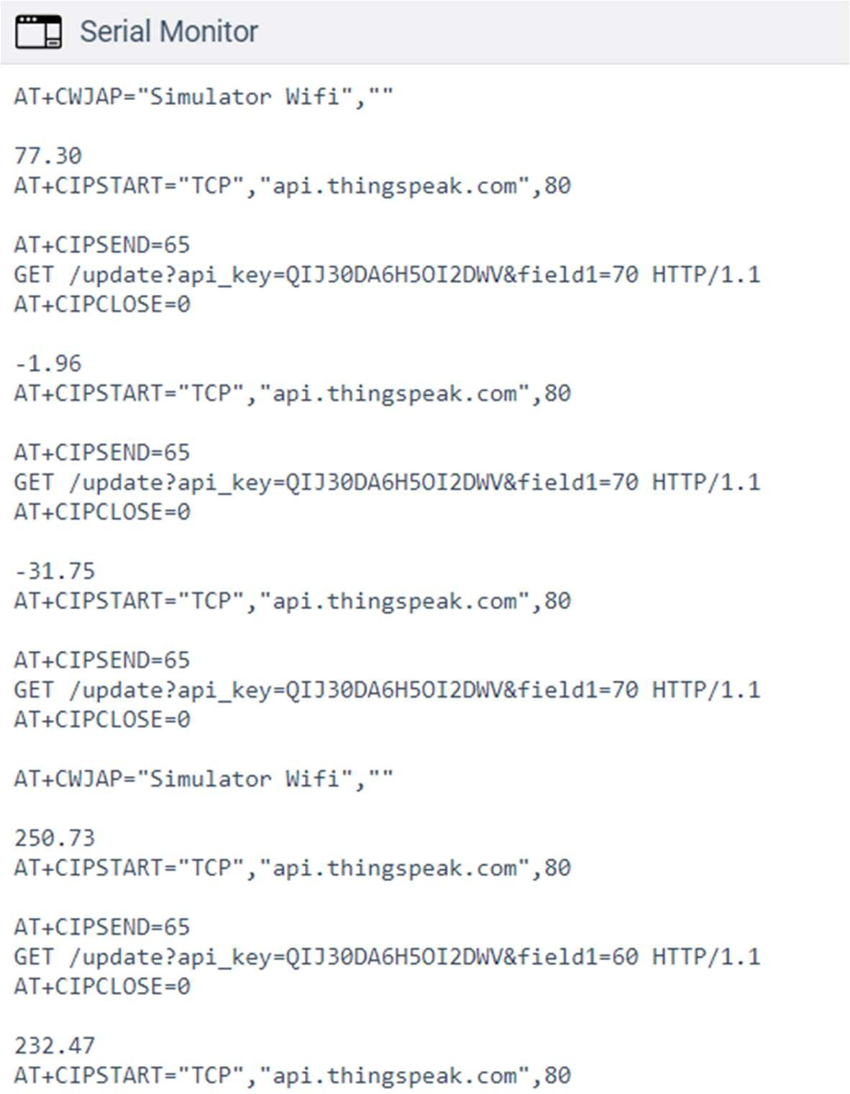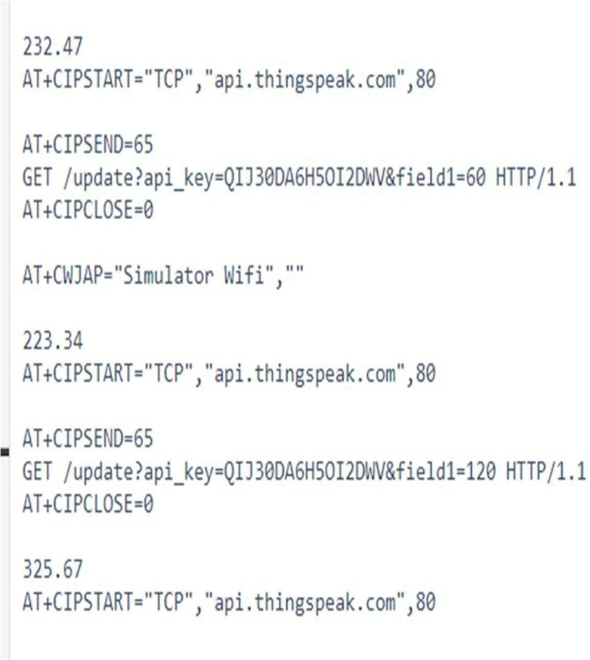

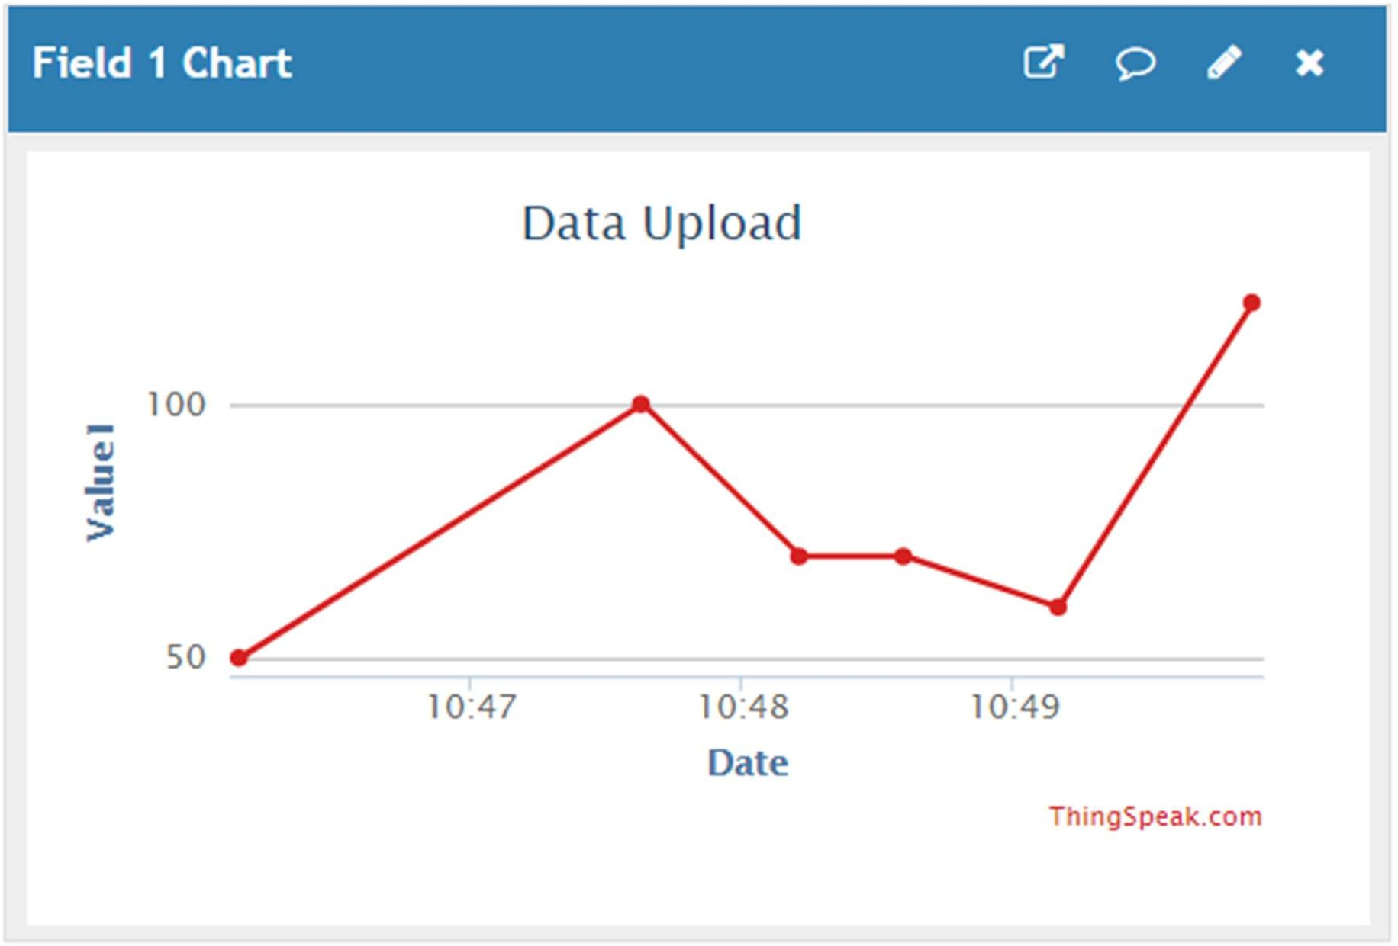

# Practical No. 28

**Aim:** To interface Temperature sensor and ESP8266 with Arduino and update temperature reading to Thingspeak.

**Component:**

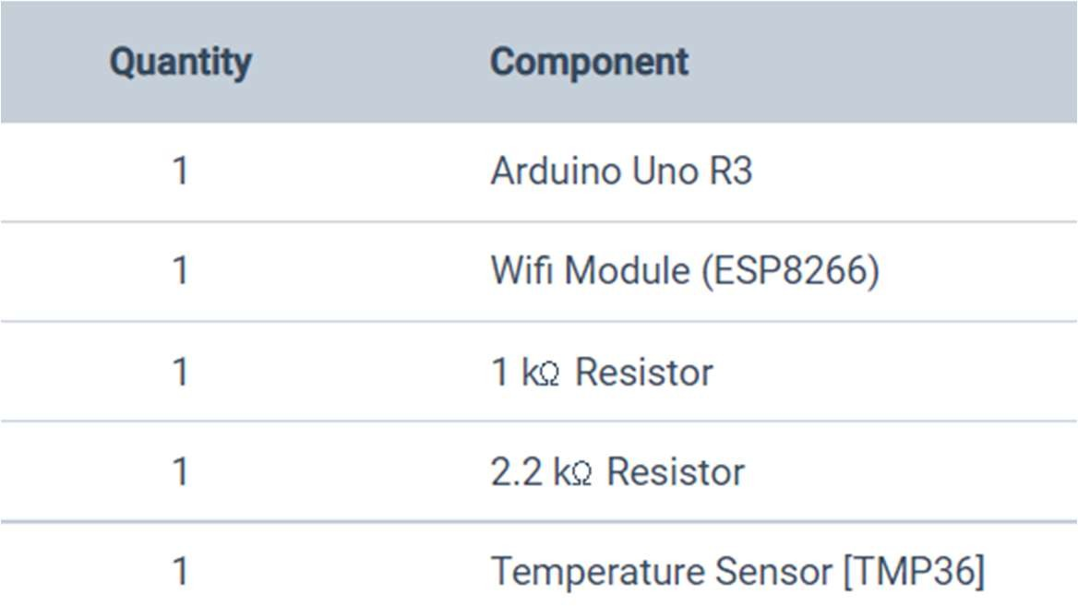

**Circuit Diagram:**

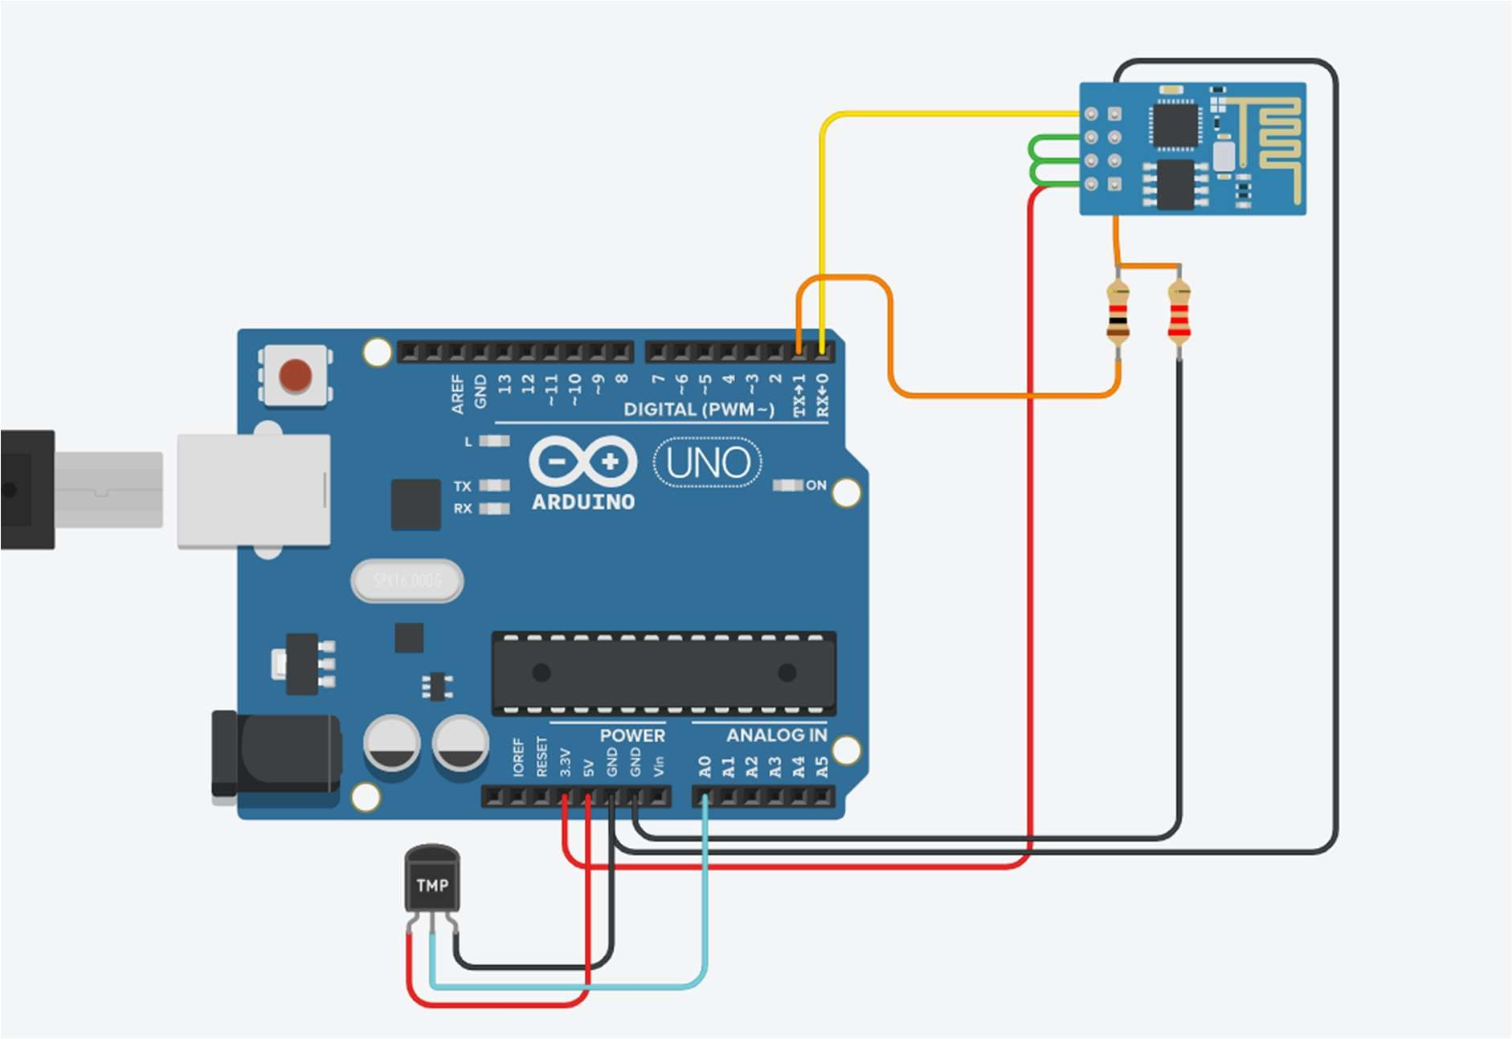

**Program:**

void setup()

{

Serial.begin(115200); pinMode(A0, INPUT); delay(1000);

Serial.println("AT+CWJAP=\"Simulator Wifi\",\"\"\r\n"); delay(3000);

}

void loop() {

int senseValue = analogRead(A0);

float volt = (senseValue/1020.0) * 4.9; //Volts float float tempC = (volt -0.5) * 100; //Celcius Serial.println(tempC);

Serial.println("AT+CIPSTART=\"TCP\",\"api.thingspeak.com\",80\r\n"); delay(5000);

int len = 65; Serial.print("AT+CIPSEND="); Serial.println(len);

delay(10);

Serial.print("GET /update?api_key=AT0I0YF0H855GT2U&field1=" + String(tempC)+" HTTP/1.1\r\n");

delay(100); Serial.println("AT+CIPCLOSE=0\r\n"); delay(6000);

}

**Output:**

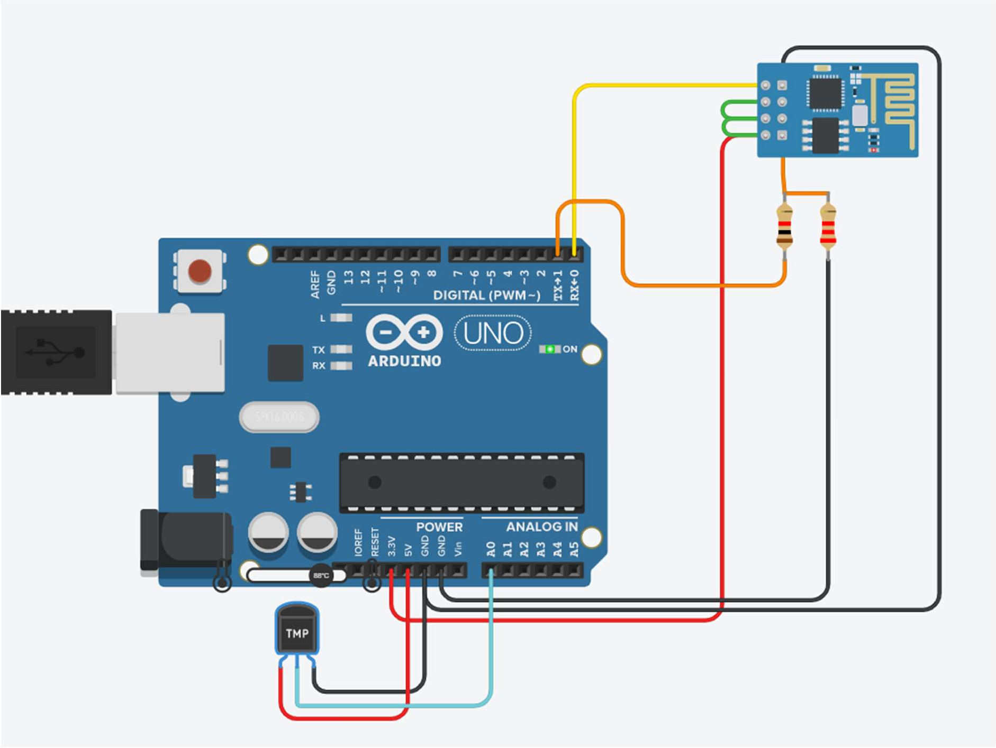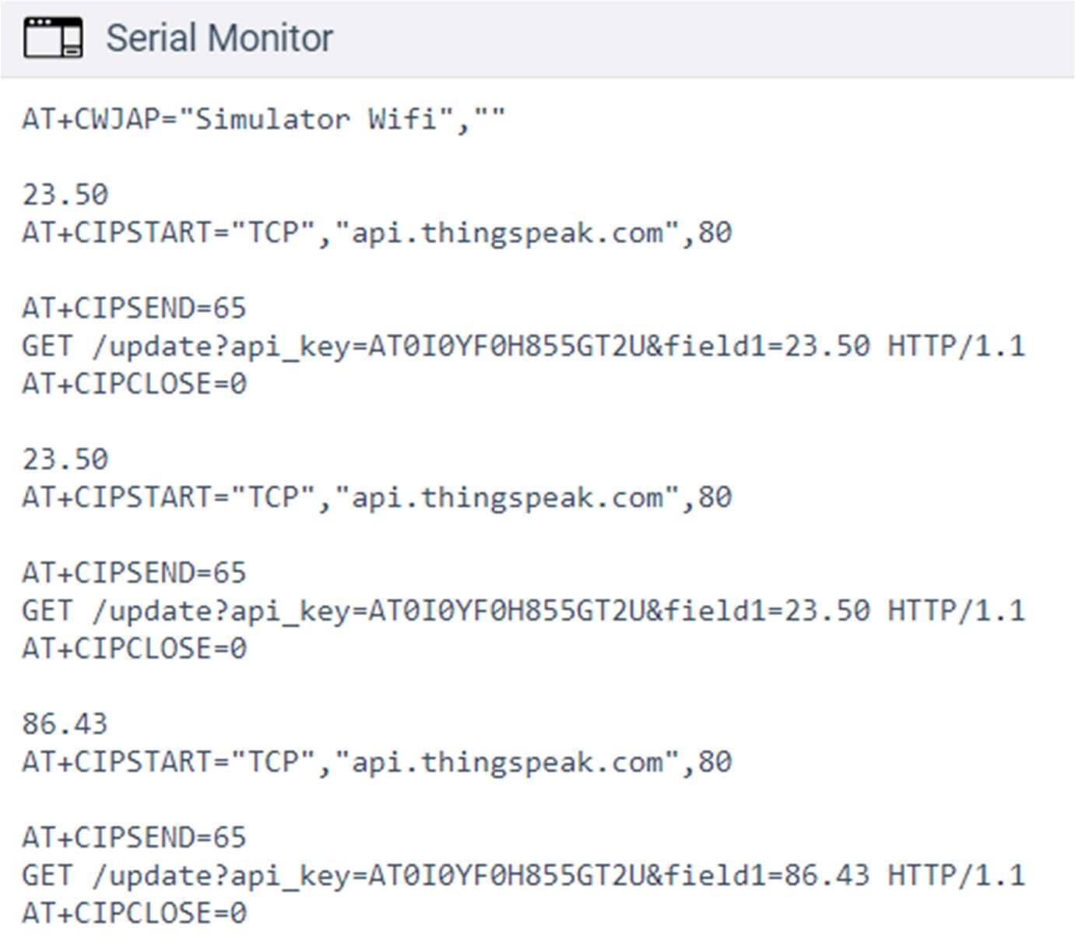

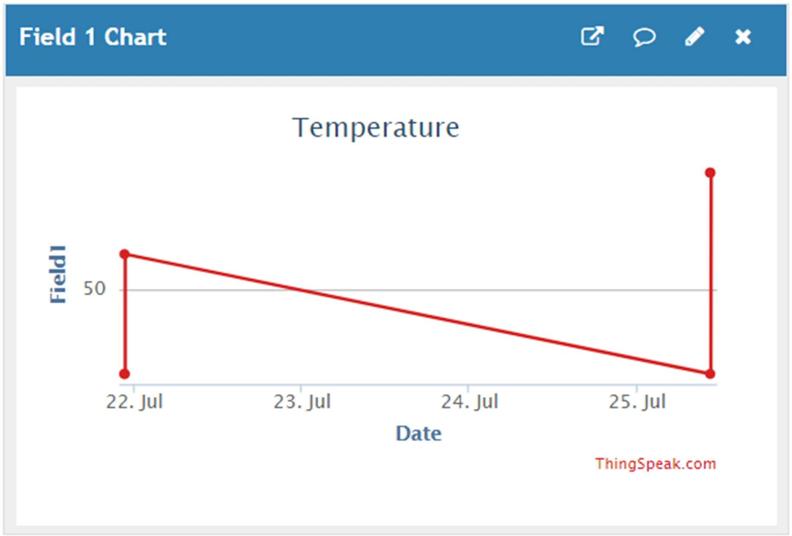

# Practical No. 29

**Aim:** To interface LDR sensor, LED and ESP8266 with Arduino and update light intensity values to Thingspeak and tweet “LIGHT ON” message on tweeter when light intensity value is less than 300.

**Component:**

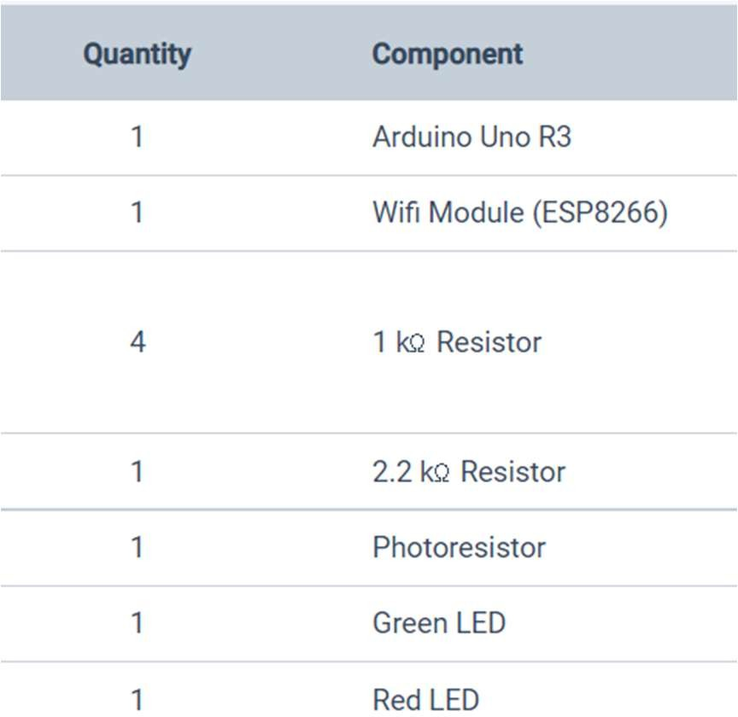

**Circuit Diagram:**

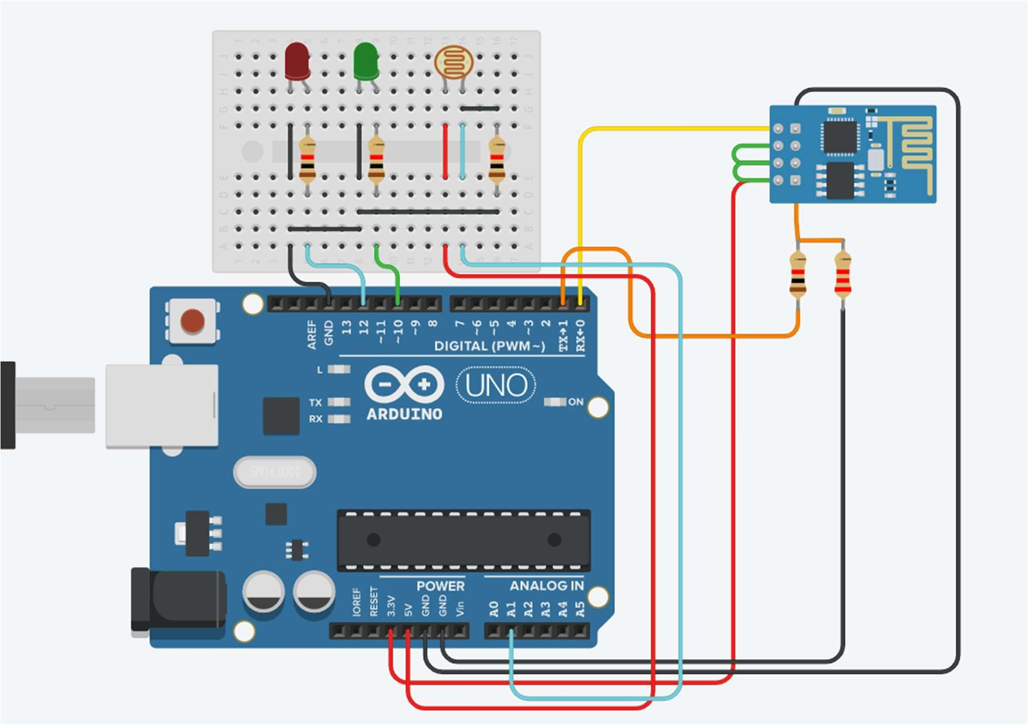

**Program:**

int sense_value; void setup() {

Serial.begin(115200); pinMode(10, OUTPUT); pinMode(12, OUTPUT); pinMode(A1, INPUT); delay(1000);

Serial.println("AT+CWJAP=\"Simulator Wifi\",\"\"\r\n"); delay(3000);

}

void loop()

{

int sense_value = analogRead(A1); Serial.println();

if (sense_value <= 300){ digitalWrite(12, HIGH); digitalWrite(10, LOW);

}

else {

digitalWrite(10, HIGH); digitalWrite(12, LOW);

}

Serial.println("AT+CIPSTART=\"TCP\",\"api.thingspeak.com\",80\r\n"); delay(500);

int len = 65; Serial.print("AT+CIPSEND="); Serial.println(len);

delay(10);

Serial.print("GET /update?api_key=T1HHE4KTNLIKELVC&field1=" + String(sense_value)+" HTTP/1.1\r\n");

delay(100); Serial.println("AT+CIPCLOSE=0\r\n"); delay(600);

}

**Steps:**

## Create channel for Tweet with LDR

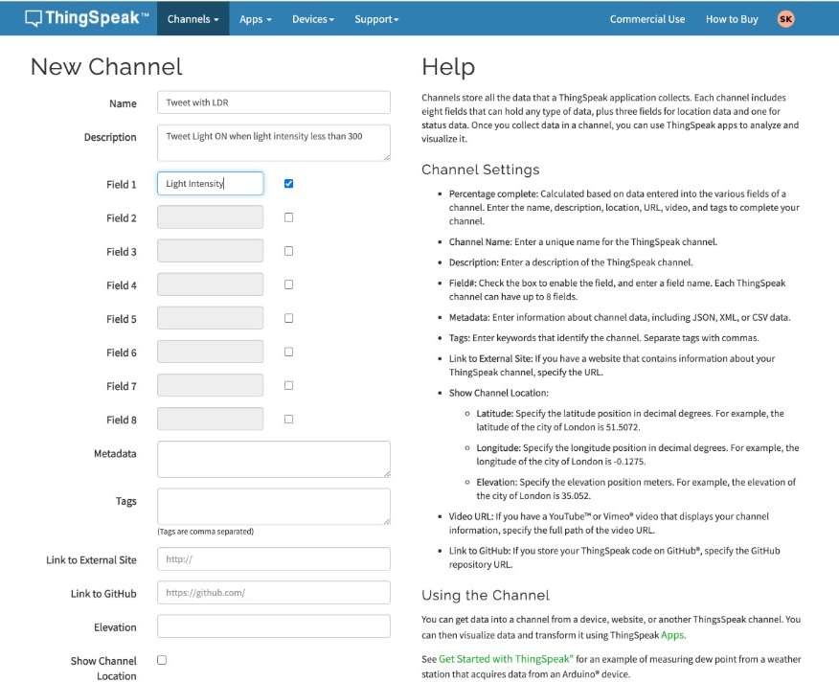

1. **Channel view**

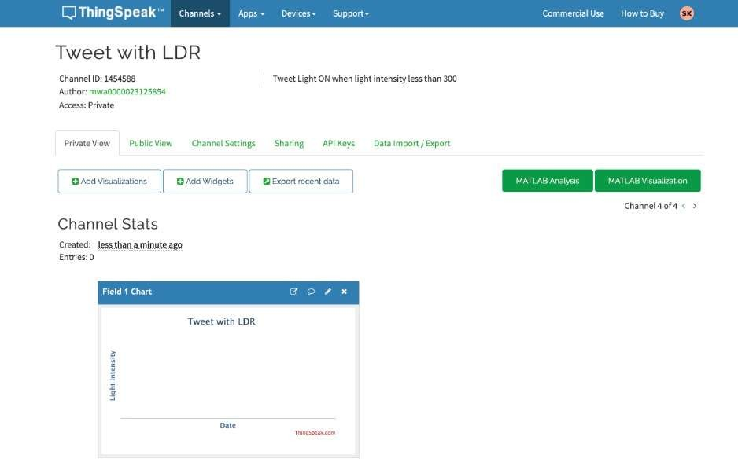

## API view

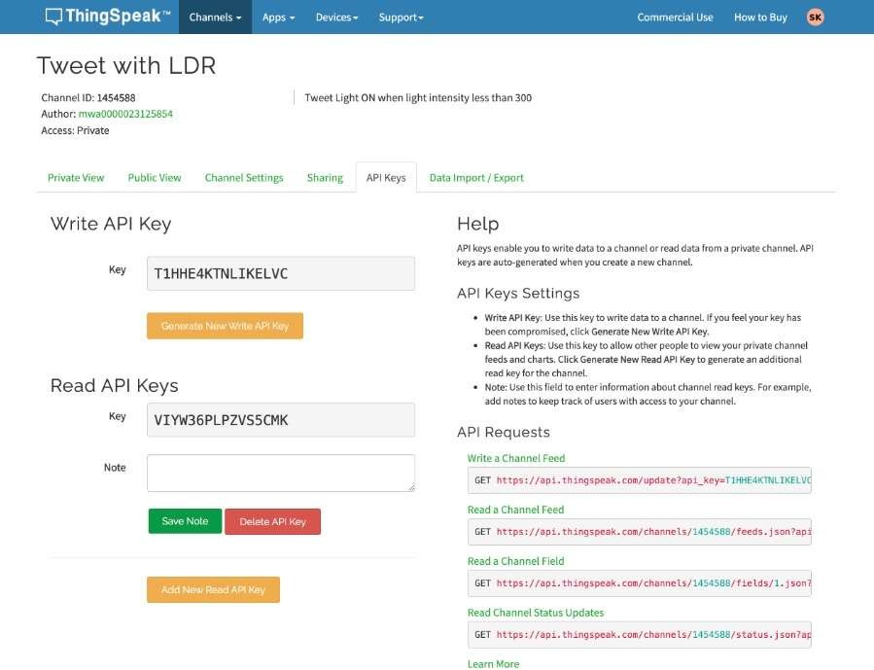

1. **React App**

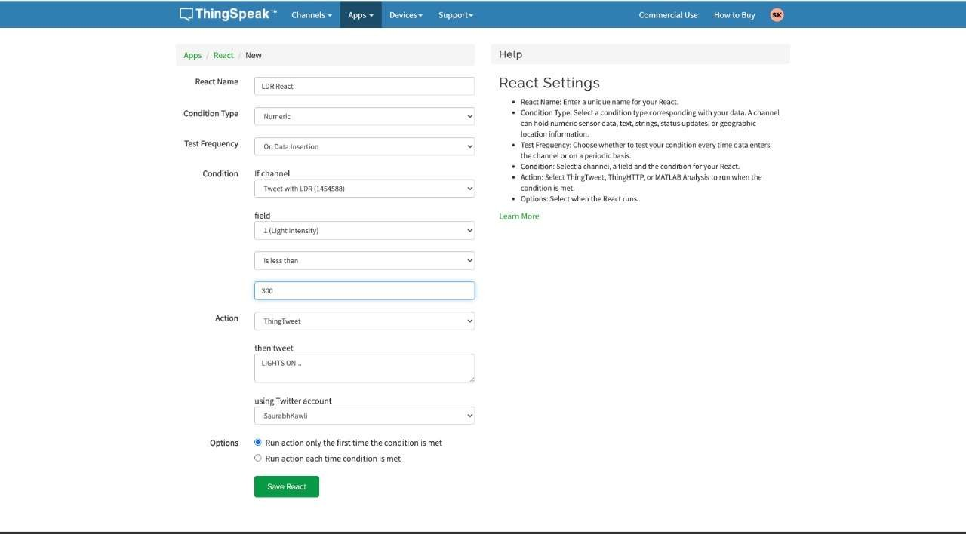

1. **Start simulator and decrease LDR value below 300**

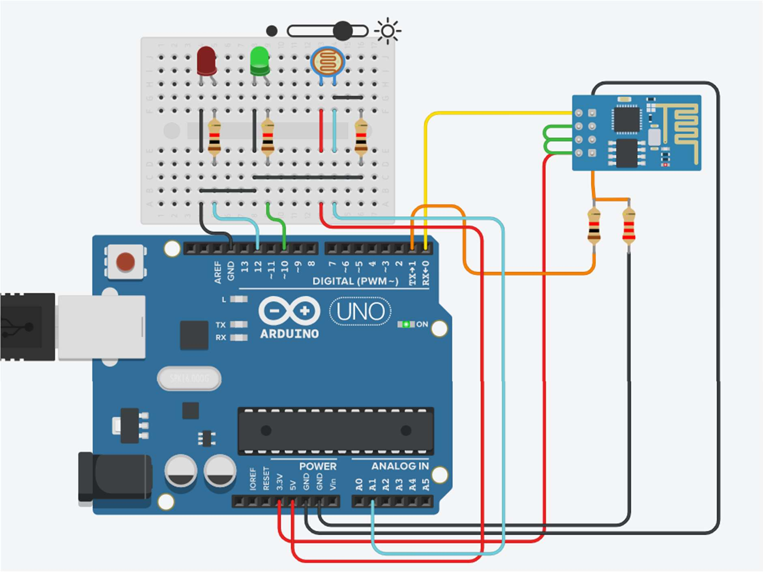

1. **Channel stats**

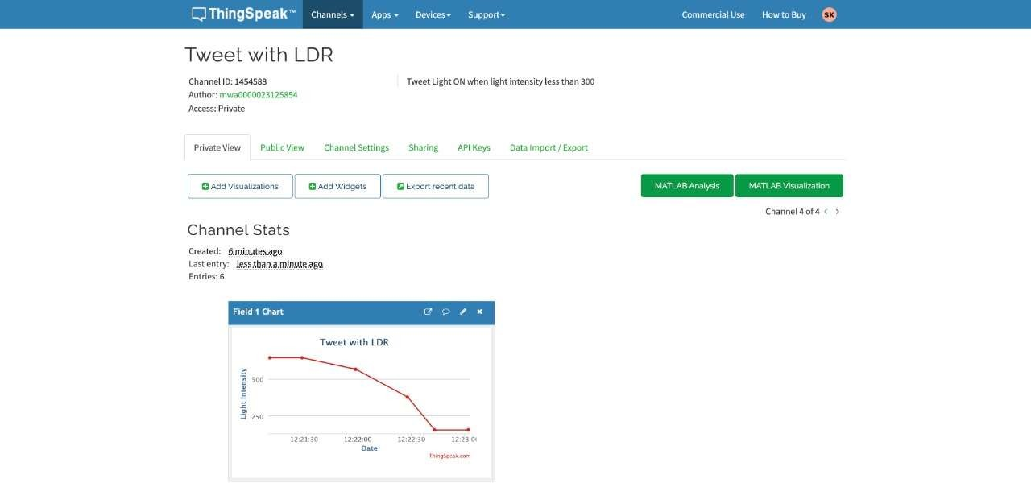

1. **Tweet**



# Practical No. 30

**Aim:** To interface Temperature sensor and ESP8266 with Arduino and update temperature values to Thingspeak and tweet “High Temp” message on tweeter when temperature value is greater than 40C.

**Component:**

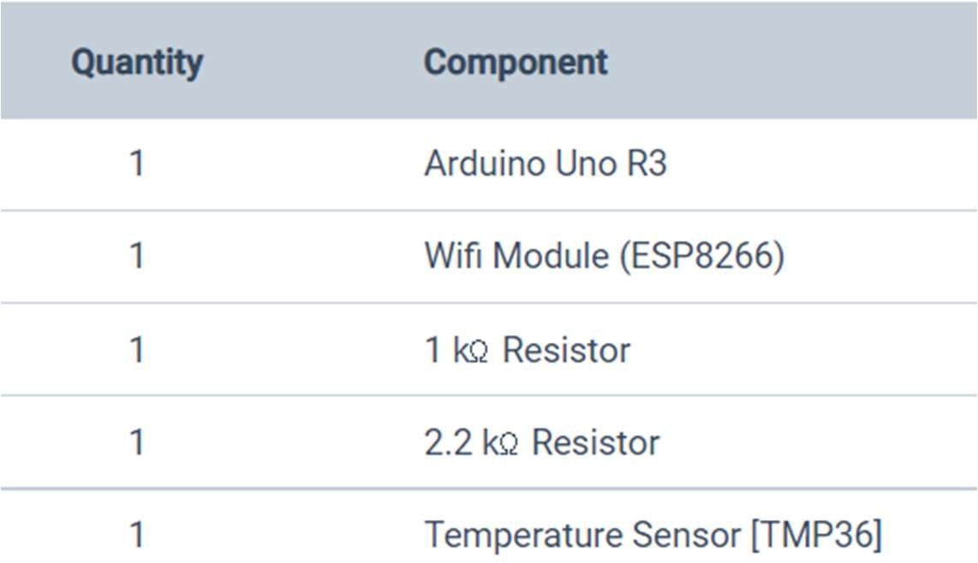

**Circuit Diagram:**

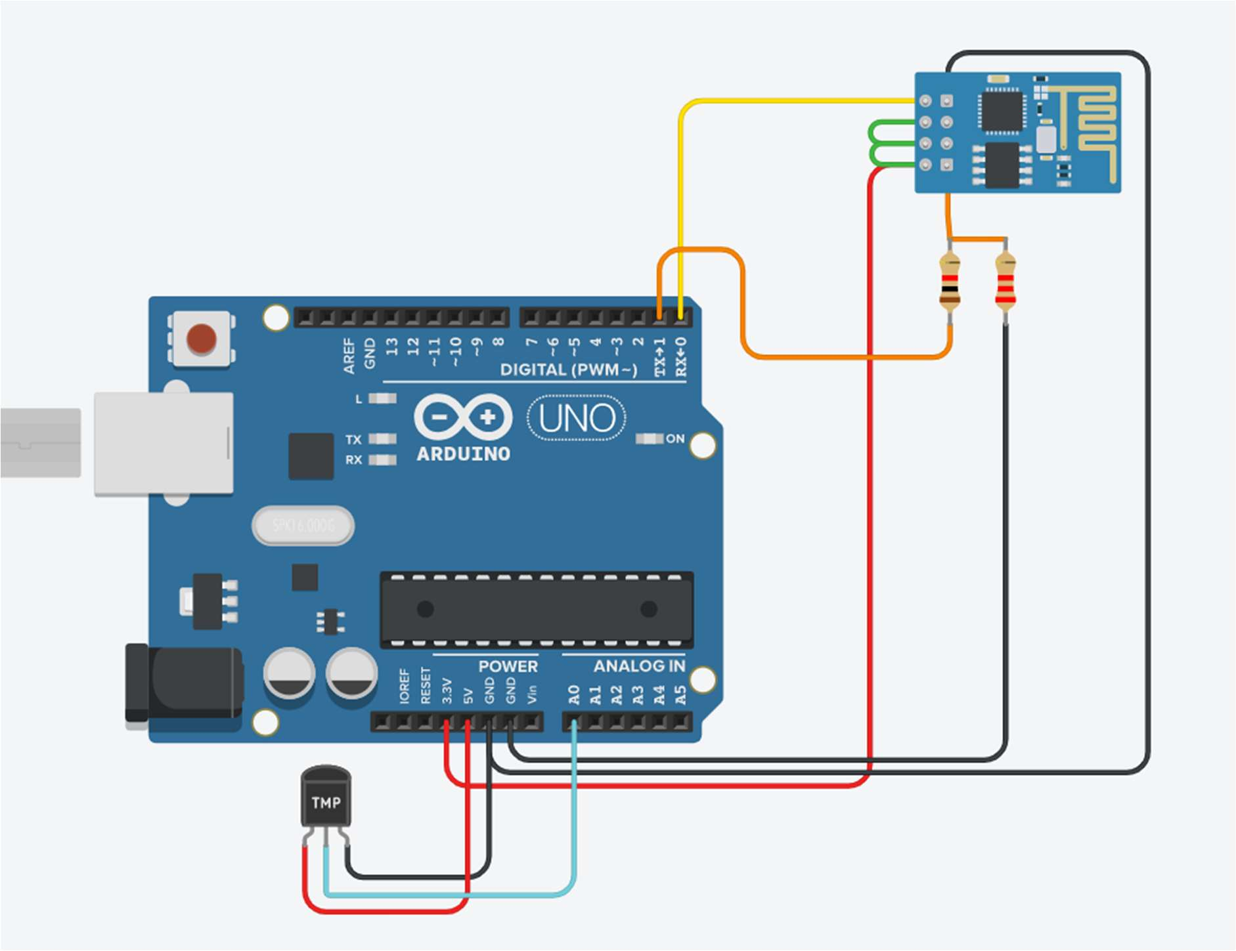

**Program:**

void setup()

{

Serial.begin(115200); pinMode(A0, INPUT); delay(1000);

Serial.println("AT+CWJAP=\"Simulator Wifi\",\"\"\r\n"); delay(3000);

}

void loop() {

int senseValue = analogRead(A0);

float volt = (senseValue/1020.0) * 4.9; //Volts float float tempC = (volt -0.5) * 100; //Celcius Serial.println(tempC);

Serial.println("AT+CIPSTART=\"TCP\",\"api.thingspeak.com\",80\r\n"); delay(5000);

int len = 65; Serial.print("AT+CIPSEND="); Serial.println(len);

delay(10);

Serial.print("GET /update?api_key=AT0I0YF0H855GT2U&field1=" + String(tempC)+" HTTP/1.1\r\n");

delay(100); Serial.println("AT+CIPCLOSE=0\r\n"); delay(6000);

}

**Steps:**

## Create new channel on ThingSpeak

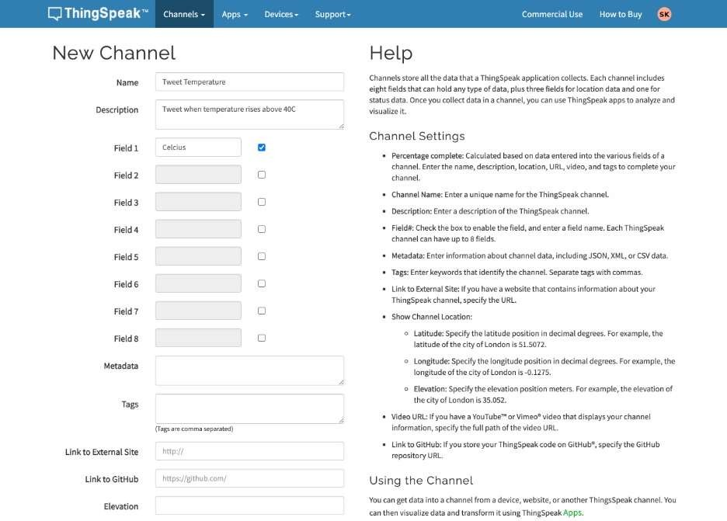

1. **Go to apps => react app => create new**

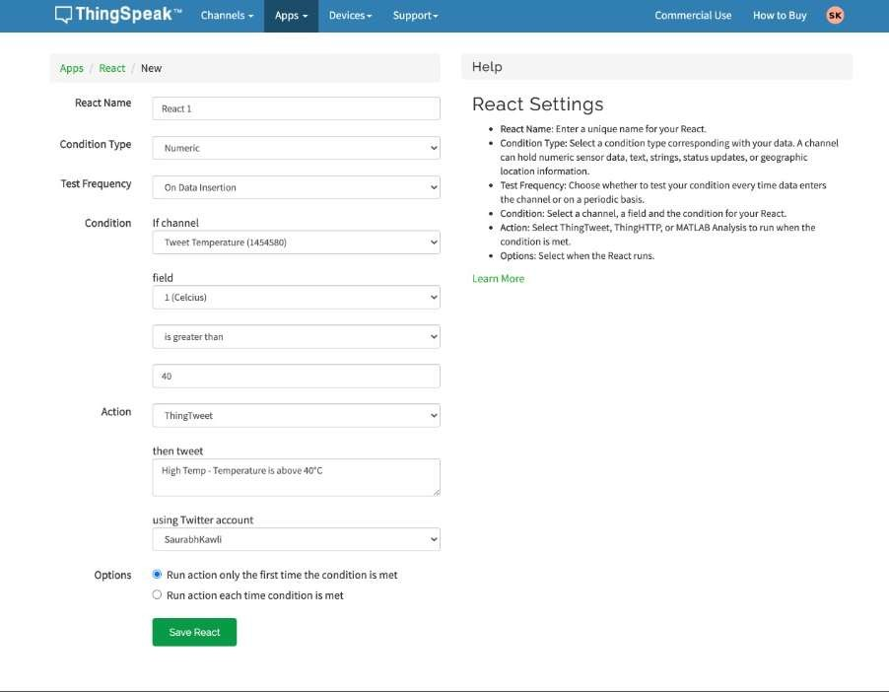

1. **Tweet Temperature channel**

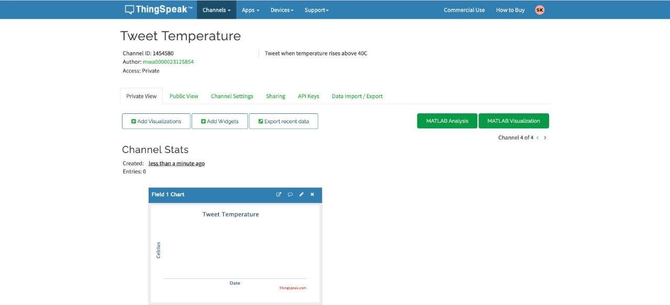

1. **Start the simulator and increase temperature above 40**
2. **Channel Stats graph**

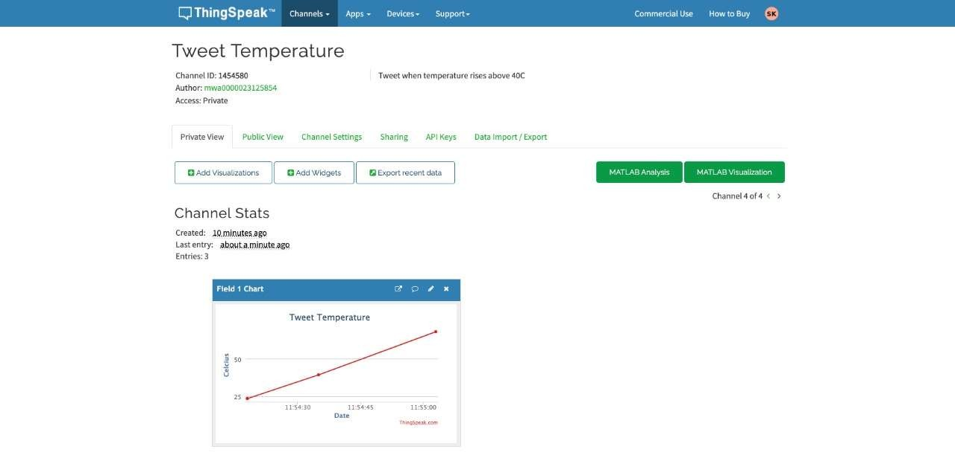

1. **See the Tweet**

